UNITED STATES
SECURITIES AND EXCHANGE COMMISSION
Washington, D.C. 20549
_____________________
FORM 10-Q
_____________________
(Mark One)
x |  |  | QUARTERLY REPORT PURSUANT TO SECTION 13 OR 15(d) OF THE SECURITIES EXCHANGE ACT OF 1934
For the quarterly period ended June 30, 2026;
or
o |  |  | TRANSITION REPORT PURSUANT TO SECTION 13 OR 15(d) OF THE SECURITIES EXCHANGE ACT OF 1934
For the transition period from_________to_________
Commission file number 001-38161

_____________________
Cibus, Inc.
(Exact name of registrant as specified in its charter)
_____________________
Delaware |  |  |  |  |  | 27-1967997
(State or other jurisdiction of  incorporation or organization) |  |  |  |  |  | (I.R.S. Employer  Identification No.)
6455 Nancy Ridge Drive  San Diego, CA |  |  |  |  |  | 92121
(Address of principal executive offices) |  |  |  |  |  | (Zip Code)
(858) 450-0008
(Registrant’s telephone number, including area code)
N/A
(Former name, former address and former fiscal year, if changed since last report)
_____________________
Securities registered pursuant to Section 12(b) of the Act.
Title of each class |  |  |  |  |  | Trading  Symbol(s) |  |  |  |  |  | Name of each exchange  on which registered
Class A Common Stock, $0.0001 par value per share |  |  |  |  |  | CBUS |  |  |  |  |  | The NASDAQ Stock Market LLC
Indicate by check mark whether the registrant (1) has filed all reports required to be filed by Section 13 or 15(d) of the Securities Exchange Act of 1934 during the preceding 12 months (or for such shorter period that the registrant was required to file such reports), and (2) has been subject to such filing requirements for the past 90 days. Yes x No o
Indicate by check mark whether the registrant has submitted electronically every Interactive Data File required to be submitted pursuant to Rule 405 of Regulation S-T (§232.405 of this chapter) during the preceding 12 months (or for such shorter period that the registrant was required to submit such files). Yes x No o
Indicate by check mark whether the registrant is a large accelerated filer, an accelerated filer, a non-accelerated filer, a smaller reporting company or an emerging growth company. See the definitions of “large accelerated filer,” “accelerated filer,” “smaller reporting company,” and “emerging growth company” in Rule 12b-2 of the Exchange Act:
Large accelerated filer |  |  | o |  |  |  |  |  | Accelerated filer |  |  | o
Non-accelerated filer |  |  | x |  |  |  |  |  | Smaller reporting company |  |  | x
 |  |  |  |  |  |  |  |  | Emerging growth company |  |  | o
If an emerging growth company, indicate by check mark if the registrant has elected not to use the extended transition period for complying with any new or revised financial accounting standards provided pursuant to Section 13(a) of the Exchange Act. o
Indicate by check mark whether the registrant is a shell company (as defined in Rule 12b-2 of the Exchange Act). o Yes x No
As of August 7, 2026, there were 76,428,964 shares of the registrant’s Class A Common Stock, $0.0001 par value per share (Class A Common Stock) outstanding (excluding 34,126 restricted shares of Class A Common Stock, which remain subject to vesting), and no shares of the registrant’s Class B Common Stock, $0.0001 par value per share, outstanding.

Table of Contents
PART I. FINANCIAL INFORMATION |  |  | 4
Item 1. Condensed Consolidated Financial Statements |  |  | 4
Item 2. Management’s Discussion and Analysis of Financial Condition and Results of Operations |  |  | 24
Item 4. Controls and Procedures |  |  | 31
PART II. OTHER INFORMATION |  |  | 32
Item 1. Legal Proceedings |  |  | 32
Item 1A. Risk Factors |  |  | 32
Item 2. Unregistered Sales of Equity Securities and Use of Proceeds |  |  | 32
Item 5. Other Information |  |  | 32
Item 6. Exhibits |  |  | 33
SIGNATURES |  |  | 34

Terms

When the terms “Cibus,” the “Company” or “its” are used in this Quarterly Report on Form 10-Q, unless the context otherwise requires, those terms are being used to refer to Cibus, Inc. and its consolidated subsidiaries. When the term “Cibus Global” is used, it is being used to refer to Cibus Global, LLC, a direct, wholly-owned subsidiary of the Company.

The Company owns or has the right to use the trademarks, service marks, and trade names that it uses in conjunction with the operation of its business. Some of the more important marks and names that it owns or has rights to use that may appear in this Quarterly Report on Form 10-Q include: “Cibus®,” “RTDS®,” “Rapid Trait Development SystemTM,” “Trait MachineTM,” and “Future of BreedingTM.” This Quarterly Report on Form 10-Q may also contain additional trade names, trademarks, and service marks belonging to other companies. The Company does not intend its use or display of other parties’ trademarks, trade names, or service marks to imply, and such use or display should not be construed to imply a relationship with, or endorsement or sponsorship of these other parties.

Cautionary Note Regarding Forward-Looking Statements
This Quarterly Report on Form 10-Q contains “forward-looking statements” within the meaning of the federal securities laws, including Section 27A of the Securities Act of 1933, as amended (the Securities Act) and the rules and regulations promulgated thereunder, and Section 21E of the Securities Exchange Act of 1934, as amended (the Exchange Act) and the rules and regulations promulgated thereunder. The Company may also make forward-looking statements in other reports filed with the Securities and Exchange Commission (SEC), in materials delivered to stockholders, and in press releases. In addition, the Company’s representatives may from time-to-time make oral forward-looking statements.
The Company has made these forward-looking statements in reliance on the safe harbor provisions of the United States Private Securities Litigation Reform Act of 1995. Although the Company believes the expectations reflected in the forward-looking statements are reasonable, it cannot guarantee future results, level of activity, performance or achievements. In some cases, you can identify these statements by forward-looking words such as “anticipates,” “believes,” “continue,” “could,” “estimates,” “expects,” “intends,” “may,” “might,” “plans,” “predicts,” “projects,” “scheduled,” “should,” “targets,” “will,” “would,” or the negative of these terms and other similar terminology. Forward-looking statements in this Quarterly Report on Form 10-Q include statements about the Company’s future financial performance, including its liquidity and capital resources, cost saving initiatives and their impact on annual cash burn rates, cash runway, and its ability to continue as a going concern; the advancement, timing and progress of the Company’s platform development and trait development in crop platforms; the ability to obtain partner funding to support its non-Rice productivity trait portfolio; the anticipated timing for the presentation of data related to trait development and other operational activities; the timeframes for transferring traits in customers’ elite germplasm; the ability to implement commercial agreements with potential customers, the timeframe for commercialization of germplasm with the Company’s traits by seed company customers and the integration of Cibus technology into customer pipelines; the timing for, and degree of, adoption by farmers of germplasm with the Company’s traits following commercialization; the capacity of the Company’s productivity traits to deliver competitive yield improvements; the ability of gene editing to address climate change at scale; the timing and nature of regulatory developments relating to gene editing; the market opportunity for the Company’s plant traits, including the number of addressable acres, and the trait fees that the Company expects to receive; and the Company’s ability to enter into and maintain significant collaborations and commercial relationships. These and other forward-looking statements are predictions and projections about future events and trends based on the Company’s current expectations, objectives, and intentions and are premised on current assumptions. The Company’s actual results, level of activity, performance, or achievements could be materially different than those expressed, implied, or anticipated by forward-looking statements due to a variety of factors, including, but not limited to: the Company’s need for additional near-term funding to finance its activities and challenges in obtaining additional capital on acceptable terms, or at all; changes in expected or existing competition; challenges to the Company’s
- 1 -

intellectual property protection and unexpected costs associated with defending intellectual property rights; increased or unanticipated time and resources required for the Company’s development efforts for its priority opportunities in Rice and biofragrance products and sustainable ingredients; the Company’s reliance on third parties in connection with its development activities and for commercialization; challenges associated with the Company’s ability to effectively license its productivity traits and sustainable ingredient products; the risk that farmers do not recognize the value in germplasm containing the Company’s traits or that farmers and processors fail to work effectively with crops containing the Company’s traits; delays or disruptions in the Company’s platform or trait product development efforts; the inability to identify partners to fund the Company’s non-Rice productivity trait portfolio; challenges that arise in respect of the Company’s production of high-quality plants and seeds cost effectively on a large scale; the Company’s dependence on distributions from Cibus Global to pay taxes and cover its corporate and overhead expenses; regulatory developments that disfavor or impose significant burdens on gene editing processes or products; delays and uncertainties regarding regulatory developments in the European Union; the Company’s ability to achieve commercial success or to effectively negotiate commercial agreements; commodity prices and other market risks facing the agricultural sector; technological developments that could render the Company’s technologies obsolete; impacts of the Company’s headcount reductions and other cost reduction measures, which may include operational and strategic challenges, and the potential for additional cost reduction measures; changes in macroeconomic and market conditions, including inflation, supply chain constraints, and rising interest rates, and economic volatility and uncertainty arising from dynamic trade policies, including tariffs and retaliatory tariffs, and market reactions to such policies; dislocations in the capital markets and challenges in accessing liquidity and the impact of such liquidity challenges on the Company’s ability to execute on its business plan; the Company’s assessment of the period of time through which its financial resources will be adequate to support operations; and the risks and uncertainties described in “Item 1A. Risk Factors,” in the Company’s Annual Report on Form 10-K, which was filed with the SEC on March 17, 2026, or as they may be updated or supplemented from time-to-time in the Company’s subsequent reports on Forms 10-Q and 8-K filed with the SEC. The foregoing factors should be considered an integral part of “Item 2. Management’s Discussion and Analysis of Financial Condition and Results of Operations.” Investors are cautioned not to place undue reliance on any forward-looking statements.
Any forward-looking statements made by the Company in this Quarterly Report on Form 10-Q are based only on currently available information and speak only as of the date hereof. Except as otherwise required by securities and other applicable laws, the Company does not assume any obligation to publicly provide revisions or updates to any forward-looking statements, whether as a result of new information, future developments or otherwise, should circumstances change.
Market Data
This Quarterly Report on Form 10-Q contains market data and industry statistics and forecasts that are based on independent industry publications, other publicly available information, and the Company’s internal sources and estimates (including, its knowledge of, and experience to date in, the potential markets for its products). Although the Company believes that third party sources are reliable, it does not guarantee the accuracy or completeness of the information extracted from these sources, and the Company has not independently verified such information. Similarly, while the Company believes its management estimates to be reasonable, they have not been verified by any independent sources. The market and industry data and estimates presented in this Quarterly Report on Form 10-Q involve risks and uncertainties and are subject to change based on various factors, including those discussed in the section entitled “Item 1A. Risk Factors” in the Annual Report and other subsequent reports on Forms 10-Q and 8-K filed with the SEC. Forecasts and other forward-looking estimates about the Company’s industry or performance within its industry are subject to the risks and uncertainties regarding forward-looking statements described under the caption “Cautionary Note Regarding Forward-Looking Statements.” Accordingly, results could differ materially from those expressed in the estimates made by the independent parties and by the Company, and investors should not place undue reliance on this information.
Website Disclosure
The Company uses its website (www.cibus.com), its corporate X account (formerly Twitter) (@CibusGlobal), and its corporate LinkedIn account (https://www.linkedin.com/company/cibus-global) as routine channels of distribution of company information, including press releases, analyst presentations, and supplemental financial information, as a means of disclosing material non-public information and for complying with its disclosure obligations under Regulation FD. Accordingly, investors should monitor its website and its corporate X and LinkedIn accounts in addition to following press releases, filings with the SEC, and public conference calls and webcasts.

Additionally, the Company provides notifications of announcements as part of its website. Investors and others can receive notifications of new press releases posted on the Company’s website by signing up for email alerts.

None of the information provided on the Company’s website, in its press releases or public conference calls and webcasts, or through social media is incorporated into, or deemed to be a part of, this Quarterly Report on Form 10-Q or in any other report or document it files with the SEC unless such document specifically states otherwise, and any references to its website or its corporate X and LinkedIn accounts are intended to be inactive textual references only.
Implications of Being a Smaller Reporting Company

Cibus is a “smaller reporting company” as defined in the Exchange Act. Cibus may continue to be a smaller reporting company even though it no longer qualifies as an “emerging growth company.” As a smaller reporting company, Cibus is exempt from the auditor
- 2 -

attestation requirements of the Sarbanes-Oxley Act of 2002 and may also take advantage of certain scaled disclosure accommodations. Cibus will remain a smaller reporting company until the fiscal year following the determination that its common stock held by non-affiliates is $250 million or more (measured on the last business day of Cibus’ second fiscal quarter) or Cibus’ annual revenues are $100 million or more during the most recently completed fiscal year and Cibus’ common stock held by non-affiliates is $700 million or more (measured on the last business day of Cibus’ second fiscal quarter).

- 3 -

PART I. FINANCIAL INFORMATION

Item 1. Condensed Consolidated Financial Statements

CIBUS, INC.
CONDENSED CONSOLIDATED BALANCE SHEETS
(Unaudited and in Thousands, Except Par Value and Share Amounts)
 |  |  | June 30, 2026 |  |  |  |  |  | December 31, 2025
Assets
Current assets:
Cash and cash equivalents |  |  | $ | 20,429 |  |  |  |  | $ | 9,923
Accounts receivable |  |  | 838 |  |  |  |  |  | 503
Prepaid expenses and other current assets |  |  | 2,189 |  |  |  |  |  | 1,643
Total current assets |  |  | 23,456 |  |  |  |  |  | 12,069
Property, plant, and equipment, net |  |  | 4,919 |  |  |  |  |  | 6,300
Operating lease right-of-use assets |  |  | 21,015 |  |  |  |  |  | 21,557
Intangible assets, net |  |  | 30,770 |  |  |  |  |  | 31,679
Goodwill |  |  | 232,516 |  |  |  |  |  | 232,516
Other non-current assets |  |  | 771 |  |  |  |  |  | 926
Total assets |  |  | $ | 313,447 |  |  |  |  | $ | 305,047
Liabilities and stockholders’ equity
Current liabilities:
Accounts payable |  |  | $ | 5,612 |  |  |  |  | $ | 8,070
Accrued expenses |  |  | 1,893 |  |  |  |  |  | 1,946
Accrued compensation |  |  | 2,606 |  |  |  |  |  | 3,061
Deferred revenue |  |  | 627 |  |  |  |  |  | 536
Current portion of notes payable |  |  | 812 |  |  |  |  |  | 435
Current portion of operating lease obligations |  |  | 2,859 |  |  |  |  |  | 2,731
Class A common stock warrants |  |  | 38 |  |  |  |  |  | 79
Total current liabilities |  |  | 14,447 |  |  |  |  |  | 16,858
Notes payable, net of current portion |  |  | 53 |  |  |  |  |  | 93
Operating lease obligations, net of current portion |  |  | 29,018 |  |  |  |  |  | 29,783
Royalty liability - related parties |  |  | 253,519 |  |  |  |  |  | 234,923
Other non-current liabilities |  |  | 1,608 |  |  |  |  |  | 1,561
Total liabilities |  |  | 298,645 |  |  |  |  |  | 283,218
Commitments and contingencies (See Note 8)
Stockholders’ equity:
Class A common stock, $0.0001 par value; 210,000,000 shares authorized; 76,712,407 shares issued and 76,423,033 shares outstanding as of June 30, 2026, and 54,604,232 shares issued and 54,325,852 shares outstanding as of December 31, 2025 |  |  | 13 |  |  |  |  |  | 11
Class B common stock, $0.0001 par value; 90,000,000 shares authorized; no shares issued and outstanding as of June 30, 2026, and December 31, 2025 |  |  | — |  |  |  |  |  | —
Additional paid-in capital |  |  | 918,639 |  |  |  |  |  | 882,171
Class A common stock in treasury, at cost; 249,317 shares as of June 30, 2026, and 193,195 shares as of December 31, 2025 |  |  | (2,256) |  |  |  |  |  | (2,141)
Accumulated deficit |  |  | (901,618) |  |  |  |  |  | (858,251)
Accumulated other comprehensive income |  |  | 24 |  |  |  |  |  | 39
Total stockholders’ equity |  |  | 14,802 |  |  |  |  |  | 21,829
Total liabilities and stockholders’ equity |  |  | $ | 313,447 |  |  |  |  | $ | 305,047
See accompanying notes to these condensed consolidated financial statements.

- 4 -

CIBUS, INC.
CONDENSED CONSOLIDATED STATEMENTS OF OPERATIONS
(Unaudited and in Thousands, Except Share and Per Share Amounts)
 |  |  | Three Months Ended June 30, |  |  |  |  |  |  |  |  |  |  |  | Six Months Ended June 30,
 |  |  | 2026 |  |  |  |  |  | 2025 |  |  |  |  |  | 2026 |  |  |  |  |  | 2025
Revenue:
Revenue |  |  | $ | 994 |  |  |  |  | $ | 933 |  |  |  |  | $ | 2,675 |  |  |  |  | $ | 1,967
Total revenue |  |  | 994 |  |  |  |  |  | 933 |  |  |  |  |  | 2,675 |  |  |  |  |  | 1,967
Operating expenses:
Research and development |  |  | 8,506 |  |  |  |  |  | 12,228 |  |  |  |  |  | 17,223 |  |  |  |  |  | 24,027
Selling, general, and administrative |  |  | 5,413 |  |  |  |  |  | 6,651 |  |  |  |  |  | 10,497 |  |  |  |  |  | 16,507
Goodwill impairment |  |  | — |  |  |  |  |  | — |  |  |  |  |  | — |  |  |  |  |  | 20,950
Total operating expenses |  |  | 13,919 |  |  |  |  |  | 18,879 |  |  |  |  |  | 27,720 |  |  |  |  |  | 61,484
Loss from operations |  |  | (12,925) |  |  |  |  |  | (17,946) |  |  |  |  |  | (25,045) |  |  |  |  |  | (59,517)
Royalty liability interest expense - related parties |  |  | (9,475) |  |  |  |  |  | (8,668) |  |  |  |  |  | (18,596) |  |  |  |  |  | (17,045)
Other interest income, net |  |  | 111 |  |  |  |  |  | 106 |  |  |  |  |  | 139 |  |  |  |  |  | 225
Non-operating income (expense), net |  |  | 150 |  |  |  |  |  | (23) |  |  |  |  |  | 148 |  |  |  |  |  | 416
Loss before income taxes |  |  | (22,139) |  |  |  |  |  | (26,531) |  |  |  |  |  | (43,354) |  |  |  |  |  | (75,921)
Income tax expense |  |  | (6) |  |  |  |  |  | (27) |  |  |  |  |  | (13) |  |  |  |  |  | (29)
Net loss |  |  | $ | (22,145) |  |  |  |  | $ | (26,558) |  |  |  |  | $ | (43,367) |  |  |  |  | $ | (75,950)
Net loss attributable to noncontrolling interest |  |  | — |  |  |  |  |  | (1,186) |  |  |  |  |  | — |  |  |  |  |  | (3,692)
Net loss attributable to Cibus, Inc. stockholders |  |  | $ | (22,145) |  |  |  |  | $ | (25,372) |  |  |  |  | $ | (43,367) |  |  |  |  | $ | (72,258)
Basic and diluted net loss per share of Class A common stock |  |  | $ | (0.29) |  |  |  |  | $ | (0.61) |  |  |  |  | $ | (0.61) |  |  |  |  | $ | (1.88)
Weighted average shares of Class A common stock outstanding – basic and diluted |  |  | 76,755,936 |  |  |  |  |  | 41,618,893 |  |  |  |  |  | 71,011,006 |  |  |  |  |  | 38,353,931
See accompanying notes to these condensed consolidated financial statements.

- 5 -

CIBUS, INC.
CONDENSED CONSOLIDATED STATEMENTS OF COMPREHENSIVE LOSS
(Unaudited and in Thousands)
 |  |  | Three Months Ended June 30, |  |  |  |  |  |  |  |  |  |  |  | Six Months Ended June 30,
 |  |  | 2026 |  |  |  |  |  | 2025 |  |  |  |  |  | 2026 |  |  |  |  |  | 2025
Net loss |  |  | $ | (22,145) |  |  |  |  | $ | (26,558) |  |  |  |  | $ | (43,367) |  |  |  |  | $ | (75,950)
Foreign currency translation adjustments |  |  | (1) |  |  |  |  |  | 16 |  |  |  |  |  | (15) |  |  |  |  |  | 29
Comprehensive loss |  |  | (22,146) |  |  |  |  |  | (26,542) |  |  |  |  |  | (43,382) |  |  |  |  |  | (75,921)
Comprehensive loss attributable to noncontrolling interest |  |  | — |  |  |  |  |  | (1,186) |  |  |  |  |  | — |  |  |  |  |  | (3,691)
Comprehensive loss attributable to Cibus, Inc. stockholders |  |  | $ | (22,146) |  |  |  |  | $ | (25,356) |  |  |  |  | $ | (43,382) |  |  |  |  | $ | (72,230)
See accompanying notes to these condensed consolidated financial statements.

- 6 -

CIBUS, INC.
CONDENSED CONSOLIDATED STATEMENTS OF REDEEMABLE NONCONTROLLING INTEREST AND STOCKHOLDERS’ EQUITY
(Unaudited and in Thousands, Except Shares Outstanding)
 |  |  |  |  |  |  |  | Class A Common Stock |  |  |  |  |  |  |  |  |  |  |  | Class B Common Stock
Three Months Ended  June 30, 2026 |  |  |  |  |  |  |  | Shares |  |  |  |  |  | Amount |  |  |  |  |  | Shares |  |  |  |  |  | Amount |  |  |  |  |  | Additional  Paid-In  Capital |  |  |  |  |  | Shares  in  Treasury |  |  |  |  |  | Accumulated  Deficit |  |  |  |  |  | Accumulated Other Comprehensive Income (loss) |  |  |  |  |  |  |  |  |  | Total  Stockholders’  Equity
Balance at March 31, 2026 |  |  |  |  |  |  |  | 76,283,095 |  |  |  |  |  | $ | 13 |  |  |  |  | — |  |  |  |  |  | $ | — |  |  |  |  | $ | 917,136 |  |  |  |  | $ | (2,221) |  |  |  |  | $ | (879,473) |  |  |  |  | $ | 25 |  |  |  |  |  |  |  |  | $ | 35,480
Net loss |  |  |  |  |  |  |  | — |  |  |  |  |  | — |  |  |  |  |  | — |  |  |  |  |  | — |  |  |  |  |  | — |  |  |  |  |  | — |  |  |  |  |  | (22,145) |  |  |  |  |  | — |  |  |  |  |  |  |  |  |  | (22,145)
Stock-based compensation |  |  |  |  |  |  |  | — |  |  |  |  |  | — |  |  |  |  |  | — |  |  |  |  |  | — |  |  |  |  |  | 1,484 |  |  |  |  |  | — |  |  |  |  |  | — |  |  |  |  |  | — |  |  |  |  |  |  |  |  |  | 1,484
Issuance of common stock upon vesting of restricted stock awards and units |  |  |  |  |  |  |  | 160,305 |  |  |  |  |  | — |  |  |  |  |  | — |  |  |  |  |  | — |  |  |  |  |  | — |  |  |  |  |  | — |  |  |  |  |  | — |  |  |  |  |  | — |  |  |  |  |  |  |  |  |  | —
Issuance of common stock from the ATM facility, net of offering expenses |  |  |  |  |  |  |  | 3,059 |  |  |  |  |  | — |  |  |  |  |  | — |  |  |  |  |  | — |  |  |  |  |  | — |  |  |  |  |  | — |  |  |  |  |  | — |  |  |  |  |  | — |  |  |  |  |  |  |  |  |  | —
Issuance of common stock in registered offering, net |  |  |  |  |  |  |  | — |  |  |  |  |  | — |  |  |  |  |  | — |  |  |  |  |  | — |  |  |  |  |  | 19 |  |  |  |  |  | — |  |  |  |  |  | — |  |  |  |  |  | — |  |  |  |  |  |  |  |  |  | 19
Shares withheld for payment of minimum employee taxes withheld upon net share settlement of restricted stock units |  |  |  |  |  |  |  | (23,426) |  |  |  |  |  | — |  |  |  |  |  | — |  |  |  |  |  | — |  |  |  |  |  | — |  |  |  |  |  | (35) |  |  |  |  |  | — |  |  |  |  |  | — |  |  |  |  |  |  |  |  |  | (35)
Foreign currency translation adjustments |  |  |  |  |  |  |  | — |  |  |  |  |  | — |  |  |  |  |  | — |  |  |  |  |  | — |  |  |  |  |  | — |  |  |  |  |  | — |  |  |  |  |  | — |  |  |  |  |  | (1) |  |  |  |  |  |  |  |  |  | (1)
Balance at June 30, 2026 |  |  |  |  |  |  |  | 76,423,033 |  |  |  |  |  | $ | 13 |  |  |  |  | — |  |  |  |  |  | $ | — |  |  |  |  | $ | 918,639 |  |  |  |  | $ | (2,256) |  |  |  |  | $ | (901,618) |  |  |  |  | $ | 24 |  |  |  |  |  |  |  |  | $ | 14,802

 |  |  |  |  |  |  |  | Class A Common Stock |  |  |  |  |  |  |  |  |  |  |  | Class B Common Stock
Three Months Ended  June 30, 2025 |  |  |  |  |  |  |  | Shares |  |  |  |  |  | Amount |  |  |  |  |  | Shares |  |  |  |  |  | Amount |  |  |  |  |  | Additional  Paid-In  Capital |  |  |  |  |  | Shares  in  Treasury |  |  |  |  |  | Accumulated  Deficit |  |  |  |  |  | Accumulated Other Comprehensive Income |  |  |  |  |  | Total Cibus, Inc. Stockholders’ Equity |  |  |  |  |  | Noncontrolling Interest |  |  |  |  |  | Total  Stockholders’  Equity
Balance at March 31, 2025 |  |  |  |  |  |  |  | 32,657,738 |  |  |  |  |  | $ | 9 |  |  |  |  | 1,712,373 |  |  |  |  |  | $ | — |  |  |  |  | $ | 850,302 |  |  |  |  | $ | (2,012) |  |  |  |  | $ | (778,052) |  |  |  |  | $ | 27 |  |  |  |  | $ | 70,274 |  |  |  |  | $ | 3,683 |  |  |  |  | $ | 73,957
Net loss |  |  |  |  |  |  |  | — |  |  |  |  |  | — |  |  |  |  |  | — |  |  |  |  |  | — |  |  |  |  |  | — |  |  |  |  |  | — |  |  |  |  |  | (25,372) |  |  |  |  |  | — |  |  |  |  |  | (25,372) |  |  |  |  |  | (1,186) |  |  |  |  |  | (26,558)
Stock-based compensation |  |  |  |  |  |  |  | — |  |  |  |  |  | — |  |  |  |  |  | — |  |  |  |  |  | — |  |  |  |  |  | 1,978 |  |  |  |  |  | — |  |  |  |  |  | — |  |  |  |  |  | — |  |  |  |  |  | 1,978 |  |  |  |  |  | — |  |  |  |  |  | 1,978
Issuance of common stock upon vesting of restricted stock awards and units |  |  |  |  |  |  |  | 66,377 |  |  |  |  |  | — |  |  |  |  |  | — |  |  |  |  |  | — |  |  |  |  |  | — |  |  |  |  |  | — |  |  |  |  |  | — |  |  |  |  |  | — |  |  |  |  |  | — |  |  |  |  |  | — |  |  |  |  |  | —
Issuance of common stock and pre-funded warrants in registered offering, net |  |  |  |  |  |  |  | 15,714,285 |  |  |  |  |  | 2 |  |  |  |  |  | — |  |  |  |  |  | — |  |  |  |  |  | 24,954 |  |  |  |  |  | — |  |  |  |  |  | — |  |  |  |  |  | — |  |  |  |  |  | 24,956 |  |  |  |  |  | — |  |  |  |  |  | 24,956
Issuance of common stock upon exercise of pre-funded warrants |  |  |  |  |  |  |  | 4,050,000 |  |  |  |  |  | — |  |  |  |  |  | — |  |  |  |  |  | — |  |  |  |  |  | — |  |  |  |  |  | — |  |  |  |  |  | — |  |  |  |  |  | — |  |  |  |  |  | — |  |  |  |  |  | — |  |  |  |  |  | —
Reclassification of common warrant liability to stockholders’ equity |  |  |  |  |  |  |  | — |  |  |  |  |  | — |  |  |  |  |  | — |  |  |  |  |  | — |  |  |  |  |  | 153 |  |  |  |  |  | — |  |  |  |  |  | — |  |  |  |  |  | — |  |  |  |  |  | 153 |  |  |  |  |  | — |  |  |  |  |  | 153
Shares withheld for payment of minimum employee taxes withheld upon net share settlement of restricted stock units |  |  |  |  |  |  |  | (7,987) |  |  |  |  |  | — |  |  |  |  |  | — |  |  |  |  |  | — |  |  |  |  |  | — |  |  |  |  |  | (26) |  |  |  |  |  | — |  |  |  |  |  | — |  |  |  |  |  | (26) |  |  |  |  |  | — |  |  |  |  |  | (26)
Change in noncontrolling interest including issuance of common stock upon exchange of common units |  |  |  |  |  |  |  | — |  |  |  |  |  | — |  |  |  |  |  | — |  |  |  |  |  | — |  |  |  |  |  | 144 |  |  |  |  |  | — |  |  |  |  |  | — |  |  |  |  |  | — |  |  |  |  |  | 144 |  |  |  |  |  | (144) |  |  |  |  |  | —
Foreign currency translation adjustments |  |  |  |  |  |  |  | — |  |  |  |  |  | — |  |  |  |  |  | — |  |  |  |  |  | — |  |  |  |  |  | — |  |  |  |  |  | — |  |  |  |  |  | — |  |  |  |  |  | 16 |  |  |  |  |  | 16 |  |  |  |  |  | — |  |  |  |  |  | 16
Balance at June 30, 2025 |  |  |  |  |  |  |  | 52,480,413 |  |  |  |  |  | $ | 11 |  |  |  |  | 1,712,373 |  |  |  |  |  | $ | — |  |  |  |  | $ | 877,531 |  |  |  |  | $ | (2,038) |  |  |  |  | $ | (803,424) |  |  |  |  | $ | 43 |  |  |  |  | $ | 72,123 |  |  |  |  | $ | 2,353 |  |  |  |  | $ | 74,476
See accompanying notes to these condensed consolidated financial statements.

- 7 -

CIBUS, INC.
CONDENSED CONSOLIDATED STATEMENTS OF REDEEMABLE NONCONTROLLING INTEREST AND STOCKHOLDERS’ EQUITY
(Unaudited and in Thousands, Except Shares Outstanding)
 |  |  |  |  |  | Class A Common Stock |  |  |  |  |  |  |  |  |  |  |  | Class B Common Stock
Six Months Ended  June 30, 2026 |  |  |  |  |  | Shares |  |  |  |  |  | Amount |  |  |  |  |  | Shares |  |  |  |  |  | Amount |  |  |  |  |  | Additional  Paid-In  Capital |  |  |  |  |  | Shares  in  Treasury |  |  |  |  |  | Accumulated  Deficit |  |  |  |  |  | Accumulated Other Comprehensive Income (loss) |  |  |  |  |  | Total Cibus, Inc. Stockholders’ Equity
Balance at December 31, 2025 |  |  |  |  |  | 54,325,852 |  |  |  |  |  | $ | 11 |  |  |  |  | — |  |  |  |  |  | $ | — |  |  |  |  | $ | 882,171 |  |  |  |  | $ | (2,141) |  |  |  |  | $ | (858,251) |  |  |  |  | $ | 39 |  |  |  |  | $ | 21,829
Net loss |  |  |  |  |  | — |  |  |  |  |  | — |  |  |  |  |  | — |  |  |  |  |  | — |  |  |  |  |  | — |  |  |  |  |  | — |  |  |  |  |  | (43,367) |  |  |  |  |  | — |  |  |  |  |  | (43,367)
Stock-based compensation |  |  |  |  |  | — |  |  |  |  |  | — |  |  |  |  |  | — |  |  |  |  |  | — |  |  |  |  |  | 3,055 |  |  |  |  |  | — |  |  |  |  |  | — |  |  |  |  |  | — |  |  |  |  |  | 3,055
Issuance of common stock upon vesting of restricted stock awards and units |  |  |  |  |  | 336,836 |  |  |  |  |  | — |  |  |  |  |  | — |  |  |  |  |  | — |  |  |  |  |  | — |  |  |  |  |  | — |  |  |  |  |  | — |  |  |  |  |  | — |  |  |  |  |  | —
Issuance of common stock from the ATM facility, net of offering expenses |  |  |  |  |  | 3,059 |  |  |  |  |  | — |  |  |  |  |  | — |  |  |  |  |  | — |  |  |  |  |  | — |  |  |  |  |  | — |  |  |  |  |  | — |  |  |  |  |  | — |  |  |  |  |  | —
Issuance of common stock in registered offering, net |  |  |  |  |  | 21,813,408 |  |  |  |  |  | 2 |  |  |  |  |  | — |  |  |  |  |  | — |  |  |  |  |  | 33,413 |  |  |  |  |  | — |  |  |  |  |  | — |  |  |  |  |  | — |  |  |  |  |  | 33,415
Shares withheld for payment of minimum employee taxes withheld upon net share settlement of restricted stock units |  |  |  |  |  | (56,122) |  |  |  |  |  | — |  |  |  |  |  | — |  |  |  |  |  | — |  |  |  |  |  | — |  |  |  |  |  | (115) |  |  |  |  |  | — |  |  |  |  |  | — |  |  |  |  |  | (115)
Foreign currency translation adjustments |  |  |  |  |  | — |  |  |  |  |  | — |  |  |  |  |  | — |  |  |  |  |  | — |  |  |  |  |  | — |  |  |  |  |  | — |  |  |  |  |  | — |  |  |  |  |  | (15) |  |  |  |  |  | (15)
Balance at June 30, 2026 |  |  |  |  |  | 76,423,033 |  |  |  |  |  | $ | 13 |  |  |  |  | — |  |  |  |  |  | $ | — |  |  |  |  | $ | 918,639 |  |  |  |  | $ | (2,256) |  |  |  |  | $ | (901,618) |  |  |  |  | $ | 24 |  |  |  |  | $ | 14,802

 |  |  |  |  |  |  |  |  |  |  |  | Class A Common Stock |  |  |  |  |  |  |  |  |  |  |  | Class B Common Stock
Six Months Ended  June 30, 2025 |  |  |  |  |  | Redeemable Noncontrolling Interest |  |  |  |  |  | Shares |  |  |  |  |  | Amount |  |  |  |  |  | Shares |  |  |  |  |  | Amount |  |  |  |  |  | Additional  Paid-In  Capital |  |  |  |  |  | Shares  in  Treasury |  |  |  |  |  | Accumulated  Deficit |  |  |  |  |  | Accumulated Other Comprehensive Income |  |  |  |  |  | Total Cibus, Inc. Stockholders’ Equity |  |  |  |  |  | Noncontrolling Interest |  |  |  |  |  | Total  Stockholders’  Equity
Balance at December 31, 2024 |  |  |  |  |  | $ | 5,674 |  |  |  |  | 27,939,023 |  |  |  |  |  | $ | 9 |  |  |  |  | 1,720,929 |  |  |  |  |  | $ | — |  |  |  |  | $ | 825,298 |  |  |  |  | $ | (1,999) |  |  |  |  | $ | (731,166) |  |  |  |  | $ | 15 |  |  |  |  | $ | 92,157 |  |  |  |  | $ | — |  |  |  |  | $ | 92,157
Net loss |  |  |  |  |  | — |  |  |  |  |  | — |  |  |  |  |  | — |  |  |  |  |  | — |  |  |  |  |  | — |  |  |  |  |  | — |  |  |  |  |  | — |  |  |  |  |  | (72,258) |  |  |  |  |  | — |  |  |  |  |  | (72,258) |  |  |  |  |  | (3,692) |  |  |  |  |  | (75,950)
Stock-based compensation |  |  |  |  |  | — |  |  |  |  |  | — |  |  |  |  |  | — |  |  |  |  |  | — |  |  |  |  |  | — |  |  |  |  |  | 4,477 |  |  |  |  |  | — |  |  |  |  |  | — |  |  |  |  |  | — |  |  |  |  |  | 4,477 |  |  |  |  |  | — |  |  |  |  |  | 4,477
Issuance of common stock upon vesting of restricted stock awards and units |  |  |  |  |  | — |  |  |  |  |  | 141,899 |  |  |  |  |  | — |  |  |  |  |  | — |  |  |  |  |  | — |  |  |  |  |  | — |  |  |  |  |  | — |  |  |  |  |  | — |  |  |  |  |  | — |  |  |  |  |  | — |  |  |  |  |  | — |  |  |  |  |  | —
Issuance of common stock and pre-funded warrants in registered offering, net |  |  |  |  |  | — |  |  |  |  |  | 20,054,285 |  |  |  |  |  | 2 |  |  |  |  |  | — |  |  |  |  |  | — |  |  |  |  |  | 46,384 |  |  |  |  |  | — |  |  |  |  |  | — |  |  |  |  |  | — |  |  |  |  |  | 46,386 |  |  |  |  |  | — |  |  |  |  |  | 46,386
Issuance of common stock upon exercise of pre-funded warrants |  |  |  |  |  | — |  |  |  |  |  | 4,350,000 |  |  |  |  |  | — |  |  |  |  |  | — |  |  |  |  |  | — |  |  |  |  |  | — |  |  |  |  |  | — |  |  |  |  |  | — |  |  |  |  |  | — |  |  |  |  |  | — |  |  |  |  |  | — |  |  |  |  |  | —
Reclassification of common warrant liability to stockholders’ equity |  |  |  |  |  | — |  |  |  |  |  | — |  |  |  |  |  | — |  |  |  |  |  | — |  |  |  |  |  | — |  |  |  |  |  | 1,742 |  |  |  |  |  | — |  |  |  |  |  | — |  |  |  |  |  | — |  |  |  |  |  | 1,742 |  |  |  |  |  | — |  |  |  |  |  | 1,742
Shares withheld for payment of minimum employee taxes withheld upon net share settlement of restricted stock units |  |  |  |  |  | — |  |  |  |  |  | (13,350) |  |  |  |  |  | — |  |  |  |  |  | — |  |  |  |  |  | — |  |  |  |  |  | — |  |  |  |  |  | (39) |  |  |  |  |  | — |  |  |  |  |  | — |  |  |  |  |  | (39) |  |  |  |  |  | — |  |  |  |  |  | (39)
Reclassification of redeemable noncontrolling interest |  |  |  |  |  | (5,674) |  |  |  |  |  | — |  |  |  |  |  | — |  |  |  |  |  | — |  |  |  |  |  | — |  |  |  |  |  | — |  |  |  |  |  | — |  |  |  |  |  | — |  |  |  |  |  | — |  |  |  |  |  | — |  |  |  |  |  | 5,674 |  |  |  |  |  | 5,674
Change in noncontrolling interest including issuance of common stock upon exchange of common units |  |  |  |  |  | — |  |  |  |  |  | 8,556 |  |  |  |  |  | — |  |  |  |  |  | (8,556) |  |  |  |  |  | — |  |  |  |  |  | (370) |  |  |  |  |  | — |  |  |  |  |  | — |  |  |  |  |  | — |  |  |  |  |  | (370) |  |  |  |  |  | 370 |  |  |  |  |  | —
Foreign currency translation adjustments |  |  |  |  |  | — |  |  |  |  |  | — |  |  |  |  |  | — |  |  |  |  |  | — |  |  |  |  |  | — |  |  |  |  |  | — |  |  |  |  |  | — |  |  |  |  |  | — |  |  |  |  |  | 28 |  |  |  |  |  | 28 |  |  |  |  |  | 1 |  |  |  |  |  | 29
Balance at June 30, 2025 |  |  |  |  |  | $ | — |  |  |  |  | 52,480,413 |  |  |  |  |  | $ | 11 |  |  |  |  | 1,712,373 |  |  |  |  |  | $ | — |  |  |  |  | $ | 877,531 |  |  |  |  | $ | (2,038) |  |  |  |  | $ | (803,424) |  |  |  |  | $ | 43 |  |  |  |  | $ | 72,123 |  |  |  |  | $ | 2,353 |  |  |  |  | $ | 74,476
See accompanying notes to these condensed consolidated financial statements.

- 8 -

CIBUS, INC.
CONDENSED CONSOLIDATED STATEMENTS OF CASH FLOWS
(Unaudited and in Thousands)
 |  |  |  |  |  | Six Months Ended June 30,
 |  |  |  |  |  | 2026 |  |  |  |  |  | 2025
Operating activities
Net loss |  |  |  |  |  | $ | (43,367) |  |  |  |  | $ | (75,950)
Adjustments to reconcile net loss to net cash used in operating activities:
Royalty liability interest expense - related parties |  |  |  |  |  | 18,596 |  |  |  |  |  | 17,045
Goodwill impairment |  |  |  |  |  | — |  |  |  |  |  | 20,950
Depreciation and amortization |  |  |  |  |  | 2,359 |  |  |  |  |  | 3,209
Stock-based compensation |  |  |  |  |  | 3,055 |  |  |  |  |  | 4,477
Loss on disposal of assets, net |  |  |  |  |  | 4 |  |  |  |  |  | 80
Change in fair value of liability classified Class A common stock warrants |  |  |  |  |  | (41) |  |  |  |  |  | (455)
Other |  |  |  |  |  | (2) |  |  |  |  |  | 49
Changes in operating assets and liabilities:
Accounts receivable |  |  |  |  |  | (335) |  |  |  |  |  | 88
Prepaid expenses and other current assets |  |  |  |  |  | 149 |  |  |  |  |  | (44)
Accounts payable |  |  |  |  |  | (907) |  |  |  |  |  | 82
Accrued expenses |  |  |  |  |  | (86) |  |  |  |  |  | 3,998
Accrued compensation |  |  |  |  |  | (463) |  |  |  |  |  | (213)
Deferred revenue |  |  |  |  |  | 88 |  |  |  |  |  | (17)
Right-of-use assets and lease obligations, net |  |  |  |  |  | (95) |  |  |  |  |  | 1,141
Other assets and liabilities, net |  |  |  |  |  | 151 |  |  |  |  |  | 129
Net cash used in operating activities |  |  |  |  |  | (20,894) |  |  |  |  |  | (25,431)
Investing activities
Proceeds from sales of property, plant, and equipment |  |  |  |  |  | 43 |  |  |  |  |  | —
Purchases of property, plant, and equipment |  |  |  |  |  | (73) |  |  |  |  |  | (384)
Net cash used in investing activities |  |  |  |  |  | (30) |  |  |  |  |  | (384)
Financing activities
Proceeds from issuances of securities |  |  |  |  |  | 37,260 |  |  |  |  |  | 50,100
Costs paid related to issuances of securities |  |  |  |  |  | (5,357) |  |  |  |  |  | (1,951)
Payment of taxes related to restricted stock units withheld from employees |  |  |  |  |  | (115) |  |  |  |  |  | (39)
Repayments of notes payable |  |  |  |  |  | (352) |  |  |  |  |  | (279)
Net cash provided by financing activities |  |  |  |  |  | 31,436 |  |  |  |  |  | 47,831
Effect of exchange rate changes on cash and cash equivalents |  |  |  |  |  | (6) |  |  |  |  |  | 14
Net increase in cash and cash equivalents |  |  |  |  |  | 10,506 |  |  |  |  |  | 22,030
Cash and cash equivalents – beginning of period |  |  |  |  |  | 9,923 |  |  |  |  |  | 14,433
Cash and cash equivalents – end of period |  |  |  |  |  | $ | 20,429 |  |  |  |  | $ | 36,463
See accompanying notes to these condensed consolidated financial statements.

- 9 -

CIBUS, INC.
NOTES TO THE CONDENSED CONSOLIDATED FINANCIAL STATEMENTS

1. NATURE OF BUSINESS & SUMMARY OF SIGNIFICANT ACCOUNTING POLICIES
Nature of Business and Organization
Cibus, Inc. (Cibus or the Company) carries on its business through Cibus Global, LLC (Cibus Global) and its subsidiaries. Cibus Global is a plant trait company using gene editing technologies to develop and license gene edited plant traits that improve farming productivity or produce renewable low carbon plant products. Cibus’ primary business is the development of plant traits for some of the world’s major agricultural food crops that help address specific productivity, profitability, sustainability, or yield challenges in farming. As the Company is still developing its technology and products, it has not yet begun earning royalty revenues.
Cibus Global, a Delaware limited liability company, was formed on May 10, 2019. Immediately prior to the effective date of this formation, Cibus Global was organized as a British Virgin Islands company (Cibus Global, Ltd.), which was formed on September 11, 2008.
The Company was organized in an “Up-C” structure, and the Company’s only material asset consists of common membership units of Cibus Global (Common Units). The Company’s amended and restated certificate of incorporation designates two classes of the Company’s common stock: (i) Class A Common Stock, par value $0.0001 per share (the Class A Common Stock), which shares have full voting and economic rights, and (ii) Class B Common Stock, par value $0.0001 per share (the Class B Common Stock), which shares have full voting, but no economic rights. For holders of Class B Common Stock, each share of Class B Common Stock was paired with a Common Unit (collectively, an Up-C Unit). As of December 31, 2025, there were no remaining Common Unit holders of the noncontrolling interest of Cibus Global and 100 percent of the Common Units of Cibus Global are held by Cibus.
Basis of Presentation
The unaudited condensed consolidated financial statements of Cibus, Inc. have been prepared in accordance with accounting principles generally accepted in the United States (U.S. GAAP or GAAP) for interim financial information and the rules and regulations of the Securities and Exchange Commission (SEC) applicable to interim financial statements and has included the accounts of Cibus and its wholly owned subsidiaries. All intercompany accounts and transactions have been eliminated in consolidation. In the Company’s opinion, the accompanying condensed consolidated financial statements reflect all adjustments necessary for a fair statement of its statements of financial position, results of operations, and cash flows for the periods presented but they do not include all of the information and footnotes required by U.S. GAAP for complete financial statements. Except as otherwise disclosed herein, these adjustments consist of normal recurring items. Operating results for interim periods are not necessarily indicative of results that may be expected for the fiscal year as a whole or any other interim period.
For further information, refer to the audited consolidated financial statements and notes thereto included in the Company’s Annual Report on Form 10-K for the year ended December 31, 2025, filed with the SEC on March 17, 2026 (Annual Report). The accompanying condensed consolidated balance sheet as of December 31, 2025, was derived from the audited consolidated financial statements. This Quarterly Report on Form 10-Q should be read in conjunction with the Company’s consolidated financial statements and notes thereto included in the Annual Report.
Going Concern
The Company has incurred losses since its inception and anticipates that it will continue to generate losses for the next several years. The Company’s net loss was $43.4 million and cash used in operating activities was $20.9 million for the six months ended June 30, 2026. As of June 30, 2026, the Company had $20.4 million of cash and cash equivalents and $14.4 million of current liabilities. These factors raise substantial doubt about the Company’s ability to continue as a going concern within one year from the issuance of these condensed consolidated financial statements.

Cibus has taken a series of cost cutting initiatives designed to streamline its cost structure, however, Cibus will need to raise additional capital to support its business plans and successful execution of these plans is not within the Company’s control. Cibus expects to finance a portion of future cash needs through (i) cash on hand, (ii) commercialization activities, which may result in various types of revenue streams from future product development agreements and technology licenses, including upfront and milestone payments, annual license fees, and royalties, (iii) government or other third party funding, (iv) public or private equity or debt financings (including through the continued availability of the ATM Facility, as defined in Note 5, or another continuous offering facility), or (v) a combination of the foregoing.
If the Company is unable to raise additional capital in a sufficient amount or on acceptable terms, the Company may have to implement additional, more stringent cost reduction measures to manage liquidity, and the Company may have to significantly delay, scale back, or cease operations, in part or in full. If the Company raises additional funds through the issuance of additional debt or equity securities, including as part of a strategic alternative, it could result in substantial dilution to its existing stockholders and increased fixed payment obligations, and these securities may have rights senior to those of the Company’s shares of common stock. Any of these events could
- 10 -

significantly impact the Company’s business, financial condition, and prospects.
The accompanying condensed consolidated financial statements have been prepared on a going concern basis, which contemplates the realization of assets and satisfaction of liabilities in the ordinary course of business. The financial statements do not include any adjustments relating to the recoverability and classification of recorded asset amounts or the amounts and classification of liabilities that might result from the outcome of the uncertainties described above.
Use of Estimates
The preparation of the Company’s condensed consolidated financial statements and related disclosures in conformity with GAAP requires management to make estimates and assumptions that affect the reported amounts of assets and liabilities, and disclosures of contingent liabilities at the date of the condensed consolidated financial statements and the reported amounts of revenue and expenses during the reporting period. Management evaluates its estimates on an ongoing basis. Although estimates are based on the Company’s historical experience, knowledge of current events and actions it may undertake in the future, actual results may ultimately materially differ from these estimates and assumptions. Key estimates made by the Company include revenue recognition, useful lives and impairment of long-lived assets, valuation of equity-based awards and related equity-based compensation expense, valuation of intangible assets, valuation allowances on deferred tax assets, the assumptions underlying the determination of the estimated incremental borrowing rate for the determination of the Company’s operating leases, valuation of warrant liabilities, and the valuation of the Royalty Liability (which refers to the Company’s future royalty payment obligations that the Company undertook to provide to certain investors, including related parties, in exchange for certain warrants that these investors acquired in financing transactions in November 2013 and December 2014 and subsequently surrendered to Cibus Global).
Contract Assets and Liabilities
Contract assets primarily include amounts related to contractual rights to consideration for completed performance not yet invoiced. The Company recognized $0.3 million in contract assets as of June 30, 2026. There was $0.2 million in contract assets as of December 31, 2025, which are included in prepaid expenses and other current assets in the accompanying condensed consolidated balance sheets.
The Company records contract liabilities when cash payments are received or due in advance of performance, primarily related to advances of upfront and milestone payments from contract research and collaboration agreements. Contract liabilities consist of deferred revenue on the accompanying condensed consolidated balance sheets. The Company expects to recognize the amounts included in deferred revenues within one year.
The following table represents the deferred revenue activity for the three months ended June 30, 2026, and 2025:
In Thousands |  |  |  |  |  | 2026 |  |  |  |  |  | 2025
Balance as of March 31, |  |  |  |  |  | $ | 449 |  |  |  |  | $ | 863
Unearned revenue from cash received during the period |  |  |  |  |  | 180 |  |  |  |  |  | 112
Revenue recognized that was included in the balance at the beginning of the period |  |  |  |  |  | (2) |  |  |  |  |  | (57)
Balance as of June 30, |  |  |  |  |  | $ | 627 |  |  |  |  | $ | 918
The following table represents the deferred revenue activity for the six months ended June 30, 2026, and 2025:
In Thousands |  |  |  |  |  | 2026 |  |  |  |  |  | 2025
Balance as of December 31, |  |  |  |  |  | $ | 536 |  |  |  |  | $ | 932
Unearned revenue from cash received during the period |  |  |  |  |  | 624 |  |  |  |  |  | 914
Revenue recognized that was included in the balance at the beginning of the period |  |  |  |  |  | (533) |  |  |  |  |  | (928)
Balance as of June 30, |  |  |  |  |  | $ | 627 |  |  |  |  | $ | 918
Net Loss Per Share of Class A Common Stock
Weighted average shares of Class A Common Stock outstanding excludes unvested Class A Common Stock, which will be treated as outstanding for financial statement presentation purposes only after such awards have vested and, therefore, have ceased to be subject to a risk of forfeiture. Accordingly, unvested shares of Class A Restricted Stock (as defined below) are excluded from the calculation of net loss per share of Class A Common Stock.

See Note 5 for a detailed discussion of the pre-funded warrants issued in January 2025 and subsequent exercises. Outstanding pre-funded warrants are considered equity instruments and are reported in stockholders’ equity in the Company’s consolidated balance sheets. The weighted average shares of Class A Common Stock outstanding includes the shares issuable upon exercise of the pre-funded warrants and are included in the determination of the Company’s basic and diluted net loss per share of Class A Common Stock.
- 11 -

For all periods presented, there is no difference in the number of shares used to calculate basic and diluted shares outstanding as inclusion of the common stock equivalent securities would be antidilutive.
The following table shows the computation of basic and diluted net loss per share of Class A Common Stock for the three and six months ended June 30, 2026, and 2025:
 |  |  |  |  |  | Three Months Ended June 30, |  |  |  |  |  |  |  |  |  |  |  | Six Months Ended June 30,
In Thousands, Except Share and Per Share Amounts |  |  |  |  |  | 2026 |  |  |  |  |  | 2025 |  |  |  |  |  | 2026 |  |  |  |  |  | 2025
Numerator:
Net loss attributable to Cibus, Inc. stockholders |  |  |  |  |  | $ | (22,145) |  |  |  |  | $ | (25,372) |  |  |  |  | $ | (43,367) |  |  |  |  | $ | (72,258)
Denominator:
Weighted average shares of Class A common stock outstanding |  |  |  |  |  | 76,355,936 |  |  |  |  |  | 38,148,014 |  |  |  |  |  | 70,611,006 |  |  |  |  |  | 34,879,069
Effect of pre-funded warrants |  |  |  |  |  | 400,000 |  |  |  |  |  | 3,470,879 |  |  |  |  |  | 400,000 |  |  |  |  |  | 3,474,862
Weighted average shares of Class A common stock outstanding – basic and diluted |  |  |  |  |  | 76,755,936 |  |  |  |  |  | 41,618,893 |  |  |  |  |  | 71,011,006 |  |  |  |  |  | 38,353,931
Basic and diluted net loss per share of Class A common stock |  |  |  |  |  | $ | (0.29) |  |  |  |  | $ | (0.61) |  |  |  |  | $ | (0.61) |  |  |  |  | $ | (1.88)
The Company’s potential dilutive securities, which include common stock warrants, unvested restricted stock units, unvested restricted stock awards, and options to purchase Class A Common Stock, have been excluded from the computation of diluted net loss per share of Class A Common Stock as the effect would be antidilutive. Therefore, the weighted average number of shares of Class A Common Stock outstanding used to calculate both basic and diluted net loss per share of Class A Common Stock is the same.
The following potential dilutive securities, presented on an as converted basis, were excluded from the calculation of net loss per share of Class A Common Stock due to their antidilutive effect:

 |  |  | As of June 30,
 |  |  | 2026 |  |  |  |  |  | 2025
Stock options outstanding |  |  | 3,805,072 |  |  |  |  |  | 1,309,968
Unvested restricted stock units |  |  | 2,829,817 |  |  |  |  |  | 1,108,895
Unvested restricted stock awards |  |  | 40,057 |  |  |  |  |  | 153,490
Common warrants |  |  | 10,496,523 |  |  |  |  |  | 10,496,523
Total |  |  | 17,171,469 |  |  |  |  |  | 13,068,876
Segment Reporting
Cibus has one operating and reportable segment. The Chief Operating Decision Maker (CODM) is the Chief Executive Officer who manages business activities, assesses performance, and allocates resources on a consolidated basis. For the three and six months ended June 30, 2026, and 2025, all revenues from the Company’s external customers were derived, and all long-lived assets were located, in the United States. The operating segment revenues are derived from customers as a result of Cibus providing research and development (R&D) services to develop plant traits which are specific genetic characteristics in the DNA of a plant’s seed.

The CODM utilizes consolidated net loss in assessing performance and allocating resources by comparing net loss against prior periods and the Company’s forecast. The measure of segment assets is reported on the condensed consolidated balance sheets as total consolidated assets.

- 12 -

Segment financial information, including significant segment expenses, which are regularly provided to the CODM and included in net loss was as follows:
 |  |  |  |  |  | Three Months Ended June 30, |  |  |  |  |  |  |  |  |  |  |  | Six Months Ended June 30,
In Thousands |  |  |  |  |  | 2026 |  |  |  |  |  | 2025 |  |  |  |  |  | 2026 |  |  |  |  |  | 2025
Revenue |  |  |  |  |  | $ | 994 |  |  |  |  | $ | 933 |  |  |  |  | $ | 2,675 |  |  |  |  | $ | 1,967
Less:
Personnel expenses |  |  |  |  |  | 5,224 |  |  |  |  |  | 6,787 |  |  |  |  |  | 11,012 |  |  |  |  |  | 13,548
Professional fees |  |  |  |  |  | 2,000 |  |  |  |  |  | 2,708 |  |  |  |  |  | 3,324 |  |  |  |  |  | 8,131
Stock-based compensation |  |  |  |  |  | 1,484 |  |  |  |  |  | 1,978 |  |  |  |  |  | 3,055 |  |  |  |  |  | 4,477
Goodwill impairment |  |  |  |  |  | — |  |  |  |  |  | — |  |  |  |  |  | — |  |  |  |  |  | 20,950
Other segment expenses (1) |  |  |  |  |  | 5,211 |  |  |  |  |  | 7,406 |  |  |  |  |  | 10,329 |  |  |  |  |  | 14,378
Total operating expenses |  |  |  |  |  | 13,919 |  |  |  |  |  | 18,879 |  |  |  |  |  | 27,720 |  |  |  |  |  | 61,484
Loss from operations |  |  |  |  |  | (12,925) |  |  |  |  |  | (17,946) |  |  |  |  |  | (25,045) |  |  |  |  |  | (59,517)
Royalty liability interest expense - related parties |  |  |  |  |  | (9,475) |  |  |  |  |  | (8,668) |  |  |  |  |  | (18,596) |  |  |  |  |  | (17,045)
Other interest income, net |  |  |  |  |  | 111 |  |  |  |  |  | 106 |  |  |  |  |  | 139 |  |  |  |  |  | 225
Non-operating income (expense), net |  |  |  |  |  | 150 |  |  |  |  |  | (23) |  |  |  |  |  | 148 |  |  |  |  |  | 416
Income tax expense |  |  |  |  |  | (6) |  |  |  |  |  | (27) |  |  |  |  |  | (13) |  |  |  |  |  | (29)
Total segment loss |  |  |  |  |  | $ | (22,145) |  |  |  |  | $ | (26,558) |  |  |  |  | $ | (43,367) |  |  |  |  | $ | (75,950)
_______________________________________
(1) Other segment expenses are primarily comprised of facilities and asset related expenses such as rent, asset depreciation and amortization, utilities, property taxes, and repairs and maintenance and also include insurance, dues and subscriptions, licenses, lab supplies, product development, and travel.
Recently Issued Accounting Pronouncements
From time-to-time, new accounting pronouncements are issued by the Financial Accounting Standards Board (FASB) or other standard setting bodies and adopted by the Company as of the specified effective date. Unless otherwise discussed, the impact of recently issued standards that are not yet effective are not expected to have a material impact on the Company’s financial position, results of operations, or cash flows upon adoption. As of June 30, 2026, there were no changes in the Company's recently issued accounting pronouncements as disclosed in its Annual Report.

2. FINANCIAL INSTRUMENTS MEASURED AT FAIR VALUE
Financial Instruments Measured at Fair Value and Financial Statement Presentation
The accounting guidance establishes a three-tier hierarchy, which prioritizes the inputs used in the valuation methodologies in measuring fair value as of the measurement date as follows:
Level 1: Fair values are based on unadjusted quoted prices in active trading markets for identical assets and liabilities.
Level 2: Fair values are based on observable quoted prices other than those in Level 1, such as quoted prices for similar assets or liabilities in active markets or quoted prices for identical assets or liabilities in inactive markets.
Level 3: Fair values are based on at least one significant unobservable input for the asset or liability.
The Company’s policy is to recognize transfers between levels of the fair value hierarchy on the date of the event or change in circumstances that caused the transfer. There were no transfers into or out of Level 3 during the six months ended June 30, 2026, and 2025.
- 13 -

Financial Instruments Required to be Carried at Fair Value
The Company’s financial instruments measured at fair value and their respective levels in the fair value hierarchy as of June 30, 2026, and December 31, 2025, were as follows:
 |  |  |  |  |  | June 30, 2026 |  |  |  |  |  |  |  |  |  |  |  |  |  |  |  |  |  |  |  |  |  |  |  | December 31, 2025
 |  |  |  |  |  | Fair Value of Liabilities |  |  |  |  |  |  |  |  |  |  |  |  |  |  |  |  |  |  |  |  |  |  |  | Fair Value of Liabilities
In Thousands |  |  |  |  |  | Level 1 |  |  |  |  |  | Level 2 |  |  |  |  |  | Level 3 |  |  |  |  |  | Total |  |  |  |  |  | Level 1 |  |  |  |  |  | Level 2 |  |  |  |  |  | Level 3 |  |  |  |  |  | Total
Common warrants |  |  |  |  |  | $ | — |  |  |  |  | $ | — |  |  |  |  | $ | 38 |  |  |  |  | $ | 38 |  |  |  |  | $ | — |  |  |  |  | $ | — |  |  |  |  | $ | 79 |  |  |  |  | $ | 79
Total |  |  |  |  |  | $ | — |  |  |  |  | $ | — |  |  |  |  | $ | 38 |  |  |  |  | $ | 38 |  |  |  |  | $ | — |  |  |  |  | $ | — |  |  |  |  | $ | 79 |  |  |  |  | $ | 79
The following table summarizes the common warrants activity for the three months ended June 30, 2026, and 2025:
In Thousands |  |  |  |  |  | 2026 |  |  |  |  |  | 2025
Balance as of March 31, |  |  |  |  |  | $ | 89 |  |  |  |  | $ | 217
Reclassified to stockholders’ equity |  |  |  |  |  | — |  |  |  |  |  | (153)
Change in fair value |  |  |  |  |  | (51) |  |  |  |  |  | 7
Balance as of June 30, |  |  |  |  |  | $ | 38 |  |  |  |  | $ | 71
The following table summarizes the common warrants activity for the six months ended June 30, 2026, and 2025:
In Thousands |  |  |  |  |  | 2026 |  |  |  |  |  | 2025
Balance as of December 31, |  |  |  |  |  | $ | 79 |  |  |  |  | $ | 2,268
Reclassified to stockholders’ equity |  |  |  |  |  | — |  |  |  |  |  | (1,742)
Change in fair value |  |  |  |  |  | (41) |  |  |  |  |  | (455)
Balance as of June 30, |  |  |  |  |  | $ | 38 |  |  |  |  | $ | 71
In January 2025, as a result of contractual amendments with certain holders of common warrants, the Company reclassified the fair value of 1,100,000 common warrants issued in 2024 of $1.6 million from Class A common stock warrants liability to a component of stockholders’ equity within additional paid-in capital in the accompanying consolidated balance sheets. The change in fair value of the Class A common stock warrants liability related to these common warrants of $0.3 million between December 31, 2024, and January 24, 2025, is reflected in non-operating income (expense), net in the Company’s consolidated statements of operations for the six months ended June 30, 2025.
Furthermore, as a result of the Company obtaining the requisite approval from its stockholders on May 22, 2025, with respect to those common warrants issued in 2024 held by Mr. Riggs, the Company reclassified the fair value of 98,040 common warrants issued in 2024 of $0.1 million from Class A common stock warrants liability to a component of stockholders’ equity within additional paid-in capital in the accompanying condensed consolidated balance sheets. The change in fair value of the Class A common stock warrants liability related to these common warrants of $0.1 million between March 31, 2025, and May 23, 2025, is reflected in non-operating income (expense), net in the Company’s condensed consolidated statements of operations for the three and six months ended June 30, 2025.
The Company estimates the fair value of the liability classified common warrants as of the date of issuance and at the end of every reporting period using a Black-Scholes option pricing model, which requires it to make assumptions regarding future stock price volatility and dividend yield. The Company estimates the risk-free interest rate based on the United States Treasury zero-coupon yield curve for the remaining life of the common warrants. The Company uses its own historical stock price volatility, over the remaining life of the common warrants. The Company does not pay dividends and does not expect to pay dividends in the foreseeable future.

- 14 -

The estimated fair values of the common warrants, and the assumptions used for the Black-Scholes option pricing model were as follows:
 |  |  | As of June 30, 2026 |  |  |  |  |  | As of December 31, 2025
Estimated fair value of common warrants per share |  |  | $— - $0.38 |  |  |  |  |  | $0.04 - $0.65
Assumptions:
Risk-free interest rate |  |  | 4.0% - 4.1% |  |  |  |  |  | 3.7%
Expected volatility |  |  | 104.7% - 113.3% |  |  |  |  |  | 113.2% - 114.7%
Expected term to liquidation (in years) |  |  | 1.1 - 3.0 |  |  |  |  |  | 2.1 - 4.0
As of June 30, 2026, and 2025, the Company had no other financial instruments measured at fair value.

3. PROPERTY, PLANT, AND EQUIPMENT, NET
Property, plant, and equipment, net consists of the following:
In Thousands, except useful life |  |  |  |  |  | Useful Life  (Years) |  |  |  |  |  | As of June 30, 2026 |  |  |  |  |  | As of December 31, 2025
Property, plant, and equipment, net:
Buildings |  |  |  |  |  | 10 - 20 |  |  |  |  |  | $ | 900 |  |  |  |  | $ | 900
Leasehold improvements |  |  |  |  |  | shorter of lease term or useful life |  |  |  |  |  | 2,458 |  |  |  |  |  | 2,458
Office furniture and equipment |  |  |  |  |  | 5 - 10 |  |  |  |  |  | 15,091 |  |  |  |  |  | 15,091
Computer equipment and software |  |  |  |  |  | 3 - 5 |  |  |  |  |  | 4,889 |  |  |  |  |  | 4,737
Assets in progress |  |  |  |  |  | N/A |  |  |  |  |  | — |  |  |  |  |  | 155
Total property, plant, and equipment |  |  |  |  |  |  |  |  |  |  |  | 23,338 |  |  |  |  |  | 23,341
Less accumulated depreciation and amortization |  |  |  |  |  |  |  |  |  |  |  | (18,419) |  |  |  |  |  | (17,041)
Total |  |  |  |  |  |  |  |  |  |  |  | $ | 4,919 |  |  |  |  | $ | 6,300

Depreciation and amortization expense is as follows:
 |  |  |  |  |  | Three Months Ended June 30, |  |  |  |  |  |  |  |  |  |  |  | Six Months Ended June 30,
In Thousands |  |  |  |  |  | 2026 |  |  |  |  |  | 2025 |  |  |  |  |  | 2026 |  |  |  |  |  | 2025
Depreciation and amortization expense |  |  |  |  |  | $ | 681 |  |  |  |  | $ | 1,093 |  |  |  |  | $ | 1,396 |  |  |  |  | $ | 2,245

4. GOODWILL AND INTANGIBLE ASSETS
Goodwill
There was no change to the Company’s goodwill during the six months ended June 30, 2026.
Goodwill activity is as follows for the six months ended June 30, 2025:
In Thousands |  |  |  |  |  | Goodwill
Balance as of December 31, 2024 |  |  |  |  |  | $ | 253,466
Goodwill impairment |  |  |  |  |  | (20,950)
Balance as of June 30, 2025 |  |  |  |  |  | $ | 232,516
During the first quarter of 2025, the Company experienced a triggering event and assessed its goodwill for impairment. The Company considered the decline in its stock price since its last assessment of goodwill and concluded it was more likely than not that its goodwill would be impaired. The Company then performed a quantitative analysis and concluded that its goodwill was impaired. Management makes critical assumptions and estimates in completing impairment assessments of goodwill. The Company utilized the discounted cash flow method to calculate the fair value of the reporting unit. The Company’s future cash flow projections include assumptions on
- 15 -

variables such as future royalties and operating margins, economic conditions, probability of success, market competition, inflation, and discount rates. In addition, the Company compares the fair value of the reporting unit to the Company’s overall market capitalization. The Company utilized its most recent cash flow projections in combination with the Company’s stock price as of March 31, 2025, to calculate the fair value of the reporting unit using a long-term growth rate of 3 percent and a discount rate of 47 percent, which are Level 3 fair value measurements. The Company determined its goodwill was impaired by $21.0 million, which is recorded in the accompanying condensed consolidated statements of operations for the six months ended June 30, 2025.
The Company’s gross amount of goodwill prior to accumulated impairment losses as of June 30, 2026, and 2025, was $585.3 million. The Company’s accumulated goodwill impairment loss as of June 30, 2026, and 2025, was $352.8 million.
A triggering event that could indicate impairment and necessitate an evaluation of goodwill includes, but is not limited to, macroeconomic conditions, industry and market considerations, increases in Cibus’ costs, commercial performance relative to strategic initiatives, adverse regulatory developments, or the decline in Cibus’ market capitalization.

To the extent a triggering event occurs and Cibus concludes that goodwill has become further impaired, Cibus may be required to incur material write-offs relating to such impairment and any such write-offs could have a material impact on the Company’s future operating results and financial position.
Intangible Assets
Intangible assets as of June 30, 2026, were as follows:
In Thousands |  |  |  |  |  | Gross Carrying Amount |  |  |  |  |  | Accumulated Amortization |  |  |  |  |  | Intangible Assets, Net
Developed technology |  |  |  |  |  | $ | 14,148 |  |  |  |  | $ | (2,181) |  |  |  |  | $ | 11,967
Trade name |  |  |  |  |  | 22,230 |  |  |  |  |  | (3,427) |  |  |  |  |  | 18,803
Total |  |  |  |  |  | $ | 36,378 |  |  |  |  | $ | (5,608) |  |  |  |  | $ | 30,770
Intangible assets as of December 31, 2025, were as follows:
In Thousands |  |  |  |  |  | Gross Carrying Amount |  |  |  |  |  | Accumulated Amortization |  |  |  |  |  | Intangible Assets, Net
Developed technology |  |  |  |  |  | $ | 14,148 |  |  |  |  | $ | (1,828) |  |  |  |  | $ | 12,320
Trade name |  |  |  |  |  | 22,230 |  |  |  |  |  | (2,871) |  |  |  |  |  | 19,359
Total |  |  |  |  |  | $ | 36,378 |  |  |  |  | $ | (4,699) |  |  |  |  | $ | 31,679
Total amortization expense is as follows:
 |  |  |  |  |  | Three Months Ended June 30, |  |  |  |  |  |  |  |  |  |  |  | Six Months Ended June 30,
In Thousands |  |  |  |  |  | 2026 |  |  |  |  |  | 2025 |  |  |  |  |  | 2026 |  |  |  |  |  | 2025
Amortization expense |  |  |  |  |  | $ | 454 |  |  |  |  | $ | 454 |  |  |  |  | $ | 909 |  |  |  |  | $ | 909

- 16 -

As of June 30, 2026, future amortization expense is estimated as follows:
In Thousands |  |  |  |  |  | Amortization Expense
Remainder of 2026 |  |  |  |  |  | $ | 910
2027 |  |  |  |  |  | 1,819
2028 |  |  |  |  |  | 1,819
2029 |  |  |  |  |  | 1,819
2030 |  |  |  |  |  | 1,819
2031 |  |  |  |  |  | 1,819
Thereafter |  |  |  |  |  | 20,765
Total future amortization expense |  |  |  |  |  | $ | 30,770

5. STOCKHOLDERS’ EQUITY
Pursuant to the Company’s second amended and restated certificate of incorporation, the Company is authorized to issue up to 310,000,000 shares, consisting of (i) up to 300,000,000 shares of common stock, par value $0.0001 per share, divided into (A) up to 210,000,000 shares of Class A Common Stock and (B) up to 90,000,000 shares of Class B Common Stock and (ii) up to 10,000,000 shares of preferred stock, par value $0.0001 per share.
Warrant transactions for the six months ended June 30, 2026, were as follows:
 |  |  | Pre-Funded Warrants |  |  |  |  |  | Weighted Average  Exercise  Price Per Share |  |  |  |  |  | Common Warrants |  |  |  |  |  | Weighted Average  Exercise  Price Per Share
Outstanding as of December 31, 2025 |  |  | 400,000 |  |  |  |  |  | $ | 0.0001 |  |  |  |  | 10,496,523 |  |  |  |  |  | $ | 3.58
Issued |  |  | — |  |  |  |  |  | — |  |  |  |  |  | — |  |  |  |  |  | —
Forfeited/canceled |  |  | — |  |  |  |  |  | — |  |  |  |  |  | — |  |  |  |  |  | —
Exercised |  |  | — |  |  |  |  |  | — |  |  |  |  |  | — |  |  |  |  |  | —
Outstanding as of June 30, 2026 |  |  | 400,000 |  |  |  |  |  | $ | 0.0001 |  |  |  |  | 10,496,523 |  |  |  |  |  | $ | 3.58
Exercisable as of June 30, 2026 |  |  | 400,000 |  |  |  |  |  | $ | 0.0001 |  |  |  |  | 10,496,523 |  |  |  |  |  | $ | 3.58
January 2026 SEC-Registered Public Offering
In the January 2026 Follow-On Offering, the Company issued 14,836,664 shares of its Class A Common Stock, including 333,333 shares issued to Mr. Riggs. The offering price for each share of Class A Common Stock was $1.50. The Company received net proceeds related to the January 2026 Follow-On Offering of approximately $19.8 million after deducting approximately $2.5 million for underwriting discounts and commissions and certain other offering expenses payable by the Company.

March 2026 SEC-Registered Public Offering
In the March 2026 Follow-On Offering, the Company issued 6,976,744 shares of its Class A Common Stock. The offering price for each share of Class A Common Stock was $2.15. The Company received net proceeds related to the March 2026 Follow-On Offering of approximately $13.6 million after deducting approximately $1.4 million for underwriting discounts and commissions and certain other offering expenses payable by the Company.
ATM Facility
On May 15, 2026, the Company entered into an Open Market Sale Agreement (Sales Agreement) with Jefferies, LLC (Jefferies). Pursuant to the terms of the Sales Agreement, the Company may offer and sell through Jefferies, from time-to-time and at its sole discretion, shares of the Company’s Class A Common Stock, having an aggregate offering price of up to $50.0 million (ATM Facility). During the six months ended June 30, 2026, the Company issued 3,059 shares of Class A Common Stock under the ATM Facility. Due to commissions and other offering expenses payable by the Company related to the establishment of the ATM Facility, there were no net proceeds received in the six months ended June 30, 2026.
- 17 -

Class A Common Stock
Shares of Class A Common Stock have full voting and economic rights. Unvested shares of Class A Restricted Stock, as defined below, which were issued as equity compensation to certain of the Company’s employees and executive officers, carry all voting, dividend, distribution, and other rights as apply to shares of Class A Common Stock generally, except that (i) shares of Class A Restricted Stock are subject to transfer restrictions and (ii) dividends and distributions are held by the Company until vesting of the underlying shares of Class A Restricted Stock and remain subject to the same forfeiture provisions as such shares.
Class A Restricted Stock
Restricted shares of Class A Common Stock (Class A Restricted Stock) are considered to be legally issued and outstanding as of the date of grant, notwithstanding that these shares remain subject to risk of forfeiture if the vesting conditions for such shares are not met. For financial statement presentation purposes, Class A Restricted Stock is treated as issued, but will only be treated as outstanding after such awards have vested and, therefore, have ceased to be subject to a risk of forfeiture. Accordingly, unvested shares of Class A Restricted Stock are excluded from the calculation of basic net loss per share of Class A Common Stock.
Class B Common Stock

Shares of Class B Common Stock have full voting rights. Shares of Class B Common Stock have no economic rights and do not participate in dividends or undistributed earnings. However, holders of Class B Common Stock hold a corresponding number of economic, non-voting Common Units through which they would receive pro rata distributions from Cibus Global. No shares of Class B Common Stock were outstanding as of June 30, 2026.

Cibus Global Common Units

The Company’s exchange agreement set forth the terms and conditions upon which holders of Up-C Units, comprising an equal number of shares of Class B Common Stock and Cibus Global Common Units, could exchange such Up-C Units for shares of Class A Common Stock. The Up-C Units were generally exchangeable for shares of Class A Common Stock on a one-for-one basis, subject to certain restrictions. The holders of Up-C Units’ ownership of Common Units represented the noncontrolling interest.
Up-C Unit exchanges during the three and six months ended June 30, 2026, and 2025 were as follows:
 |  |  |  |  |  | Three Months Ended June 30, |  |  |  |  |  |  |  |  |  |  |  | Six Months Ended June 30,
 |  |  |  |  |  | 2026 |  |  |  |  |  | 2025 |  |  |  |  |  | 2026 |  |  |  |  |  | 2025
Up-C Units exchanged by holders for Class A Common Stock |  |  |  |  |  | — |  |  |  |  |  | — |  |  |  |  |  | — |  |  |  |  |  | 8,556
As of June 30, 2026, there were 76,423,033 Cibus Global Common Units outstanding. Of the 76,423,033 Cibus Global Common Units outstanding, all are held by Cibus, Inc. as there are no remaining holders of Up-C Units.
Preferred Stock
Pursuant to the second amended and restated certificate of incorporation, the Company is authorized to issue 10,000,000 shares of preferred stock, par value $0.0001 per share. As of June 30, 2026, the Company has not issued any preferred stock.

6. STOCK-BASED COMPENSATION
The Company uses broad-based stock plans to attract and retain highly qualified officers and employees and to help ensure that management’s interests are aligned with those of its shareholders. The Company has also granted equity-based awards to directors, non-employees, and certain employees of Cellectis, formerly the Company’s largest shareholder and parent company prior to the completion of the merger with Cibus Global.
In December 2014, the Company adopted the Calyxt, Inc. Equity Incentive Plan (2014 Plan), which allowed for the grant of stock options, and in June 2017, it adopted the Calyxt, Inc. 2017 Omnibus Incentive Plan (2017 Plan), which allowed for the grant of stock options, restricted stock units (RSUs), performance stock units (PSUs), and other types of equity awards. The name of the 2017 Plan was amended to reflect the name change of the Company to Cibus, Inc.
As of June 30, 2026, 2,847,624 shares were available for grant in the form of stock options, Class A Restricted Stock, RSUs, and PSUs under the 2017 Plan. There are no longer any stock-based awards outstanding under the 2014 Plan. No further awards are available for grant or will be granted under the 2014 Plan.
- 18 -

Stock Options
The weighted average fair value of stock options granted, and the assumptions used for the Black-Scholes option pricing model were as follows:
 |  |  |  |  |  | Six Months Ended June 30,
 |  |  |  |  |  | 2026 |  |  |  |  |  | 2025
Weighted average fair value of stock options granted |  |  |  |  |  | $ | 1.18 |  |  |  |  | $ | 1.92
Assumptions:
Risk-free interest rate |  |  |  |  |  | 3.6% - 4.3% |  |  |  |  |  | 4.1%
Expected volatility |  |  |  |  |  | 109.7% - 112.6% |  |  |  |  |  | 106.2% - 110.5%
Expected term (in years) |  |  |  |  |  | 5.0 - 6.3 |  |  |  |  |  | 5.5 - 6.0
Option strike prices are set at 100 percent or more of the closing share price on the date of grant and generally vest over three to four years following the grant date. Options generally expire 10 years after the date of grant.
Information on stock option activity is as follows:
 |  |  |  |  |  | Options  Exercisable |  |  |  |  |  | Weighted Average  Exercise  Price Per  Share |  |  |  |  |  | Options  Outstanding |  |  |  |  |  | Weighted Average  Exercise  Price Per  Share
Balance as of December 31, 2025 |  |  |  |  |  | 382,808 |  |  |  |  |  | $ | 99.71 |  |  |  |  | 1,358,797 |  |  |  |  |  | $ | 30.25
Granted |  |  |  |  |  | — |  |  |  |  |  | — |  |  |  |  |  | 2,535,785 |  |  |  |  |  | 1.40
Vested |  |  |  |  |  | 540,560 |  |  |  |  |  | 2.44 |  |  |  |  |  | — |  |  |  |  |  | —
Exercised |  |  |  |  |  | — |  |  |  |  |  | — |  |  |  |  |  | — |  |  |  |  |  | —
Expired |  |  |  |  |  | (57,740) |  |  |  |  |  | 96.81 |  |  |  |  |  | (57,740) |  |  |  |  |  | 96.81
Forfeited |  |  |  |  |  | (31,770) |  |  |  |  |  | 4.55 |  |  |  |  |  | (31,770) |  |  |  |  |  | 4.55
Balance as of June 30, 2026 |  |  |  |  |  | 833,858 |  |  |  |  |  | $ | 40.48 |  |  |  |  | 3,805,072 |  |  |  |  |  | $ | 10.23
Stock-based compensation expense related to stock option awards is as follows:
 |  |  |  |  |  | Three Months Ended June 30, |  |  |  |  |  |  |  |  |  |  |  | Six Months Ended June 30,
In Thousands |  |  |  |  |  | 2026 |  |  |  |  |  | 2025 |  |  |  |  |  | 2026 |  |  |  |  |  | 2025
Stock-based compensation expense |  |  |  |  |  | $ | 375 |  |  |  |  | $ | 313 |  |  |  |  | $ | 830 |  |  |  |  | $ | 545
As of June 30, 2026, options outstanding had a $0.1 million aggregate intrinsic value and a weighted average remaining contractual term of 9.2 years. As of June 30, 2026, options exercisable had a nominal aggregate intrinsic value and a weighted average remaining contractual term of 7.8 years.
As of June 30, 2026, unrecognized compensation expense related to non-vested stock options was $4.0 million which has a weighted average remaining recognition period of 2.9 years.
Restricted Stock Awards
The Company granted awards of Class A Restricted Stock (RSAs), in connection with its merger with Cibus Global, to Cibus Global members who held unvested restricted profits interest units. The RSAs will continue to vest following their original vesting schedules over the remaining life of the awards which is generally two months to four years after the date of grant.
- 19 -

Information on RSA activity is as follows:
 |  |  | Restricted Stock  Awards |  |  |  |  |  | Weighted Average Grant  Date Fair Value
Unvested balance as of December 31, 2025 |  |  | 85,185 |  |  |  |  |  | $ | 31.50
Granted |  |  | — |  |  |  |  |  | —
Vested |  |  | (43,819) |  |  |  |  |  | 31.50
Forfeited |  |  | (1,309) |  |  |  |  |  | 31.50
Unvested balance as of June 30, 2026 |  |  | 40,057 |  |  |  |  |  | $ | 31.50
The total fair value of RSAs that vested is as follows:
 |  |  |  |  |  | Three Months Ended June 30, |  |  |  |  |  |  |  |  |  |  |  | Six Months Ended June 30,
In Thousands |  |  |  |  |  | 2026 |  |  |  |  |  | 2025 |  |  |  |  |  | 2026 |  |  |  |  |  | 2025
Fair value of shares vested |  |  |  |  |  | $ | 32 |  |  |  |  | $ | 85 |  |  |  |  | $ | 86 |  |  |  |  | $ | 216
There were no RSAs granted during the six months ended June 30, 2026, or 2025.
Stock-based compensation expense related to RSAs is as follows:
 |  |  |  |  |  | Three Months Ended June 30, |  |  |  |  |  |  |  |  |  |  |  | Six Months Ended June 30,
In Thousands |  |  |  |  |  | 2026 |  |  |  |  |  | 2025 |  |  |  |  |  | 2026 |  |  |  |  |  | 2025
Stock-based compensation expense |  |  |  |  |  | $ | 574 |  |  |  |  | $ | 1,196 |  |  |  |  | $ | 1,193 |  |  |  |  | $ | 3,036
As of June 30, 2026, unrecognized compensation expense related to RSAs was $1.3 million which has a weighted average remaining recognition period of 0.6 years.
Restricted Stock Units
The Company grants RSUs which generally vest over four years after the date of grant. Upon vesting, the RSUs are settled as shares of Class A Common Stock.
Information on RSU activity is as follows:
 |  |  | Restricted Stock  Units |  |  |  |  |  | Weighted Average Grant  Date Fair Value
Unvested balance as of December 31, 2025 |  |  | 1,359,207 |  |  |  |  |  | $ | 3.73
Granted |  |  | 1,799,861 |  |  |  |  |  | 1.35
Vested |  |  | (293,017) |  |  |  |  |  | 4.57
Forfeited |  |  | (36,234) |  |  |  |  |  | 2.75
Unvested balance as of June 30, 2026 |  |  | 2,829,817 |  |  |  |  |  | $ | 2.15
The total fair value of RSUs that vested is as follows:
 |  |  |  |  |  | Three Months Ended June 30, |  |  |  |  |  |  |  |  |  |  |  | Six Months Ended June 30,
In Thousands |  |  |  |  |  | 2026 |  |  |  |  |  | 2025 |  |  |  |  |  | 2026 |  |  |  |  |  | 2025
Fair value of shares vested |  |  |  |  |  | $ | 199 |  |  |  |  | $ | 89 |  |  |  |  | $ | 599 |  |  |  |  | $ | 123
The weighted average grant date fair value of RSUs granted during the six months ended June 30, 2026, was $1.35 per share. The weighted average grant date fair value of RSUs granted during the six months ended June 30, 2025, was $2.57 per share.
- 20 -

Stock-based compensation expense related to RSUs is as follows:
 |  |  |  |  |  | Three Months Ended June 30, |  |  |  |  |  |  |  |  |  |  |  | Six Months Ended June 30,
In Thousands |  |  |  |  |  | 2026 |  |  |  |  |  | 2025 |  |  |  |  |  | 2026 |  |  |  |  |  | 2025
Stock-based compensation expense |  |  |  |  |  | $ | 535 |  |  |  |  | $ | 469 |  |  |  |  | $ | 1,032 |  |  |  |  | $ | 896
As of June 30, 2026, unrecognized compensation expense related to RSUs was $5.3 million which has a weighted average remaining recognition period of 2.9 years.
Certain consolidated statement of operations amounts were as follows:
 |  |  |  |  |  | Three Months Ended June 30, |  |  |  |  |  |  |  |  |  |  |  | Six Months Ended June 30,
In Thousands |  |  |  |  |  | 2026 |  |  |  |  |  | 2025 |  |  |  |  |  | 2026 |  |  |  |  |  | 2025
Stock-based compensation expense:
Research and development |  |  |  |  |  | $ | 517 |  |  |  |  | $ | 653 |  |  |  |  | $ | 1,045 |  |  |  |  | $ | 1,621
Selling, general, and administrative |  |  |  |  |  | 967 |  |  |  |  |  | 1,325 |  |  |  |  |  | 2,010 |  |  |  |  |  | 2,856
Total |  |  |  |  |  | $ | 1,484 |  |  |  |  | $ | 1,978 |  |  |  |  | $ | 3,055 |  |  |  |  | $ | 4,477

7. INCOME TAXES
The Company provides for a valuation allowance when it is more likely than not that it will not realize a portion of the deferred tax assets. The Company has established a full valuation allowance for deferred tax assets due to the uncertainty that enough taxable income will be generated in the taxing jurisdiction to utilize the assets. Therefore, the Company has not reflected any benefit of such deferred tax assets in the accompanying condensed consolidated financial statements.
The Company uses an estimated annual effective tax rate, which is based on expected annual income, statutory tax rates, and tax planning opportunities available in the various jurisdictions in which the Company operates, to determine its quarterly provision for income taxes. Current income taxes are recorded based on statutory obligations for the current operating period for the foreign jurisdictions in which the Company has operations. As such, the Company recorded a nominal income tax provision for foreign jurisdictions for the three and six months ended June 30, 2026. No current income tax provision has been recorded for United States operations for the three and six months ended June 30, 2026, due to the Company’s history of net operating losses, and the maintenance of a full valuation allowance against its deferred tax assets.
The Company has recorded a full valuation allowance against its net deferred tax assets as the realizability of the tax benefit is not at the more likely than not threshold. Since the benefit has not been recorded, the Company determined that the liability associated with the Company’s Tax Receivables Agreement (TRA), dated May 31, 2023, is not probable and therefore no TRA liability has been recorded as of June 30, 2026.

As of June 30, 2026, there were no material changes to what the Company disclosed regarding tax uncertainties or penalties as of December 31, 2025.

8. LEASES, COMMITMENTS, AND CONTINGENCIES
Leases
The Company’s financing lease right-of-use (ROU) asset is included in other non-current assets in the condensed consolidated balance sheets.
In June 2026, the Company entered into a new lease for its warehouse facility which extended the lease term until November 30, 2031. The lease includes one option to extend the lease for five years that the Company is not reasonably certain to exercise at the lease commencement; therefore, the extension term is not recognized in the calculation of the lease liability.
- 21 -

The components of lease expense were as follows:
 |  |  |  |  |  | Three Months Ended June 30, |  |  |  |  |  |  |  |  |  |  |  | Six Months Ended June 30,
In Thousands |  |  |  |  |  | 2026 |  |  |  |  |  | 2025 |  |  |  |  |  | 2026 |  |  |  |  |  | 2025
Finance lease costs |  |  |  |  |  | $ | 27 |  |  |  |  | $ | 30 |  |  |  |  | $ | 54 |  |  |  |  | $ | 60
Operating lease costs |  |  |  |  |  | 1,215 |  |  |  |  |  | 2,120 |  |  |  |  |  | 2,435 |  |  |  |  |  | 3,647
Variable lease costs |  |  |  |  |  | 609 |  |  |  |  |  | 912 |  |  |  |  |  | 1,380 |  |  |  |  |  | 1,920
Total |  |  |  |  |  | $ | 1,851 |  |  |  |  | $ | 3,062 |  |  |  |  | $ | 3,869 |  |  |  |  | $ | 5,627
Operating lease costs for short-term leases was not material for the three and six months ended June 30, 2026, or 2025.
Supplemental cash flow information related to leases was as follows:
 |  |  |  |  |  |  |  | Six Months Ended June 30,
In Thousands |  |  |  |  |  |  |  |  |  | 2026 |  |  |  |  |  | 2025
Cash paid for amounts included in the measurement of lease liabilities:
Operating cash flows (operating leases) |  |  |  |  |  |  |  |  |  | $ | 2,530 |  |  |  |  | $ | 2,509

Supplemental balance sheet information related to leases was as follows:
 |  |  |  |  |  | As of June 30, 2026 |  |  |  |  |  |  |  |  |  |  |  | As of December 31, 2025
 |  |  |  |  |  | Operating |  |  |  |  |  | Financing |  |  |  |  |  | Operating |  |  |  |  |  | Financing
Weighted average remaining lease term (years) |  |  |  |  |  | 8.6 |  |  |  |  |  | 0.2 |  |  |  |  |  | 9.1 |  |  |  |  |  | 0.7
Weighted average discount rate |  |  |  |  |  | 7.5 |  | % |  |  |  | 10.6 |  | % |  |  |  | 7.5 |  | % |  |  |  | 10.6 |  | %
As of June 30, 2026, future minimum payments under operating leases were as follows:
In Thousands |  |  |  |  |  | Operating
Remainder of 2026 |  |  |  |  |  | $ | 2,529
2027 |  |  |  |  |  | 5,211
2028 |  |  |  |  |  | 5,253
2029 |  |  |  |  |  | 5,082
2030 |  |  |  |  |  | 5,188
Thereafter |  |  |  |  |  | 20,486
 |  |  |  |  |  | 43,749
Less: interest |  |  |  |  |  | (11,872)
Total |  |  |  |  |  | $ | 31,877
Current portion |  |  |  |  |  | $ | 2,859
Noncurrent portion |  |  |  |  |  | $ | 29,018
Litigation and Claims
From time-to-time, the Company may be involved in legal proceedings arising in the ordinary course of business. The Company is not a party to any material pending legal proceedings as of June 30, 2026.

9. ROYALTY LIABILITY - RELATED PARTIES
As of June 30, 2026, the Royalty Liability reflected an effective yield of 16.5 percent and the amount of aggregated, but unpaid, Royalty Payments is $0.6 million. As of December 31, 2025, the Royalty Liability reflected an effective yield of 16.5 percent.
- 22 -

The following table summarizes the Royalty Liability activity for the six months ended June 30, 2026, and 2025:
In Thousands |  |  |  |  |  | 2026 |  |  |  |  |  | 2025
Balance as of December 31, |  |  |  |  |  | $ | 234,923 |  |  |  |  | $ | 199,442
Interest expense recognized |  |  |  |  |  | 18,596 |  |  |  |  |  | 17,045
Balance as of June 30, |  |  |  |  |  | $ | 253,519 |  |  |  |  | $ | 216,487

10. SUPPLEMENTAL INFORMATION
Supplemental consolidated statement of cash flows information is as follows:
 |  |  |  |  |  | Six Months Ended June 30,
In Thousands |  |  |  |  |  | 2026 |  |  |  |  |  | 2025
Interest paid |  |  |  |  |  | $ | 10 |  |  |  |  | $ | 40
Non-cash transactions not reported in the condensed consolidated statements of cash flows is as follows:
 |  |  |  |  |  | Six Months Ended June 30,
In Thousands |  |  |  |  |  | 2026 |  |  |  |  |  | 2025
Property, plant, and equipment acquired through assuming liabilities |  |  |  |  |  | $ | — |  |  |  |  | $ | 15
Unpaid stock offering costs included in accounts payable |  |  |  |  |  | $ | — |  |  |  |  | $ | 71
Unpaid stock offering costs included in accrued expenses |  |  |  |  |  | $ | — |  |  |  |  | $ | 1,692
Class A common stock warrants reclassification from liability to stockholders’ equity |  |  |  |  |  | $ | — |  |  |  |  | $ | 1,742
Purchase of insurance through vendor financing |  |  |  |  |  | $ | 689 |  |  |  |  | $ | 723
Establishment of operating lease right-of-use assets and associated operating lease liabilities |  |  |  |  |  | $ | 720 |  |  |  |  | $ | —

11. COLLABORATION AGREEMENT
Cibus and Procter & Gamble (P&G), a leading multi-national consumer product company, are parties to a collaboration agreement (P&G agreement) under which P&G is partially funding and/or supporting a multi-year program to develop low carbon ingredients or materials aimed at reducing impacts on the environment during production, use, or disposal. As of June 30, 2026, the Company had $0.6 million of deferred revenue from R&D activities under the P&G agreement. The Company has determined the P&G agreement should be accounted for under Topic 606.
Revenue recognized in the condensed consolidated statements of operations related to the collaboration agreement is as follows:
 |  |  |  |  |  | Three Months Ended June 30, |  |  |  |  |  |  |  |  |  |  |  | Six Months Ended June 30,
In Thousands |  |  |  |  |  | 2026 |  |  |  |  |  | 2025 |  |  |  |  |  | 2026 |  |  |  |  |  | 2025
Collaboration agreement revenue recognized |  |  |  |  |  | $ | 846 |  |  |  |  | $ | 745 |  |  |  |  | $ | 2,282 |  |  |  |  | $ | 1,614
As of June 30, 2026, the cumulative amount of consideration allocated to the performance obligation and revenue recognized under the P&G agreement is $9.6 million.

- 23 -

Item 2. Management’s Discussion and Analysis of Financial Condition and Results of Operations.
The following discussion and analysis of the Company’s financial condition and results of operations should be read together with its condensed consolidated financial statements and related notes, which are included elsewhere in this Quarterly Report on Form 10-Q and with its Annual Report on Form 10-K for the year ended December 31, 2025, filed with the Securities and Exchange Commission (SEC) on March 17, 2026 (Annual Report), including the Consolidated Financial Statements and Notes incorporated therein.

OVERVIEW AND BUSINESS UPDATE
Plant breeding is a centerpiece of modern agriculture. However, plant breeding is a historically slow process: a breeder crosses one variety with another and selects from the offspring, and so on over cycles that can run 12 to 15 years.

Transgenic genetic engineering is faster, but it adds genetic material from other species, which puts the resulting crop into a demanding regulatory pathway. A 2022 study for CropLife International, examining the period from 2017-2022, estimated that genetically modified organism (GMO) trait development cost $115.0 million and required 16.5 years from discovery to commercialization on average, with regulatory work the longest phase and about $43.0 million of the cost.

Cibus is a technology company that uses biology to produce sustainable ingredients and helps farmers grow more food with fewer inputs. It makes precise improvements to a plant’s own genes and adds nothing from another species. Because no foreign DNA is added, its traits are regulated as conventionally bred crops in key jurisdictions. Where regulated as conventionally bred crops, Cibus’ traits do not enter the more onerous GMO regulatory pathway, and they carry neither its cost nor its timeline. Cibus traits remain subject to regulatory review in these jurisdictions, on a different and substantially shorter basis than crops containing foreign DNA. While regulations in key jurisdictions increasingly align gene editing regulatory policies with those already in place for conventional breeding, regulations vary widely from country-to-country and certain jurisdictions continue to apply more stringent requirements to traits developed using biotechnology.

A seed company brings Cibus its best variety. Cibus edits it and returns it improved, in a fraction of the time required by traditional breeding approaches. The customer keeps the variety it spent years perfecting. Cibus is not a seed company and does not compete with its customers for seed sales.

What Cibus develops are plant traits: characteristics written into a plant’s DNA that determine how it performs and how it addresses challenges it faces. The Company’s initial focus is productivity traits, which aim to improve yield against weeds, pests, and disease, reduce the need for inputs such as fungicides, insecticides, and fertilizer, or make a crop more resilient to heat, drought, and other stress.

Cibus has spent 25 years building the capability to do this, and it is not one technique. It is a single standardized proprietary system that runs from gene to plant. Inside it are trait discovery, cell biology, and tissue culture, a toolkit of editing reagents, genotyping and automation, and trait validation. Cibus has demonstrated regeneration from single cells toward enabling crop platforms in eight crops: Rice, Canola, Wheat, Flax, Peanut, Potato, Sugar Beet, and Cassava; additional crop platforms, including Soybean are in development. The Company has operational crop platforms in four crops: Rice, Canola and Winter Oilseed Rape, Flax, and Cassava. A platform is operational when edited cells have been regenerated into whole plants.

In plant agriculture, most gene editing only knocks out a specific gene’s function. Cibus can also rewrite genetic letters inside a gene and change several genes in the genome at once. That is the difference between designing a trait and selecting whatever a plant cross produces, and it is protected by more than 500 patents and applications spanning which genes to edit, how to edit them, and the traits that result.

Favorable regulatory treatment of gene editing has been increasingly prevalent across key jurisdictions, where the same regulations are being applied as to conventional breeding. The United States has applied this consistent treatment for years, the European Union adopted it for many New Genomic Techniques (NGTs) under its 2026 rules on NGTs, and independent authorities in many countries have reviewed and cleared aspects of this work, including for example: the United States Department of Agriculture’s Animal and Plant Health Inspection Service, the United States Food and Drug Administration, the California Rice Commission, and the national authorities of the United Kingdom, Chile, Ecuador, and Peru.

Cibus earns revenue two ways. Partners fund programs to develop a specific trait or sustainable ingredient or seed companies license Cibus traits and pay a royalty on every acre planted. This revenue primarily scales with acres, not with headcount. This is not a new business model: traits have earned royalties for their developers for decades, and farmers know their value. As a relationship matures, both mechanisms extend across a partner’s portfolio from a single trait in a single crop toward a pipeline of improvements in yield, disease resistance, and crop quality.

Near term, Cibus is focused on Rice herbicide tolerance and sustainable ingredients. Those two programs are where Cibus concentrates a major portion of its own development spending. Because platforms in other crops are also operational or underway, a program in any crop with an operational platform can therefore begin with trait development work rather than with years of platform construction.

- 24 -

Business update

Through the second quarter of 2026, Cibus advanced its two priority programs, completed a leadership transition, and continued the cost reduction program begun earlier in the year. The Company continues to work with its global seed company partners to change the scale and speed of breeding.

Rice: During the second quarter of 2026, Cibus continued development work on both of its Rice herbicide tolerance traits. This included field trials of an improved first-generation trait, and work to identify the specific genetic changes responsible for herbicide tolerance and for fertility in that trait. Testing of the traits transferred to the Company’s Latin American customer Interoc in May 2026 is underway, which if successful would support an initial launch of Interoc’s enhanced seed products in Latin America. In August 2026, the Company and Interoc amended their letter of intent to expand the contemplated scope of the relationship from two Rice traits to five, providing for the development of three additional traits and their potential commercialization. The parties continue to negotiate a definitive agreement. Cibus has seven Rice seed-company customers across Latin America and the United States with an approximately $200.0 million annual addressable royalty opportunity across a combined estimated 5-7 million peak addressable acres. The Company is also continuing discussions with additional seed companies in Latin America and India. With respect to Cibus’ Rice herbicide tolerance program, the Company is updating its initial launch targets in Latin America with an initial launch beginning in 2028, with expansion planned into the United States in 2029. The update with respect to Latin America reflects a strategic focus on hybrid varieties with greater long-term strategic value for Cibus.

Sustainable Ingredients: Cibus’ Sustainable Ingredients program is in a commercial ramp-up phase with the Company’s consumer-products partner for its initial biofragrance product. Cibus began receiving payments for pre-commercial scale up materials in the fourth quarter of 2025. Cibus is targeting additional scale-up orders of its other initial biofragrances in the second half of 2026, and is developing additional fragrance ingredients on the same engineered yeast. Cibus also continues to advance a partner-funded lauric oils program in soybean within the broader Sustainable Ingredients portfolio.

Other programs: In Canola, work on Light Leaf Spot disease resistance advanced under the Department for Environment, Food, and Rural Affairs (DEFRA) funded UK Farming Innovation Programme. With two years of field trials in customer germplasm and a third in the midst of being harvested, the pod shatter reduction program is moving toward planting in England under the Precision Bred Organisms framework. Cibus’ second-generation Canola herbicide tolerance trait produced yield equal to the unedited parent variety in its 2025 field trials. In nutrient-use efficiency, Cibus continued its collaboration with the John Innes Centre to evaluate edited Canola material, with material transfer expected in the third quarter of 2026. Cibus also continued work toward a fully operational Soybean platform, having announced editing Soybean cells in January 2025.

Regulatory: In June 2026, following conclusion of trilogue negotiations in December 2025, the European Union approved legislation generally treating crops improved through precise genomic edits with genetic changes comparable to those achievable through conventional breeding (no foreign DNA added) on the same basis as conventionally bred crops. Herbicide tolerant plants and plants engineered to produce pesticidal substances are excluded from this regulatory treatment. The legislation entered into force in July 2026. A two-year implementation period will follow, during which the European Commission will develop the necessary secondary legislation and implementing acts. Cibus anticipates submitting materials for regulatory determination regarding its pod-shatter-reduction trait in winter oilseed rape to the United Kingdom in the near term under the recently adopted Precision Bred Organisms framework applicable with respect to England and to the European Union once implementing regulations are finalized. Cibus has received determinations from the United States Department of Agriculture’s Animal and Plant Health Inspection Service that its traits are not “regulated articles” subject to its biotechnology regulations. Ecuador and Peru have each confirmed that Cibus’ herbicide tolerance traits in Rice are equivalent to traits developed through conventional breeding and subject to the same regulations as conventional seed. The United States Food and Drug Administration has completed its review of the Company’s altered-lignin alfalfa trait and issued a letter stating it has no further questions.

Leadership: Effective June 8, 2026, Craig Wichner was appointed Chief Executive Officer. Peter Beetham, Co-Founder, who served as Interim Chief Executive Officer, continues as President and Chief Operating Officer with a focus on operations and commercial execution. Additionally, effective April 2026, Thomas Urban was appointed to the Company's Board of Directors.

Cost structure: Cibus continued its previously announced capital discipline and operational efficiency streamlining actions, and those actions are continuing under the Company’s new Chief Executive Officer. The Company now expects an annual net cash usage run-rate of approximately $35.0 million exiting 2026, reflecting continued cost discipline, while making additional investments geared toward growth initiatives, such as technology and personnel, in Cibus’ highest priority commercial programs.
The Company has incurred net losses since its inception. As of June 30, 2026, the Company had an accumulated deficit of $901.6 million. The Company’s net loss was $43.4 million for the six months ended June 30, 2026. As Cibus continues to develop its pipeline of productivity traits and as a result of its limited commercial activities, Cibus expects to continue to incur significant expenses and operating losses for the next several years. Those expenses and losses may fluctuate significantly from quarter-to-quarter and year-to-year.

- 25 -

RESULTS OF OPERATIONS FOR THE THREE MONTHS ENDED JUNE 30, 2026, COMPARED TO THE THREE MONTHS ENDED JUNE 30, 2025
A summary of the Company’s results of operations for the three months ended June 30, 2026, and 2025 follows:
 |  |  | Three Months Ended June 30,
In Thousands, except per share and percentage values |  |  | 2026 |  |  |  |  |  | 2025 |  |  |  |  |  | $ Change |  |  |  |  |  | % Change
Revenue |  |  | $ | 994 |  |  |  |  | $ | 933 |  |  |  |  | $ | 61 |  |  |  |  | 7 |  | %
Research and development |  |  | 8,506 |  |  |  |  |  | 12,228 |  |  |  |  |  | (3,722) |  |  |  |  |  | (30) |  | %
Selling, general, and administrative |  |  | 5,413 |  |  |  |  |  | 6,651 |  |  |  |  |  | (1,238) |  |  |  |  |  | (19) |  | %
Loss from operations |  |  | (12,925) |  |  |  |  |  | (17,946) |  |  |  |  |  | 5,021 |  |  |  |  |  | 28 |  | %
Royalty liability interest expense - related parties |  |  | (9,475) |  |  |  |  |  | (8,668) |  |  |  |  |  | (807) |  |  |  |  |  | (9) |  | %
Other interest income, net |  |  | 111 |  |  |  |  |  | 106 |  |  |  |  |  | 5 |  |  |  |  |  | 5 |  | %
Non-operating income (expense), net |  |  | 150 |  |  |  |  |  | (23) |  |  |  |  |  | 173 |  |  |  |  |  | 752 |  | %
Loss before income taxes |  |  | (22,139) |  |  |  |  |  | (26,531) |  |  |  |  |  | 4,392 |  |  |  |  |  | 17 |  | %
Income tax expense |  |  | (6) |  |  |  |  |  | (27) |  |  |  |  |  | 21 |  |  |  |  |  | 78 |  | %
Net loss |  |  | $ | (22,145) |  |  |  |  | $ | (26,558) |  |  |  |  | $ | 4,413 |  |  |  |  | 17 |  | %
Net loss attributable to noncontrolling interest |  |  | — |  |  |  |  |  | (1,186) |  |  |  |  |  | 1,186 |  |  |  |  |  | 100 |  | %
Net loss attributable to Cibus, Inc. stockholders |  |  | $ | (22,145) |  |  |  |  | $ | (25,372) |  |  |  |  | $ | 3,227 |  |  |  |  | 13 |  | %
Basic and diluted net loss per share of Class A common stock |  |  | $ | (0.29) |  |  |  |  | $ | (0.61) |  |  |  |  | $ | 0.32 |  |  |  |  | 52 |  | %
Revenue
Revenue was $1.0 million in the second quarter of 2026, an increase of $0.1 million from the second quarter of 2025. The increase was driven by amounts earned from collaboration agreements related to contract research for Sustainable Ingredients.
Research and Development Expense
R&D expense was $8.5 million in the second quarter of 2026, a decrease of $3.7 million from the second quarter of 2025. The decrease was primarily due to cost reduction initiatives.
Selling, General, and Administrative Expense
SG&A expense was $5.4 million in the second quarter of 2026, a decrease of $1.2 million from the second quarter of 2025. The decrease was primarily due to a decrease of $1.0 million in professional fees and $0.5 million of cost savings related to personnel and facilities cost reduction initiatives. These decreases were partially offset by $0.3 million from increases in personnel costs from promotions, pay increases, and the addition of a permanent CEO as well as reduced allocations to R&D due to reductions in costs.
Royalty Liability Interest Expense - Related Parties
Royalty liability interest expense - related parties was $9.5 million in the second quarter of 2026, an increase of $0.8 million from the second quarter of 2025. The increase is driven by the recognition of interest expense on the Royalty Liability and is consistent with the prior year.
Other Interest Income, net
Other interest income, net was $0.1 million in the second quarter of 2026, a nominal increase from the second quarter of 2025. The nominal increase was driven by slightly higher cash balances.
Non-Operating Income (Expense), net
Non-operating income (expense), net was income of $0.2 million in the second quarter of 2026, an increase in income of $0.2 million from the second quarter of 2025. The increase in income was driven by grant income towards work performed by Cibus and the fair value adjustment of Common Warrants (as defined in Note 1 to the accompanying condensed consolidated financial statements).
Net Loss Attributable to Noncontrolling Interest
There was no net loss attributable to noncontrolling interest in the second quarter of 2026, a decrease in net loss attributable to noncontrolling interest of $1.2 million, from the second quarter of 2025. The decrease in net loss attributable to noncontrolling interest is
- 26 -

a result of all Up-C Units being exchanged in 2025, as the amount for the period is based on the percentage of Cibus Global that is not owned by Cibus, Inc.

RESULTS OF OPERATIONS FOR THE SIX MONTHS ENDED JUNE 30, 2026, COMPARED TO THE SIX MONTHS ENDED JUNE 30, 2025
A summary of the Company’s results of operations for the six months ended June 30, 2026, and 2025 follows:
 |  |  | Six Months Ended June 30,
In Thousands, except per share and percentage values |  |  | 2026 |  |  |  |  |  | 2025 |  |  |  |  |  | $ Change |  |  |  |  |  | % Change
Revenue |  |  | $ | 2,675 |  |  |  |  | $ | 1,967 |  |  |  |  | $ | 708 |  |  |  |  | 36 |  | %
Research and development |  |  | 17,223 |  |  |  |  |  | 24,027 |  |  |  |  |  | (6,804) |  |  |  |  |  | (28) |  | %
Selling, general, and administrative |  |  | 10,497 |  |  |  |  |  | 16,507 |  |  |  |  |  | (6,010) |  |  |  |  |  | (36) |  | %
Goodwill impairment |  |  | — |  |  |  |  |  | 20,950 |  |  |  |  |  | (20,950) |  |  |  |  |  | (100) |  | %
Loss from operations |  |  | (25,045) |  |  |  |  |  | (59,517) |  |  |  |  |  | 34,472 |  |  |  |  |  | 58 |  | %
Royalty liability interest expense - related parties |  |  | (18,596) |  |  |  |  |  | (17,045) |  |  |  |  |  | (1,551) |  |  |  |  |  | (9) |  | %
Other interest income, net |  |  | 139 |  |  |  |  |  | 225 |  |  |  |  |  | (86) |  |  |  |  |  | (38) |  | %
Non-operating income, net |  |  | 148 |  |  |  |  |  | 416 |  |  |  |  |  | (268) |  |  |  |  |  | (64) |  | %
Loss before income taxes |  |  | (43,354) |  |  |  |  |  | (75,921) |  |  |  |  |  | 32,567 |  |  |  |  |  | 43 |  | %
Income tax expense |  |  | (13) |  |  |  |  |  | (29) |  |  |  |  |  | 16 |  |  |  |  |  | 55 |  | %
Net loss |  |  | $ | (43,367) |  |  |  |  | $ | (75,950) |  |  |  |  | $ | 32,583 |  |  |  |  | 43 |  | %
Net loss attributable to noncontrolling interest |  |  | — |  |  |  |  |  | (3,692) |  |  |  |  |  | 3,692 |  |  |  |  |  | 100 |  | %
Net loss attributable to Cibus, Inc. stockholders |  |  | $ | (43,367) |  |  |  |  | $ | (72,258) |  |  |  |  | $ | 28,891 |  |  |  |  | 40 |  | %
Basic and diluted net loss per share of Class A common stock |  |  | $ | (0.61) |  |  |  |  | $ | (1.88) |  |  |  |  | $ | 1.27 |  |  |  |  | 68 |  | %
Revenue
Revenue was $2.7 million in the first six months of 2026, an increase of $0.7 million from the first six months of 2025. The increase was driven by amounts earned from collaboration agreements related to contract research for Sustainable Ingredients.
Research and Development Expense
R&D expense was $17.2 million in the first six months of 2026, a decrease of $6.8 million from the first six months of 2025. The decrease was primarily due to cost reduction initiatives.
Selling, General, and Administrative Expense
Selling, general, and administrative (SG&A) expense was $10.5 million in the first six months of 2026, a decrease of $6.0 million from the first six months of 2025. The decrease was primarily due to a $3.0 million litigation expense in the first quarter of 2025, a decrease of $2.1 million in professional fees, and cost savings of $1.4 million related to personnel and facilities cost reduction initiatives. These decreases were partially offset by $0.5 million from increases in personnel costs from promotions, pay increases, and the addition of a permanent CEO as well as reduced allocations to R&D due to reductions in costs.
Goodwill Impairment
There was no goodwill impairment in the first six months of 2026, a decrease of $21.0 million from the first six months of 2025. The decrease was due to the impairment of goodwill resulting from fair value assessments, based on the decline of the price of the Company’s Class A Common Stock, performed in the first quarter of 2025.
Royalty Liability Interest Expense - Related Parties
Royalty liability interest expense - related parties was $18.6 million in the first six months of 2026, an increase of $1.6 million from the first six months of 2025. The increase is driven by the recognition of interest expense on the accumulating Royalty Liability balance.
Other Interest Income, net
Other interest income, net was $0.1 million in the first six months of 2026, a decrease of $0.1 million from the first six months of 2025. The decrease was driven by lower cash balances.
- 27 -

Non-Operating Income, net
Non-operating income, net was $0.1 million in the first six months of 2026, a decrease of $0.3 million from the first six months of 2025. The decrease was driven by the fair value adjustment of liability classified common warrants partially offset by grant income towards work performed by Cibus.
Net Loss Attributable to Noncontrolling Interest
There was no net loss attributable to noncontrolling interest in the first six months of 2026, a decrease in net loss attributable to noncontrolling interest of $3.7 million from the first six months of 2025. The decrease in net loss attributable to noncontrolling interest is a result of all Up-C Units being exchanged in 2025, as the amount for the period is based on the percentage of Cibus Global that is not owned by Cibus, Inc.

LIQUIDITY AND CAPITAL RESOURCES
Liquidity
The Company’s primary source of liquidity is its cash and cash equivalents, with additional capital resources accessible from the capital markets, subject to market conditions and other factors, including limitations that may apply to the Company under applicable Nasdaq regulations.
The Company’s liquidity funds its non-discretionary cash requirements and its discretionary spending. The Company has contractual obligations related to recurring business operations, primarily related to lease payments for its corporate and laboratory facilities. The Company’s principal discretionary cash spending is for salaries, capital expenditures, short-term working capital payments, and professional and other transaction-related expenses incurred as the Company pursues additional financing. Until the Company is able to obtain additional public or private financing, it currently expects to satisfy its near-term requirements with existing cash on hand and proceeds raised from the ATM Facility, defined below.
As of June 30, 2026, the Company had $20.4 million of cash and cash equivalents. Current liabilities were $14.4 million as of June 30, 2026. The Company incurred a net loss of $43.4 million for the six months ended June 30, 2026. As of June 30, 2026, the Company had an accumulated deficit of $901.6 million and expects to continue to incur losses in the future.
Cash Flows from Operating Activities
 |  |  |  |  |  | Six Months Ended June 30,
In Thousands, except percentage values |  |  |  |  |  | 2026 |  |  |  |  |  | 2025 |  |  |  |  |  | $ Change |  |  |  |  |  | % Change
Net loss |  |  |  |  |  | $ | (43,367) |  |  |  |  | $ | (75,950) |  |  |  |  | $ | 32,583 |  |  |  |  | 43 |  | %
Royalty liability interest expense - related parties |  |  |  |  |  | 18,596 |  |  |  |  |  | 17,045 |  |  |  |  |  | 1,551 |  |  |  |  |  | 9 |  | %
Goodwill impairment |  |  |  |  |  | — |  |  |  |  |  | 20,950 |  |  |  |  |  | (20,950) |  |  |  |  |  | (100) |  | %
Depreciation and amortization |  |  |  |  |  | 2,359 |  |  |  |  |  | 3,209 |  |  |  |  |  | (850) |  |  |  |  |  | (26) |  | %
Stock-based compensation |  |  |  |  |  | 3,055 |  |  |  |  |  | 4,477 |  |  |  |  |  | (1,422) |  |  |  |  |  | (32) |  | %
Loss on disposal of assets, net |  |  |  |  |  | 4 |  |  |  |  |  | 80 |  |  |  |  |  | (76) |  |  |  |  |  | (95) |  | %
Change in fair value of liability classified Class A common stock warrants |  |  |  |  |  | (41) |  |  |  |  |  | (455) |  |  |  |  |  | 414 |  |  |  |  |  | 91 |  | %
Other |  |  |  |  |  | (2) |  |  |  |  |  | 49 |  |  |  |  |  | (51) |  |  |  |  |  | (104) |  | %
Changes in operating assets and liabilities |  |  |  |  |  | (1,498) |  |  |  |  |  | 5,164 |  |  |  |  |  | (6,662) |  |  |  |  |  | (129) |  | %
Net cash used in operating activities |  |  |  |  |  | $ | (20,894) |  |  |  |  | $ | (25,431) |  |  |  |  | $ | 4,537 |  |  |  |  | 18 |  | %
Net cash used in operating activities was $20.9 million in the first six months of 2026, a decrease in cash used of $4.5 million from the first six months of 2025. The decrease in cash used is driven by a $8.2 million decrease in net loss, primarily related to an increase of $0.7 million in revenue and $0.1 million in non-operating income in addition to cost reduction initiatives including decreases of $2.6 million in personnel and travel related expenses, $1.9 million in facilities and other corporate expenses, $1.8 million in professional fees, and $1.1 million in lab supplies and field trials. The improved net loss is offset by a decrease of $3.7 million from the changes in operating assets and liabilities. The decrease is due to $2.3 million lower accounts payable and accrued expenses, $1.2 million lower right-of-use assets and liabilities due to the end of Nancy Ridge rent abatement, $0.4 million higher accounts receivable, $0.2 million lower prepaid expenses, and $0.1 million lower deferred revenue.
- 28 -

Cash Flows from Investing Activities
 |  |  |  |  |  | Six Months Ended June 30,
In Thousands, except percentage values |  |  |  |  |  | 2026 |  |  |  |  |  | 2025 |  |  |  |  |  | $ Change |  |  |  |  |  | % Change
Proceeds from sales of property, plant, and equipment |  |  |  |  |  | $ | 43 |  |  |  |  | $ | — |  |  |  |  | $ | 43 |  |  |  |  | NM
Purchases of property, plant, and equipment |  |  |  |  |  | (73) |  |  |  |  |  | (384) |  |  |  |  |  | 311 |  |  |  |  |  | 81 |  | %
Net cash used in investing activities |  |  |  |  |  | $ | (30) |  |  |  |  | $ | (384) |  |  |  |  | $ | 354 |  |  |  |  | 92 |  | %
NM – not meaningful
Net cash used in investing activities was nominal in the first six months of 2026, a decrease of $0.4 million from the first six months of 2025. The decrease in cash used was driven by a decrease in purchases of property, plant, and equipment from the prior year.
Cash Flows from Financing Activities
 |  |  |  |  |  | Six Months Ended June 30,
In Thousands, except percentage values |  |  |  |  |  | 2026 |  |  |  |  |  | 2025 |  |  |  |  |  | $ Change |  |  |  |  |  | % Change
Proceeds from issuances of securities |  |  |  |  |  | $ | 37,260 |  |  |  |  | $ | 50,100 |  |  |  |  | $ | (12,840) |  |  |  |  | (26) |  | %
Costs paid related to issuances of securities |  |  |  |  |  | (5,357) |  |  |  |  |  | (1,951) |  |  |  |  |  | (3,406) |  |  |  |  |  | (175) |  | %
Payment of taxes related to restricted stock units withheld from employees |  |  |  |  |  | (115) |  |  |  |  |  | (39) |  |  |  |  |  | (76) |  |  |  |  |  | (195) |  | %
Repayments of notes payable |  |  |  |  |  | (352) |  |  |  |  |  | (279) |  |  |  |  |  | (73) |  |  |  |  |  | (26) |  | %
Net cash provided by financing activities |  |  |  |  |  | $ | 31,436 |  |  |  |  | $ | 47,831 |  |  |  |  | $ | (16,395) |  |  |  |  | (34) |  | %
Net cash provided by financing activities was $31.4 million in the first six months of 2026, a decrease of $16.4 million from the first six months of 2025. The decrease was primarily due to a decrease of $16.2 million of net proceeds from less capital raised in 2026.
Capital Resources
The Company’s primary source of liquidity is its cash and cash equivalents, with additional capital resources accessible, subject to market conditions and other factors, including limitations that may apply to the Company under applicable Nasdaq and SEC regulations, from the capital markets, including through stock offerings of common stock or other securities, which may be implemented pursuant to the Company’s effective registration statement on Form S-3.
January 2026 SEC-Registered Public Offering

In January 2026, the Company issued 14,836,664 shares of its Class A Common Stock, including 333,333 shares issued to Mr. Riggs (January 2026 Follow-On Offering). The offering price for each share of Class A Common Stock was $1.50. The Company received net proceeds related to the January 2026 Follow-On Offering of approximately $19.8 million after deducting approximately $2.5 million for underwriting discounts and commissions and certain other offering expenses payable by the Company.
March 2026 SEC-Registered Public Offering
In March 2026, the Company issued 6,976,744 shares of its Class A Common Stock (March 2026 Follow-On Offering). The offering price for each share of Class A Common Stock was $2.15. The Company received net proceeds related to the March 2026 Follow-On Offering of approximately $13.6 million after deducting approximately $1.4 million for underwriting discounts and commissions and certain other offering expenses payable by the Company.
ATM Facility
On May 15, 2026, the Company entered into an Open Market Sale Agreement (Sales Agreement) with Jefferies, LLC (Jefferies). Pursuant to the terms of the Sales Agreement, the Company may offer and sell through Jefferies, from time-to-time and at its sole discretion, shares of the Company’s Class A Common Stock, having an aggregate offering price of up to $50.0 million (ATM Facility). During the six months ended June 30, 2026, the Company issued 3,059 shares of Class A Common Stock under the ATM Facility. Due to commissions and other offering expenses payable by the Company related to the establishment of the ATM Facility, there were no net proceeds received in the six months ended June 30, 2026.

Operating Capital Requirements
The Company has incurred losses since its inception and anticipates that it will continue to generate losses for the next several years. The
- 29 -

Company’s net loss was $43.4 million and cash used in operating activities was $20.9 million for the six months ended June 30, 2026. As of June 30, 2026, the Company had $20.4 million of cash and cash equivalents. Current liabilities were $14.4 million as of June 30, 2026. These factors raise substantial doubt about the Company’s ability to continue as a going concern within one year from the issuance of these condensed consolidated financial statements.
Cibus has taken a series of cost cutting initiatives designed to streamline its cost structure, however, Cibus will need to raise additional capital to support its business plans and successful execution of these plans is not within the Company’s control. In light of these streamlining cost reduction actions, the Company has significantly reduced its annual net cash usage. Cibus expects an annual net cash usage run-rate of approximately $35.0 million existing 2026, reflecting such continued cost discipline, while making additional strategic investments geared toward growth, such as technology and personnel, in the Company’s highest priority commercial programs. The Company anticipates that such efforts will contribute toward an appropriate balance between improved cash flow and financial stability and strategic growth. The Company is in the process of completing the consolidation of its core operations to San Diego, California while prioritizing resources toward advancing its Rice and Sustainable Ingredients programs with additional investments to support growth such as in technology and personnel.
Cibus expects to finance a portion of future cash needs through (i) cash on hand, (ii) commercialization activities, which may result in various types of revenue streams from future product development agreements and technology licenses, including upfront and milestone payments, annual license fees, and royalties, (iii) government or other third party funding, (iv) public or private equity or debt financings (including through the continued availability of the ATM Facility or another continuous offering facility), or (v) a combination of the foregoing. However, capital generated by commercialization activities, if any, is expected to be received over a period of time and near-term additional capital may not be available on reasonable terms, if at all. Cibus' Board of Directors continues to evaluate a full range of strategic alternatives to maximize stockholder value.
The accompanying condensed consolidated financial statements have been prepared on a going concern basis, which contemplates the realization of assets and satisfaction of liabilities in the ordinary course of business. The financial statements do not include any adjustments relating to the recoverability and classification of recorded asset amounts or the amounts and classification of liabilities that might result from the outcome of the uncertainties described above.
The Company’s ability to continue as a going concern will depend on its ability to obtain additional public or private equity or debt financing (including through the continued availability of the ATM Facility or another continuous offering facility), obtain government or private grants and other similar types of funding, attain further operating efficiencies, reduce or contain expenditures, and, ultimately, to generate revenue. The Company believes that its cash and cash equivalents as of June 30, 2026, is not sufficient to fund its operations for a period of 12 months or more from the date of this filing. Taking into account the impact of cost saving initiatives implemented through the date of this Quarterly Report on Form 10-Q and without giving effect to potential financing transactions Cibus may pursue, Cibus expects that its existing cash and cash equivalents is sufficient to fund planned operating expenses and capital expenditure requirements into early in the first quarter of 2027, reflecting current cash usage expectations. The Company’s assessment of the period of time through which its financial resources will be adequate to support its operations is a forward-looking statement and involves risks and uncertainties, and actual results could vary as a result of a number of factors. The Company has based this estimate on assumptions that may prove to be wrong. Circumstances and business conditions may change that would require the Company to use its cash resources for purposes beyond those that are currently forecast. Any such unexpected uses of cash resources necessarily shorten the Company’s cash runway, as projected without taking into account such matters. In addition, changes in market conditions, including market volatility arising out of dynamic and shifting global trade policies, may reduce the Company’s opportunities to raise additional capital, including through the public or private capital markets and the ATM Facility.
The Company will need to raise additional capital to support its business plans to continue as a going concern within one year after the date that the accompanying condensed consolidated financial statements are issued. If the Company is unable to raise additional capital in a sufficient amount or on acceptable terms in the near term, the Company may have to implement additional, more stringent cost reduction measures to manage liquidity, and the Company may have to significantly delay, scale back, or cease operations, in part or in full. If the Company raises additional funds through the issuance of additional debt or equity securities, including as part of a strategic alternative, it could result in substantial dilution to its existing stockholders and increased fixed payment obligations, and these securities may have rights senior to those of the Company’s shares of common stock. These factors raise substantial doubt about the Company’s ability to continue as a going concern within one year from the issuance of the condensed consolidated financial statements included in this Quarterly Report. Any of these events could impact the Company’s business, financial condition, and prospects.
The Company’s financing needs are subject to change depending on, among other things, the success of its trait and product development efforts, the effective execution of its business model, its revenue, and its efforts to effectively manage expenses. The effects of macroeconomic events and potential geopolitical developments on the financial markets and broader economic uncertainties may make obtaining capital through equity or debt financings more challenging and may exacerbate the risk that such capital, if available, may not be available on terms acceptable to the Company.

- 30 -

CONTRACTUAL OBLIGATIONS, COMMITMENTS, AND CONTINGENCIES
In June 2026, the Company's warehouse lease term was extended until November 2031. The additional operating lease right-of-use asset and associated operating lease liability was $0.7 million.
From time-to-time, the Company may be involved in legal proceedings arising in the ordinary course of business.
The Company was not a party to any material pending legal proceedings as of June 30, 2026.

CRITICAL ACCOUNTING ESTIMATES
The preceding discussion and analysis of the Company’s financial condition and results of operations are based upon its condensed consolidated financial statements and the related disclosures, which have been prepared in accordance with United States GAAP. The preparation of these condensed consolidated financial statements requires the Company to make estimates, assumptions, and judgments that affect the reported amounts in its condensed consolidated financial statements and accompanying notes. The Company bases its estimates on historical experience and on various other assumptions that it believes to be reasonable under the circumstances, the results of which form the basis for making judgments about the carrying values of assets and liabilities that are not readily apparent from other sources. Actual results may differ from these estimates under different assumptions or conditions. The Company believes the policies discussed in Note 1, Nature of Business & Summary of Significant Accounting Policies, are the most critical to an understanding of its financial condition and results of operations because they require it to make estimates, assumptions, and judgments about matters that are inherently uncertain.
As of June 30, 2026, there were no material changes in the Company's critical accounting policies and estimates as disclosed in its Annual Report.

Item 4. Controls and Procedures.
Management’s Evaluation of Disclosure Controls and Procedures
Based on an evaluation under the supervision and with the participation of the Company’s management, its principal executive officer and principal financial officer have concluded that the Company’s disclosure controls and procedures, as defined in Rules 13a-15(e) and 15d-15(e) under the Exchange Act, were effective as of June 30, 2026.

Changes in Internal Control over Financial Reporting
No changes in the Company’s internal control over financial reporting (as defined in Rules 13a-15(f) and 15d-15(f) under the Exchange Act) occurred during the three months ended June 30, 2026, that have materially affected, or are reasonably likely to materially affect, the Company’s internal control over financial reporting.

- 31 -

PART II. OTHER INFORMATION

Item 1. Legal Proceedings.
The Company is not a party to any material pending legal proceedings as of June 30, 2026. From time-to-time, the Company may be involved in legal proceedings arising in the ordinary course of business.

Item 1A. Risk Factors.
There have been no material changes in risk factors from those disclosed in the Company’s Annual Report.

Item 2. Unregistered Sales of Equity Securities and Use of Proceeds.
Unregistered Sales of Equity Securities
During the period covered by this Quarterly Report on Form 10-Q, the Company did not issue any unregistered equity securities.
Issuer Purchases of Equity Securities
The Company did not repurchase any shares of Class A Common Stock or Class B Common Stock during the period covered by this Quarterly Report on Form 10-Q. During the six months ended June 30, 2026, 56,122 shares of Class A Common Stock were withheld for net share settlement resulting from restricted stock unit award vesting.

Item 5. Other Information.
During the Company’s fiscal quarter ended June 30, 2026, none of the Company’s directors or officers adopted, modified, or terminated a “Rule 10b5-1 trading arrangement” or “non-Rule 10b5-1 trading arrangement” (as each term is defined in Regulation 408(a) of Regulation S-K).

- 32 -

Item 6. Exhibits.
(a)Index of Exhibits
Exhibit  Number |  |  |  |  |  | Description
3.1 |  |  |  |  |  | Second Amended and Restated Certificate of Incorporation of Cibus, Inc., dated May 31, 2023 (incorporated by reference to Exhibit 3.2 to the Company’s Current Report on Form 8-K filed on June 1, 2023)
3.2 |  |  |  |  |  | Amended and Restated Bylaws of Cibus, Inc., dated May 31, 2023 (incorporated by reference to Exhibit 3.3 to the Company’s Current Report on Form 8-K filed on June 1, 2023)
10.1*†+# |  |  |  |  |  | Executive Employment Agreement, dated as of June 8, 2026, between Cibus, Inc. and Craig Wichner
10.2* |  |  |  |  |  | Open Market Sale Agreement, dated May 15, 2026, between Cibus, Inc. and Jefferies, LLC (incorporated by reference to Exhibit 1.2 to the Company’s Registration Statement on Form S-3, filed on May 15, 2026)
10.3* |  |  |  |  |  | Form of Employee Proprietary Information, Nondisclosure and Innovation Assignment Agreement
10.4* |  |  |  |  |  | Form of Employee Proprietary Information, Inventions, Non-Compete and Non-Solicit Agreement
31.1* |  |  |  |  |  | Certification of the Chief Executive Officer Pursuant to Rules 13a-14(a) and 15d-14(a) of the Exchange Act
31.2* |  |  |  |  |  | Certification of the Chief Financial Officer Pursuant to Rules 13a-14(a) and 15d-14(a) of the Exchange Act
32.1* |  |  |  |  |  | Certification of the Chief Executive Officer and Chief Financial Officer Pursuant to 18 U.S.C. Section 1350, as adopted Pursuant to Section 906 of the Sarbanes-Oxley Act of 2002
101.INS* |  |  |  |  |  | Inline XBRL Instance Document
101.SCH* |  |  |  |  |  | Inline XBRL Taxonomy Extension Schema Document
101.CAL* |  |  |  |  |  | Inline XBRL Taxonomy Extension Calculation Linkbase Document
101.DEF* |  |  |  |  |  | Inline XBRL Taxonomy Extension Definition Linkbase Document
101.LAB* |  |  |  |  |  | Inline XBRL Taxonomy Extension Label Linkbase Document
101.PRE* |  |  |  |  |  | Inline XBRL Taxonomy Extension Presentation Linkbase Document
104* |  |  |  |  |  | The cover page for the Company’s Quarterly Report on Form 10-Q for the quarter ended June 30, 2026, has been formatted in Inline XBRL (contained in Exhibit 101)
_______________________________________
* Filed herewith.
† Indicates management contract or compensatory plan.
+ Certain confidential portions of this exhibit were omitted by means of marking such portions with brackets (“[***]”) because the identified confidential portions (i) are not material and (ii) is the type of information that the Company treats as private or confidential.
# Certain information in this exhibit has been redacted pursuant to Item 601(a)(6) of Regulation S-K.

- 33 -

SIGNATURES
Pursuant to the requirements of the Exchange Act of 1934, the Registrant has duly caused this report to be signed on its behalf by the undersigned, thereunto duly authorized, on August 13, 2026.
 |  |  | CIBUS, INC.
 |  |  | By: |  |  |  |  |  | /s/ Craig Wichner
 |  |  | Name: |  |  |  |  |  | Craig Wichner
 |  |  | Title: |  |  |  |  |  | Chief Executive Officer  (Principal Executive Officer)
 |  |  | By: |  |  |  |  |  | /s/ Cornelis (Carlo) Broos
 |  |  | Name: |  |  |  |  |  | Cornelis (Carlo) Broos
 |  |  | Title: |  |  |  |  |  | Chief Financial Officer  (Principal Financial and Accounting Officer)

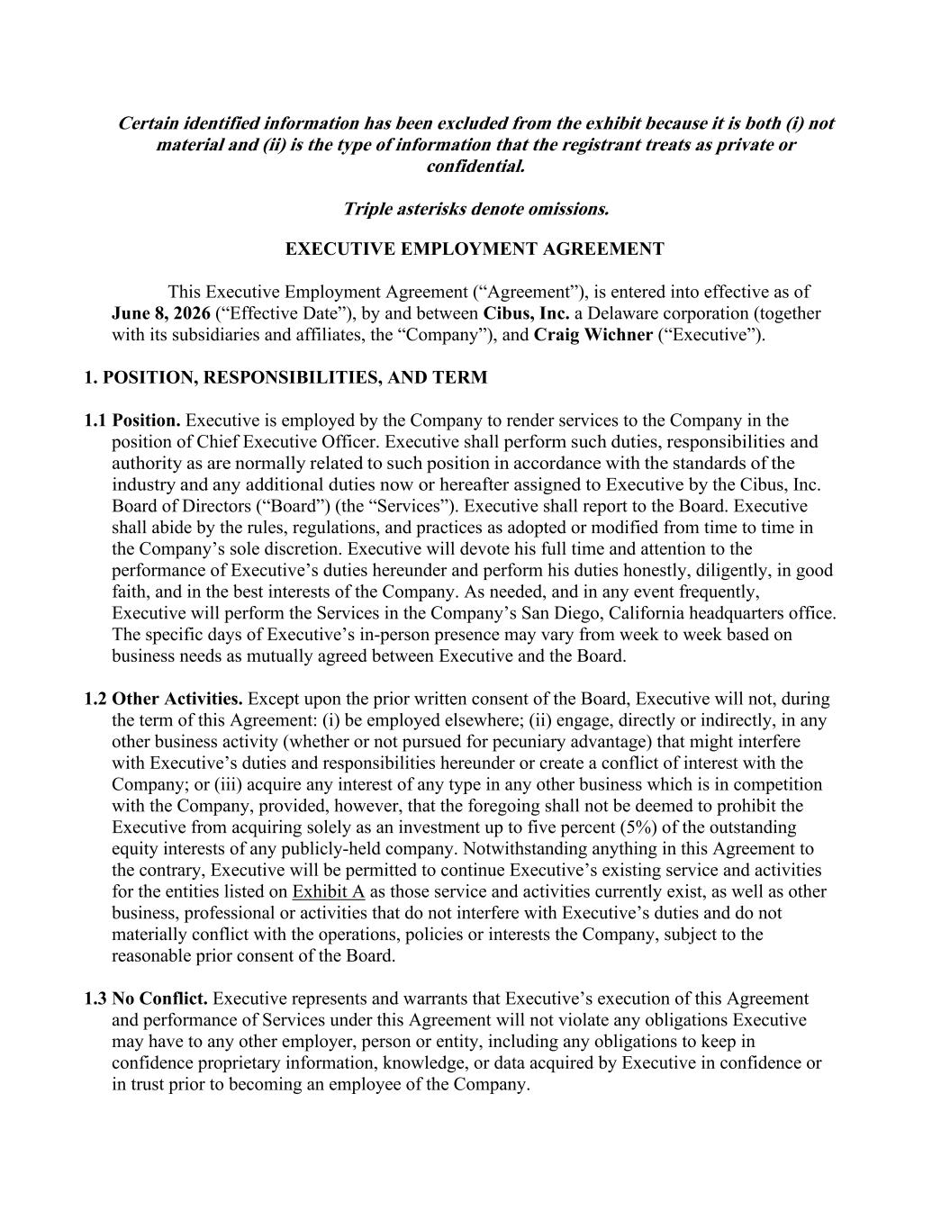
- 34 -
Certain identified information has been excluded from the exhibit because it is both (i) not material and (ii) is the type of information that the registrant treats as private or confidential. Triple asterisks denote omissions. EXECUTIVE EMPLOYMENT AGREEMENT This Executive Employment Agreement (“Agreement”), is entered into effective as of June 8, 2026 (“Effective Date”), by and between Cibus, Inc. a Delaware corporation (together with its subsidiaries and affiliates, the “Company”), and Craig Wichner (“Executive”). 1. POSITION, RESPONSIBILITIES, AND TERM 1.1 Position. Executive is employed by the Company to render services to the Company in the position of Chief Executive Officer. Executive shall perform such duties, responsibilities and authority as are normally related to such position in accordance with the standards of the industry and any additional duties now or hereafter assigned to Executive by the Cibus, Inc. Board of Directors (“Board”) (the “Services”). Executive shall report to the Board. Executive shall abide by the rules, regulations, and practices as adopted or modified from time to time in the Company’s sole discretion. Executive will devote his full time and attention to the performance of Executive’s duties hereunder and perform his duties honestly, diligently, in good faith, and in the best interests of the Company. As needed, and in any event frequently, Executive will perform the Services in the Company’s San Diego, California headquarters office. The specific days of Executive’s in-person presence may vary from week to week based on business needs as mutually agreed between Executive and the Board. 1.2 Other Activities. Except upon the prior written consent of the Board, Executive will not, during the term of this Agreement: (i) be employed elsewhere; (ii) engage, directly or indirectly, in any other business activity (whether or not pursued for pecuniary advantage) that might interfere with Executive’s duties and responsibilities hereunder or create a conflict of interest with the Company; or (iii) acquire any interest of any type in any other business which is in competition with the Company, provided, however, that the foregoing shall not be deemed to prohibit the Executive from acquiring solely as an investment up to five percent (5%) of the outstanding equity interests of any publicly-held company. Notwithstanding anything in this Agreement to the contrary, Executive will be permitted to continue Executive’s existing service and activities for the entities listed on Exhibit A as those service and activities currently exist, as well as other business, professional or activities that do not interfere with Executive’s duties and do not materially conflict with the operations, policies or interests the Company, subject to the reasonable prior consent of the Board. 1.3 No Conflict. Executive represents and warrants that Executive’s execution of this Agreement and performance of Services under this Agreement will not violate any obligations Executive may have to any other employer, person or entity, including any obligations to keep in confidence proprietary information, knowledge, or data acquired by Executive in confidence or in trust prior to becoming an employee of the Company.

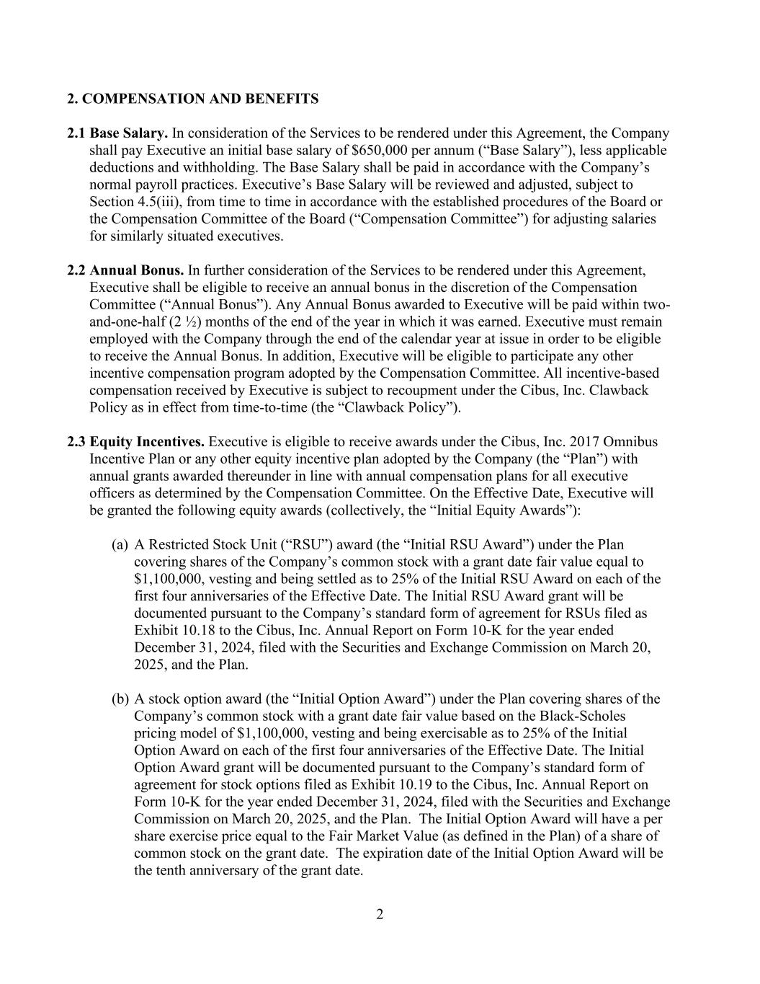
2 2. COMPENSATION AND BENEFITS 2.1 Base Salary. In consideration of the Services to be rendered under this Agreement, the Company shall pay Executive an initial base salary of $650,000 per annum (“Base Salary”), less applicable deductions and withholding. The Base Salary shall be paid in accordance with the Company’s normal payroll practices. Executive’s Base Salary will be reviewed and adjusted, subject to Section 4.5(iii), from time to time in accordance with the established procedures of the Board or the Compensation Committee of the Board (“Compensation Committee”) for adjusting salaries for similarly situated executives. 2.2 Annual Bonus. In further consideration of the Services to be rendered under this Agreement, Executive shall be eligible to receive an annual bonus in the discretion of the Compensation Committee (“Annual Bonus”). Any Annual Bonus awarded to Executive will be paid within two- and-one-half (2 ½) months of the end of the year in which it was earned. Executive must remain employed with the Company through the end of the calendar year at issue in order to be eligible to receive the Annual Bonus. In addition, Executive will be eligible to participate any other incentive compensation program adopted by the Compensation Committee. All incentive-based compensation received by Executive is subject to recoupment under the Cibus, Inc. Clawback Policy as in effect from time-to-time (the “Clawback Policy”). 2.3 Equity Incentives. Executive is eligible to receive awards under the Cibus, Inc. 2017 Omnibus Incentive Plan or any other equity incentive plan adopted by the Company (the “Plan”) with annual grants awarded thereunder in line with annual compensation plans for all executive officers as determined by the Compensation Committee. On the Effective Date, Executive will be granted the following equity awards (collectively, the “Initial Equity Awards”): (a) A Restricted Stock Unit (“RSU”) award (the “Initial RSU Award”) under the Plan covering shares of the Company’s common stock with a grant date fair value equal to $1,100,000, vesting and being settled as to 25% of the Initial RSU Award on each of the first four anniversaries of the Effective Date. The Initial RSU Award grant will be documented pursuant to the Company’s standard form of agreement for RSUs filed as Exhibit 10.18 to the Cibus, Inc. Annual Report on Form 10-K for the year ended December 31, 2024, filed with the Securities and Exchange Commission on March 20, 2025, and the Plan. (b) A stock option award (the “Initial Option Award”) under the Plan covering shares of the Company’s common stock with a grant date fair value based on the Black-Scholes pricing model of $1,100,000, vesting and being exercisable as to 25% of the Initial Option Award on each of the first four anniversaries of the Effective Date. The Initial Option Award grant will be documented pursuant to the Company’s standard form of agreement for stock options filed as Exhibit 10.19 to the Cibus, Inc. Annual Report on Form 10-K for the year ended December 31, 2024, filed with the Securities and Exchange Commission on March 20, 2025, and the Plan. The Initial Option Award will have a per share exercise price equal to the Fair Market Value (as defined in the Plan) of a share of common stock on the grant date. The expiration date of the Initial Option Award will be the tenth anniversary of the grant date.

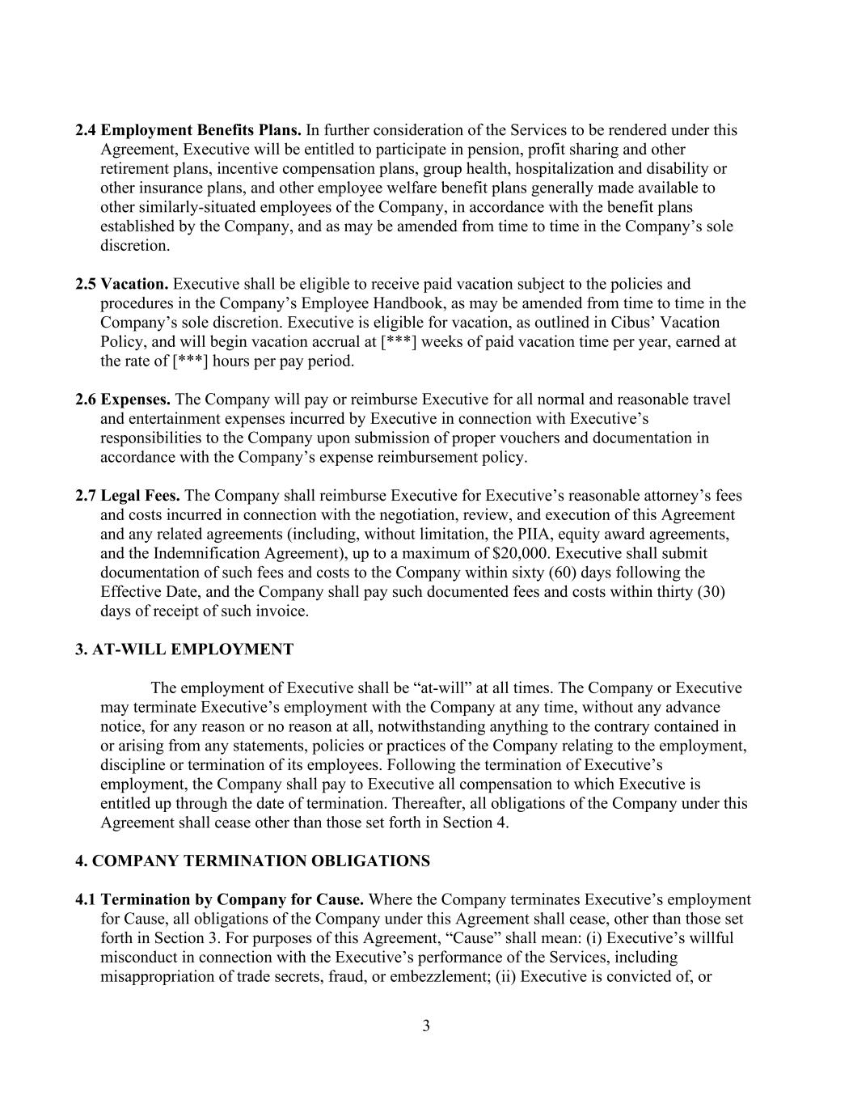
3 2.4 Employment Benefits Plans. In further consideration of the Services to be rendered under this Agreement, Executive will be entitled to participate in pension, profit sharing and other retirement plans, incentive compensation plans, group health, hospitalization and disability or other insurance plans, and other employee welfare benefit plans generally made available to other similarly-situated employees of the Company, in accordance with the benefit plans established by the Company, and as may be amended from time to time in the Company’s sole discretion. 2.5 Vacation. Executive shall be eligible to receive paid vacation subject to the policies and procedures in the Company’s Employee Handbook, as may be amended from time to time in the Company’s sole discretion. Executive is eligible for vacation, as outlined in Cibus’ Vacation Policy, and will begin vacation accrual at [***] weeks of paid vacation time per year, earned at the rate of [***] hours per pay period. 2.6 Expenses. The Company will pay or reimburse Executive for all normal and reasonable travel and entertainment expenses incurred by Executive in connection with Executive’s responsibilities to the Company upon submission of proper vouchers and documentation in accordance with the Company’s expense reimbursement policy. 2.7 Legal Fees. The Company shall reimburse Executive for Executive’s reasonable attorney’s fees and costs incurred in connection with the negotiation, review, and execution of this Agreement and any related agreements (including, without limitation, the PIIA, equity award agreements, and the Indemnification Agreement), up to a maximum of $20,000. Executive shall submit documentation of such fees and costs to the Company within sixty (60) days following the Effective Date, and the Company shall pay such documented fees and costs within thirty (30) days of receipt of such invoice. 3. AT-WILL EMPLOYMENT The employment of Executive shall be “at-will” at all times. The Company or Executive may terminate Executive’s employment with the Company at any time, without any advance notice, for any reason or no reason at all, notwithstanding anything to the contrary contained in or arising from any statements, policies or practices of the Company relating to the employment, discipline or termination of its employees. Following the termination of Executive’s employment, the Company shall pay to Executive all compensation to which Executive is entitled up through the date of termination. Thereafter, all obligations of the Company under this Agreement shall cease other than those set forth in Section 4. 4. COMPANY TERMINATION OBLIGATIONS 4.1 Termination by Company for Cause. Where the Company terminates Executive’s employment for Cause, all obligations of the Company under this Agreement shall cease, other than those set forth in Section 3. For purposes of this Agreement, “Cause” shall mean: (i) Executive’s willful misconduct in connection with the Executive’s performance of the Services, including misappropriation of trade secrets, fraud, or embezzlement; (ii) Executive is convicted of, or

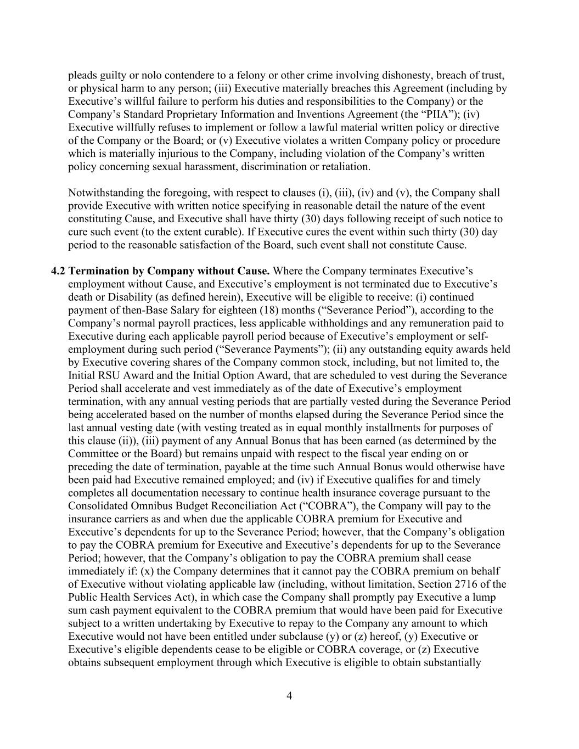
4 pleads guilty or nolo contendere to a felony or other crime involving dishonesty, breach of trust, or physical harm to any person; (iii) Executive materially breaches this Agreement (including by Executive’s willful failure to perform his duties and responsibilities to the Company) or the Company’s Standard Proprietary Information and Inventions Agreement (the “PIIA”); (iv) Executive willfully refuses to implement or follow a lawful material written policy or directive of the Company or the Board; or (v) Executive violates a written Company policy or procedure which is materially injurious to the Company, including violation of the Company’s written policy concerning sexual harassment, discrimination or retaliation. Notwithstanding the foregoing, with respect to clauses (i), (iii), (iv) and (v), the Company shall provide Executive with written notice specifying in reasonable detail the nature of the event constituting Cause, and Executive shall have thirty (30) days following receipt of such notice to cure such event (to the extent curable). If Executive cures the event within such thirty (30) day period to the reasonable satisfaction of the Board, such event shall not constitute Cause. 4.2 Termination by Company without Cause. Where the Company terminates Executive’s employment without Cause, and Executive’s employment is not terminated due to Executive’s death or Disability (as defined herein), Executive will be eligible to receive: (i) continued payment of then-Base Salary for eighteen (18) months (“Severance Period”), according to the Company’s normal payroll practices, less applicable withholdings and any remuneration paid to Executive during each applicable payroll period because of Executive’s employment or self- employment during such period (“Severance Payments”); (ii) any outstanding equity awards held by Executive covering shares of the Company common stock, including, but not limited to, the Initial RSU Award and the Initial Option Award, that are scheduled to vest during the Severance Period shall accelerate and vest immediately as of the date of Executive’s employment termination, with any annual vesting periods that are partially vested during the Severance Period being accelerated based on the number of months elapsed during the Severance Period since the last annual vesting date (with vesting treated as in equal monthly installments for purposes of this clause (ii)), (iii) payment of any Annual Bonus that has been earned (as determined by the Committee or the Board) but remains unpaid with respect to the fiscal year ending on or preceding the date of termination, payable at the time such Annual Bonus would otherwise have been paid had Executive remained employed; and (iv) if Executive qualifies for and timely completes all documentation necessary to continue health insurance coverage pursuant to the Consolidated Omnibus Budget Reconciliation Act (“COBRA”), the Company will pay to the insurance carriers as and when due the applicable COBRA premium for Executive and Executive’s dependents for up to the Severance Period; however, that the Company’s obligation to pay the COBRA premium for Executive and Executive’s dependents for up to the Severance Period; however, that the Company’s obligation to pay the COBRA premium shall cease immediately if: (x) the Company determines that it cannot pay the COBRA premium on behalf of Executive without violating applicable law (including, without limitation, Section 2716 of the Public Health Services Act), in which case the Company shall promptly pay Executive a lump sum cash payment equivalent to the COBRA premium that would have been paid for Executive subject to a written undertaking by Executive to repay to the Company any amount to which Executive would not have been entitled under subclause (y) or (z) hereof, (y) Executive or Executive’s eligible dependents cease to be eligible or COBRA coverage, or (z) Executive obtains subsequent employment through which Executive is eligible to obtain substantially

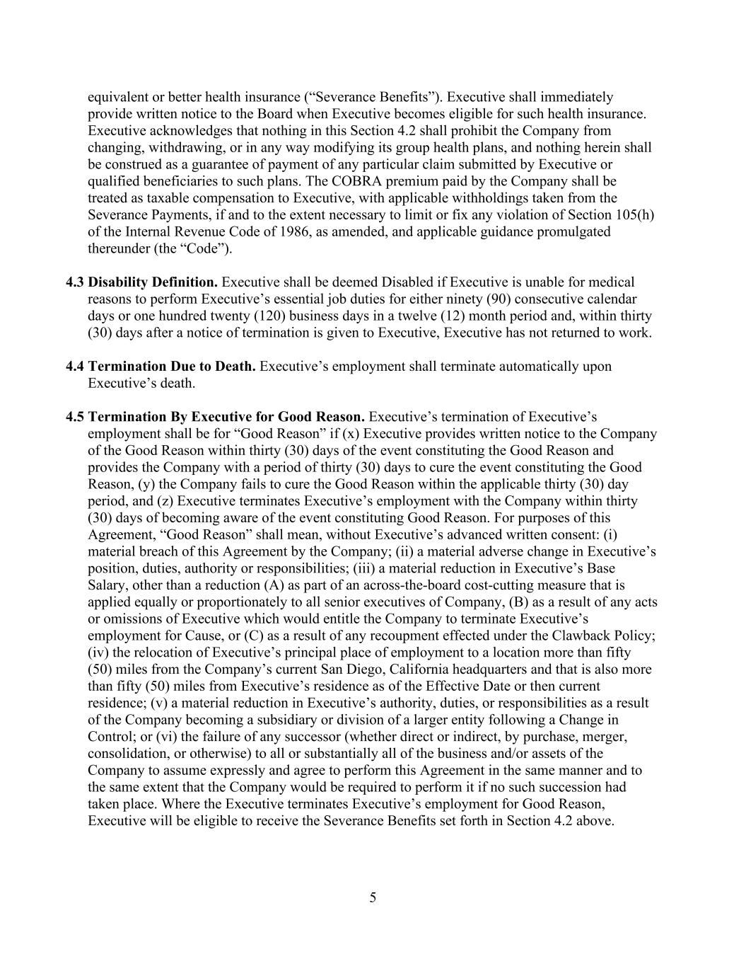
5 equivalent or better health insurance (“Severance Benefits”). Executive shall immediately provide written notice to the Board when Executive becomes eligible for such health insurance. Executive acknowledges that nothing in this Section 4.2 shall prohibit the Company from changing, withdrawing, or in any way modifying its group health plans, and nothing herein shall be construed as a guarantee of payment of any particular claim submitted by Executive or qualified beneficiaries to such plans. The COBRA premium paid by the Company shall be treated as taxable compensation to Executive, with applicable withholdings taken from the Severance Payments, if and to the extent necessary to limit or fix any violation of Section 105(h) of the Internal Revenue Code of 1986, as amended, and applicable guidance promulgated thereunder (the “Code”). 4.3 Disability Definition. Executive shall be deemed Disabled if Executive is unable for medical reasons to perform Executive’s essential job duties for either ninety (90) consecutive calendar days or one hundred twenty (120) business days in a twelve (12) month period and, within thirty (30) days after a notice of termination is given to Executive, Executive has not returned to work. 4.4 Termination Due to Death. Executive’s employment shall terminate automatically upon Executive’s death. 4.5 Termination By Executive for Good Reason. Executive’s termination of Executive’s employment shall be for “Good Reason” if (x) Executive provides written notice to the Company of the Good Reason within thirty (30) days of the event constituting the Good Reason and provides the Company with a period of thirty (30) days to cure the event constituting the Good Reason, (y) the Company fails to cure the Good Reason within the applicable thirty (30) day period, and (z) Executive terminates Executive’s employment with the Company within thirty (30) days of becoming aware of the event constituting Good Reason. For purposes of this Agreement, “Good Reason” shall mean, without Executive’s advanced written consent: (i) material breach of this Agreement by the Company; (ii) a material adverse change in Executive’s position, duties, authority or responsibilities; (iii) a material reduction in Executive’s Base Salary, other than a reduction (A) as part of an across-the-board cost-cutting measure that is applied equally or proportionately to all senior executives of Company, (B) as a result of any acts or omissions of Executive which would entitle the Company to terminate Executive’s employment for Cause, or (C) as a result of any recoupment effected under the Clawback Policy; (iv) the relocation of Executive’s principal place of employment to a location more than fifty (50) miles from the Company’s current San Diego, California headquarters and that is also more than fifty (50) miles from Executive’s residence as of the Effective Date or then current residence; (v) a material reduction in Executive’s authority, duties, or responsibilities as a result of the Company becoming a subsidiary or division of a larger entity following a Change in Control; or (vi) the failure of any successor (whether direct or indirect, by purchase, merger, consolidation, or otherwise) to all or substantially all of the business and/or assets of the Company to assume expressly and agree to perform this Agreement in the same manner and to the same extent that the Company would be required to perform it if no such succession had taken place. Where the Executive terminates Executive’s employment for Good Reason, Executive will be eligible to receive the Severance Benefits set forth in Section 4.2 above.

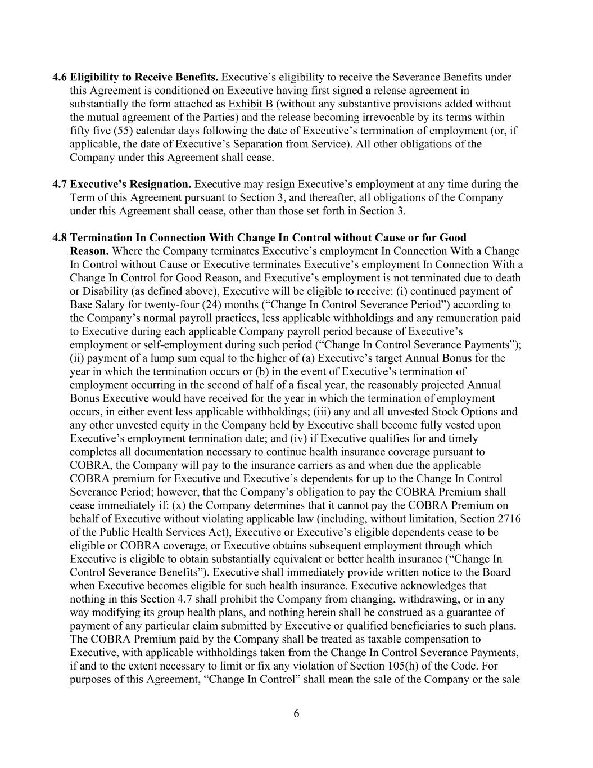
6 4.6 Eligibility to Receive Benefits. Executive’s eligibility to receive the Severance Benefits under this Agreement is conditioned on Executive having first signed a release agreement in substantially the form attached as Exhibit B (without any substantive provisions added without the mutual agreement of the Parties) and the release becoming irrevocable by its terms within fifty five (55) calendar days following the date of Executive’s termination of employment (or, if applicable, the date of Executive’s Separation from Service). All other obligations of the Company under this Agreement shall cease. 4.7 Executive’s Resignation. Executive may resign Executive’s employment at any time during the Term of this Agreement pursuant to Section 3, and thereafter, all obligations of the Company under this Agreement shall cease, other than those set forth in Section 3. 4.8 Termination In Connection With Change In Control without Cause or for Good Reason. Where the Company terminates Executive’s employment In Connection With a Change In Control without Cause or Executive terminates Executive’s employment In Connection With a Change In Control for Good Reason, and Executive’s employment is not terminated due to death or Disability (as defined above), Executive will be eligible to receive: (i) continued payment of Base Salary for twenty-four (24) months (“Change In Control Severance Period”) according to the Company’s normal payroll practices, less applicable withholdings and any remuneration paid to Executive during each applicable Company payroll period because of Executive’s employment or self-employment during such period (“Change In Control Severance Payments”); (ii) payment of a lump sum equal to the higher of (a) Executive’s target Annual Bonus for the year in which the termination occurs or (b) in the event of Executive’s termination of employment occurring in the second of half of a fiscal year, the reasonably projected Annual Bonus Executive would have received for the year in which the termination of employment occurs, in either event less applicable withholdings; (iii) any and all unvested Stock Options and any other unvested equity in the Company held by Executive shall become fully vested upon Executive’s employment termination date; and (iv) if Executive qualifies for and timely completes all documentation necessary to continue health insurance coverage pursuant to COBRA, the Company will pay to the insurance carriers as and when due the applicable COBRA premium for Executive and Executive’s dependents for up to the Change In Control Severance Period; however, that the Company’s obligation to pay the COBRA Premium shall cease immediately if: (x) the Company determines that it cannot pay the COBRA Premium on behalf of Executive without violating applicable law (including, without limitation, Section 2716 of the Public Health Services Act), Executive or Executive’s eligible dependents cease to be eligible or COBRA coverage, or Executive obtains subsequent employment through which Executive is eligible to obtain substantially equivalent or better health insurance (“Change In Control Severance Benefits”). Executive shall immediately provide written notice to the Board when Executive becomes eligible for such health insurance. Executive acknowledges that nothing in this Section 4.7 shall prohibit the Company from changing, withdrawing, or in any way modifying its group health plans, and nothing herein shall be construed as a guarantee of payment of any particular claim submitted by Executive or qualified beneficiaries to such plans. The COBRA Premium paid by the Company shall be treated as taxable compensation to Executive, with applicable withholdings taken from the Change In Control Severance Payments, if and to the extent necessary to limit or fix any violation of Section 105(h) of the Code. For purposes of this Agreement, “Change In Control” shall mean the sale of the Company or the sale

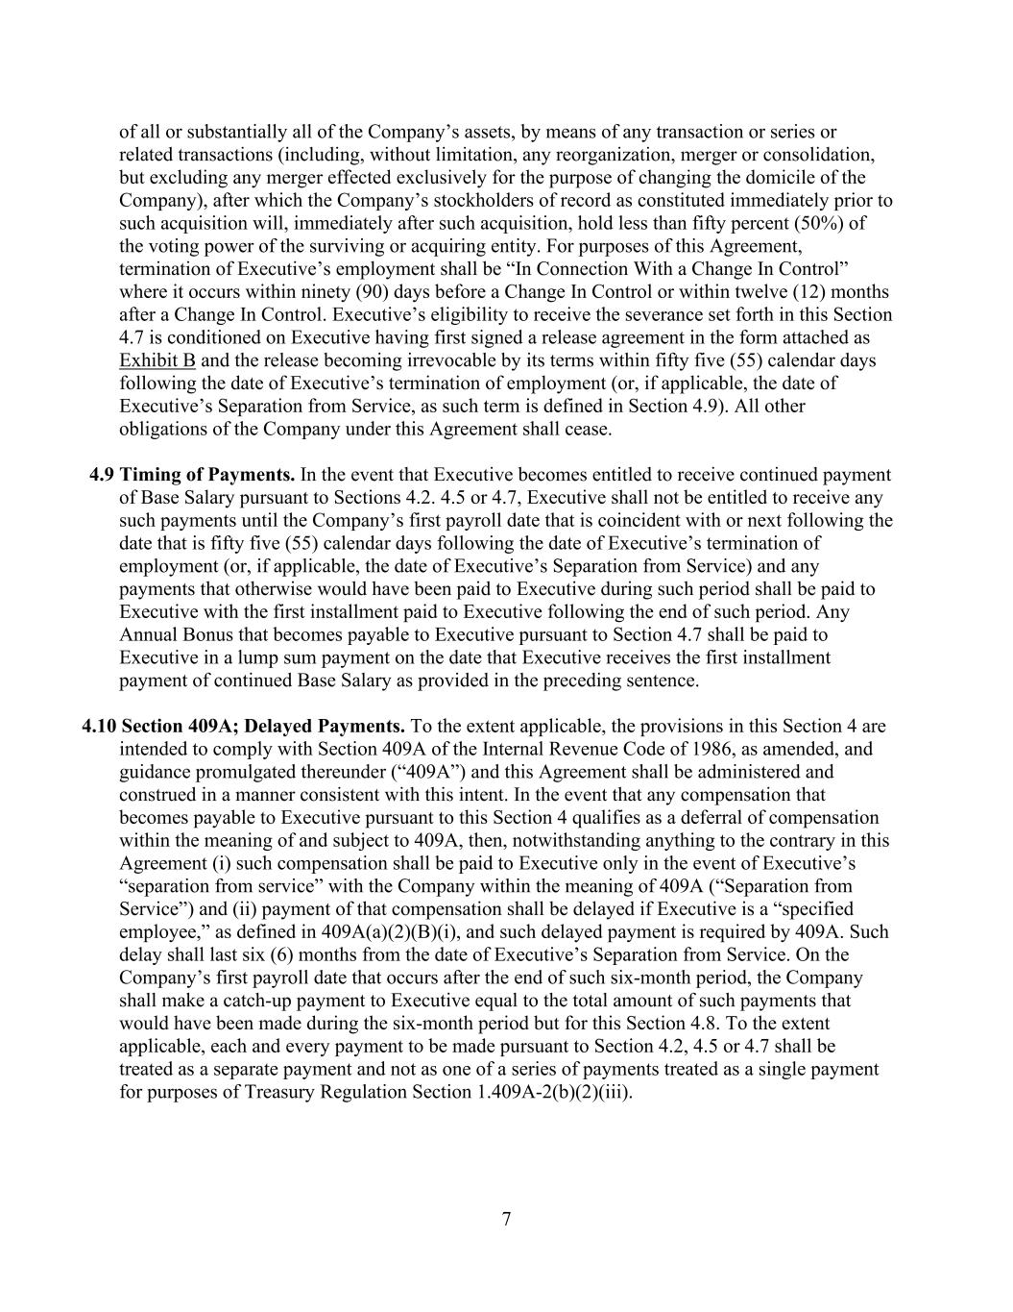
7 of all or substantially all of the Company’s assets, by means of any transaction or series or related transactions (including, without limitation, any reorganization, merger or consolidation, but excluding any merger effected exclusively for the purpose of changing the domicile of the Company), after which the Company’s stockholders of record as constituted immediately prior to such acquisition will, immediately after such acquisition, hold less than fifty percent (50%) of the voting power of the surviving or acquiring entity. For purposes of this Agreement, termination of Executive’s employment shall be “In Connection With a Change In Control” where it occurs within ninety (90) days before a Change In Control or within twelve (12) months after a Change In Control. Executive’s eligibility to receive the severance set forth in this Section 4.7 is conditioned on Executive having first signed a release agreement in the form attached as Exhibit B and the release becoming irrevocable by its terms within fifty five (55) calendar days following the date of Executive’s termination of employment (or, if applicable, the date of Executive’s Separation from Service, as such term is defined in Section 4.9). All other obligations of the Company under this Agreement shall cease. 4.9 Timing of Payments. In the event that Executive becomes entitled to receive continued payment of Base Salary pursuant to Sections 4.2. 4.5 or 4.7, Executive shall not be entitled to receive any such payments until the Company’s first payroll date that is coincident with or next following the date that is fifty five (55) calendar days following the date of Executive’s termination of employment (or, if applicable, the date of Executive’s Separation from Service) and any payments that otherwise would have been paid to Executive during such period shall be paid to Executive with the first installment paid to Executive following the end of such period. Any Annual Bonus that becomes payable to Executive pursuant to Section 4.7 shall be paid to Executive in a lump sum payment on the date that Executive receives the first installment payment of continued Base Salary as provided in the preceding sentence. 4.10 Section 409A; Delayed Payments. To the extent applicable, the provisions in this Section 4 are intended to comply with Section 409A of the Internal Revenue Code of 1986, as amended, and guidance promulgated thereunder (“409A”) and this Agreement shall be administered and construed in a manner consistent with this intent. In the event that any compensation that becomes payable to Executive pursuant to this Section 4 qualifies as a deferral of compensation within the meaning of and subject to 409A, then, notwithstanding anything to the contrary in this Agreement (i) such compensation shall be paid to Executive only in the event of Executive’s “separation from service” with the Company within the meaning of 409A (“Separation from Service”) and (ii) payment of that compensation shall be delayed if Executive is a “specified employee,” as defined in 409A(a)(2)(B)(i), and such delayed payment is required by 409A. Such delay shall last six (6) months from the date of Executive’s Separation from Service. On the Company’s first payroll date that occurs after the end of such six-month period, the Company shall make a catch-up payment to Executive equal to the total amount of such payments that would have been made during the six-month period but for this Section 4.8. To the extent applicable, each and every payment to be made pursuant to Section 4.2, 4.5 or 4.7 shall be treated as a separate payment and not as one of a series of payments treated as a single payment for purposes of Treasury Regulation Section 1.409A-2(b)(2)(iii).

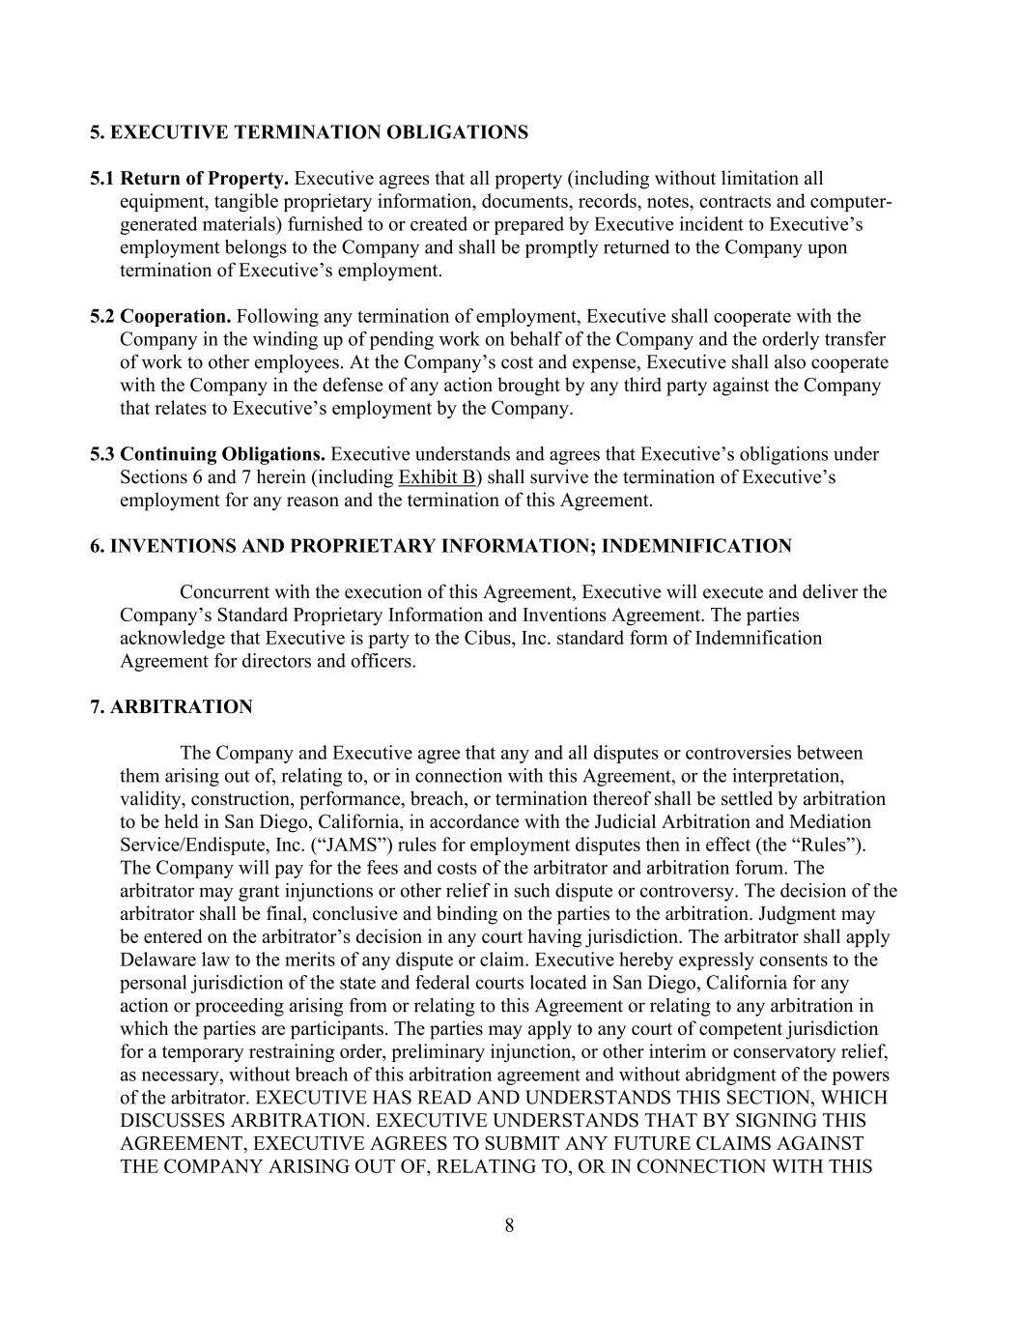
8 5. EXECUTIVE TERMINATION OBLIGATIONS 5.1 Return of Property. Executive agrees that all property (including without limitation all equipment, tangible proprietary information, documents, records, notes, contracts and computer- generated materials) furnished to or created or prepared by Executive incident to Executive’s employment belongs to the Company and shall be promptly returned to the Company upon termination of Executive’s employment. 5.2 Cooperation. Following any termination of employment, Executive shall cooperate with the Company in the winding up of pending work on behalf of the Company and the orderly transfer of work to other employees. At the Company’s cost and expense, Executive shall also cooperate with the Company in the defense of any action brought by any third party against the Company that relates to Executive’s employment by the Company. 5.3 Continuing Obligations. Executive understands and agrees that Executive’s obligations under Sections 6 and 7 herein (including Exhibit B) shall survive the termination of Executive’s employment for any reason and the termination of this Agreement. 6. INVENTIONS AND PROPRIETARY INFORMATION; INDEMNIFICATION Concurrent with the execution of this Agreement, Executive will execute and deliver the Company’s Standard Proprietary Information and Inventions Agreement. The parties acknowledge that Executive is party to the Cibus, Inc. standard form of Indemnification Agreement for directors and officers. 7. ARBITRATION The Company and Executive agree that any and all disputes or controversies between them arising out of, relating to, or in connection with this Agreement, or the interpretation, validity, construction, performance, breach, or termination thereof shall be settled by arbitration to be held in San Diego, California, in accordance with the Judicial Arbitration and Mediation Service/Endispute, Inc. (“JAMS”) rules for employment disputes then in effect (the “Rules”). The Company will pay for the fees and costs of the arbitrator and arbitration forum. The arbitrator may grant injunctions or other relief in such dispute or controversy. The decision of the arbitrator shall be final, conclusive and binding on the parties to the arbitration. Judgment may be entered on the arbitrator’s decision in any court having jurisdiction. The arbitrator shall apply Delaware law to the merits of any dispute or claim. Executive hereby expressly consents to the personal jurisdiction of the state and federal courts located in San Diego, California for any action or proceeding arising from or relating to this Agreement or relating to any arbitration in which the parties are participants. The parties may apply to any court of competent jurisdiction for a temporary restraining order, preliminary injunction, or other interim or conservatory relief, as necessary, without breach of this arbitration agreement and without abridgment of the powers of the arbitrator. EXECUTIVE HAS READ AND UNDERSTANDS THIS SECTION, WHICH DISCUSSES ARBITRATION. EXECUTIVE UNDERSTANDS THAT BY SIGNING THIS AGREEMENT, EXECUTIVE AGREES TO SUBMIT ANY FUTURE CLAIMS AGAINST THE COMPANY ARISING OUT OF, RELATING TO, OR IN CONNECTION WITH THIS

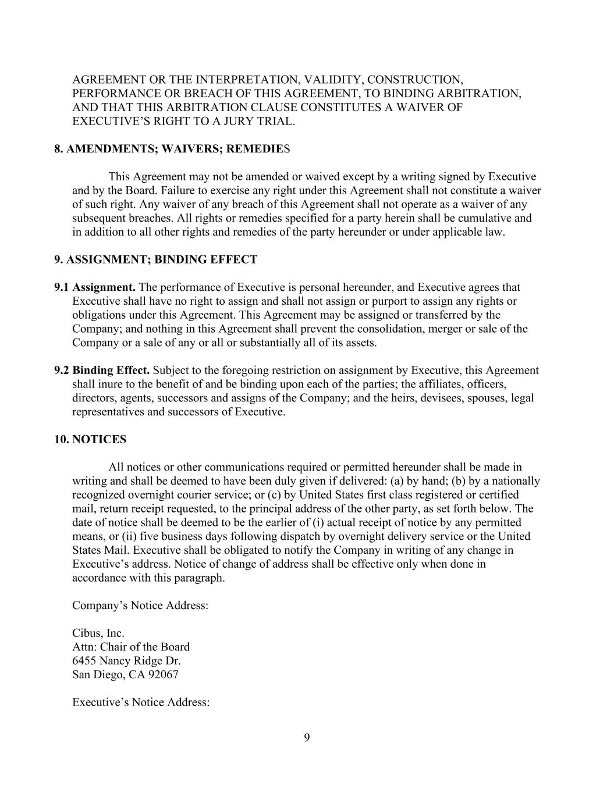
9 AGREEMENT OR THE INTERPRETATION, VALIDITY, CONSTRUCTION, PERFORMANCE OR BREACH OF THIS AGREEMENT, TO BINDING ARBITRATION, AND THAT THIS ARBITRATION CLAUSE CONSTITUTES A WAIVER OF EXECUTIVE’S RIGHT TO A JURY TRIAL. 8. AMENDMENTS; WAIVERS; REMEDIES This Agreement may not be amended or waived except by a writing signed by Executive and by the Board. Failure to exercise any right under this Agreement shall not constitute a waiver of such right. Any waiver of any breach of this Agreement shall not operate as a waiver of any subsequent breaches. All rights or remedies specified for a party herein shall be cumulative and in addition to all other rights and remedies of the party hereunder or under applicable law. 9. ASSIGNMENT; BINDING EFFECT 9.1 Assignment. The performance of Executive is personal hereunder, and Executive agrees that Executive shall have no right to assign and shall not assign or purport to assign any rights or obligations under this Agreement. This Agreement may be assigned or transferred by the Company; and nothing in this Agreement shall prevent the consolidation, merger or sale of the Company or a sale of any or all or substantially all of its assets. 9.2 Binding Effect. Subject to the foregoing restriction on assignment by Executive, this Agreement shall inure to the benefit of and be binding upon each of the parties; the affiliates, officers, directors, agents, successors and assigns of the Company; and the heirs, devisees, spouses, legal representatives and successors of Executive. 10. NOTICES All notices or other communications required or permitted hereunder shall be made in writing and shall be deemed to have been duly given if delivered: (a) by hand; (b) by a nationally recognized overnight courier service; or (c) by United States first class registered or certified mail, return receipt requested, to the principal address of the other party, as set forth below. The date of notice shall be deemed to be the earlier of (i) actual receipt of notice by any permitted means, or (ii) five business days following dispatch by overnight delivery service or the United States Mail. Executive shall be obligated to notify the Company in writing of any change in Executive’s address. Notice of change of address shall be effective only when done in accordance with this paragraph. Company’s Notice Address: Cibus, Inc. Attn: Chair of the Board 6455 Nancy Ridge Dr. San Diego, CA 92067 Executive’s Notice Address:

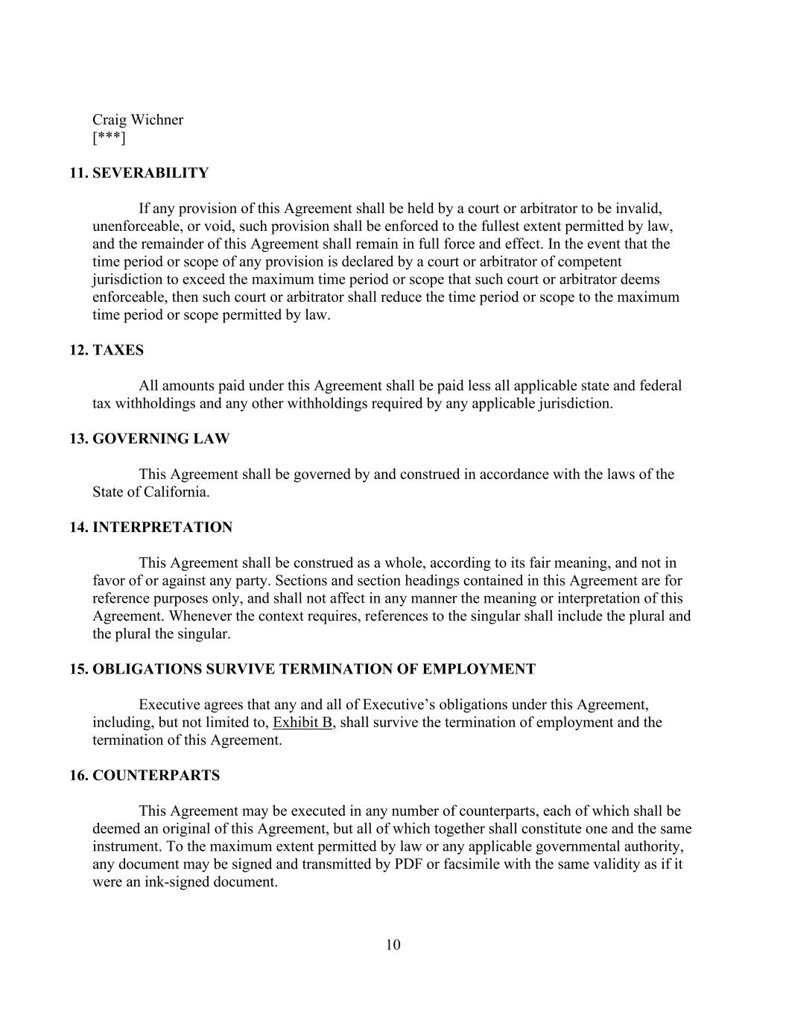
10 Craig Wichner [***] 11. SEVERABILITY If any provision of this Agreement shall be held by a court or arbitrator to be invalid, unenforceable, or void, such provision shall be enforced to the fullest extent permitted by law, and the remainder of this Agreement shall remain in full force and effect. In the event that the time period or scope of any provision is declared by a court or arbitrator of competent jurisdiction to exceed the maximum time period or scope that such court or arbitrator deems enforceable, then such court or arbitrator shall reduce the time period or scope to the maximum time period or scope permitted by law. 12. TAXES All amounts paid under this Agreement shall be paid less all applicable state and federal tax withholdings and any other withholdings required by any applicable jurisdiction. 13. GOVERNING LAW This Agreement shall be governed by and construed in accordance with the laws of the State of California. 14. INTERPRETATION This Agreement shall be construed as a whole, according to its fair meaning, and not in favor of or against any party. Sections and section headings contained in this Agreement are for reference purposes only, and shall not affect in any manner the meaning or interpretation of this Agreement. Whenever the context requires, references to the singular shall include the plural and the plural the singular. 15. OBLIGATIONS SURVIVE TERMINATION OF EMPLOYMENT Executive agrees that any and all of Executive’s obligations under this Agreement, including, but not limited to, Exhibit B, shall survive the termination of employment and the termination of this Agreement. 16. COUNTERPARTS This Agreement may be executed in any number of counterparts, each of which shall be deemed an original of this Agreement, but all of which together shall constitute one and the same instrument. To the maximum extent permitted by law or any applicable governmental authority, any document may be signed and transmitted by PDF or facsimile with the same validity as if it were an ink-signed document.

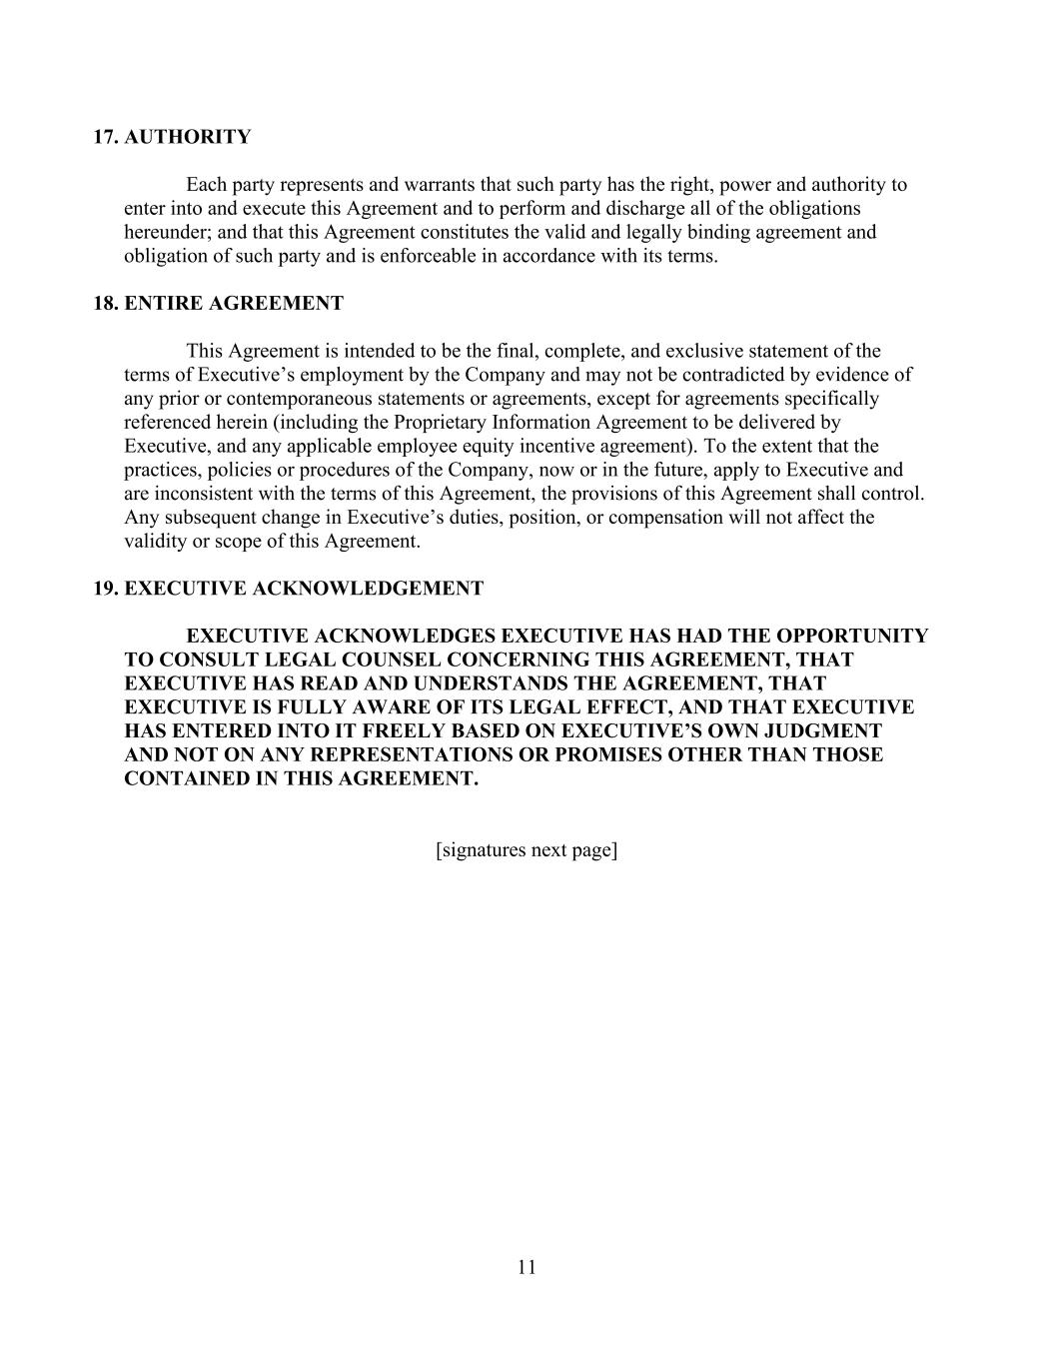
11 17. AUTHORITY Each party represents and warrants that such party has the right, power and authority to enter into and execute this Agreement and to perform and discharge all of the obligations hereunder; and that this Agreement constitutes the valid and legally binding agreement and obligation of such party and is enforceable in accordance with its terms. 18. ENTIRE AGREEMENT This Agreement is intended to be the final, complete, and exclusive statement of the terms of Executive’s employment by the Company and may not be contradicted by evidence of any prior or contemporaneous statements or agreements, except for agreements specifically referenced herein (including the Proprietary Information Agreement to be delivered by Executive, and any applicable employee equity incentive agreement). To the extent that the practices, policies or procedures of the Company, now or in the future, apply to Executive and are inconsistent with the terms of this Agreement, the provisions of this Agreement shall control. Any subsequent change in Executive’s duties, position, or compensation will not affect the validity or scope of this Agreement. 19. EXECUTIVE ACKNOWLEDGEMENT EXECUTIVE ACKNOWLEDGES EXECUTIVE HAS HAD THE OPPORTUNITY TO CONSULT LEGAL COUNSEL CONCERNING THIS AGREEMENT, THAT EXECUTIVE HAS READ AND UNDERSTANDS THE AGREEMENT, THAT EXECUTIVE IS FULLY AWARE OF ITS LEGAL EFFECT, AND THAT EXECUTIVE HAS ENTERED INTO IT FREELY BASED ON EXECUTIVE’S OWN JUDGMENT AND NOT ON ANY REPRESENTATIONS OR PROMISES OTHER THAN THOSE CONTAINED IN THIS AGREEMENT. [signatures next page]

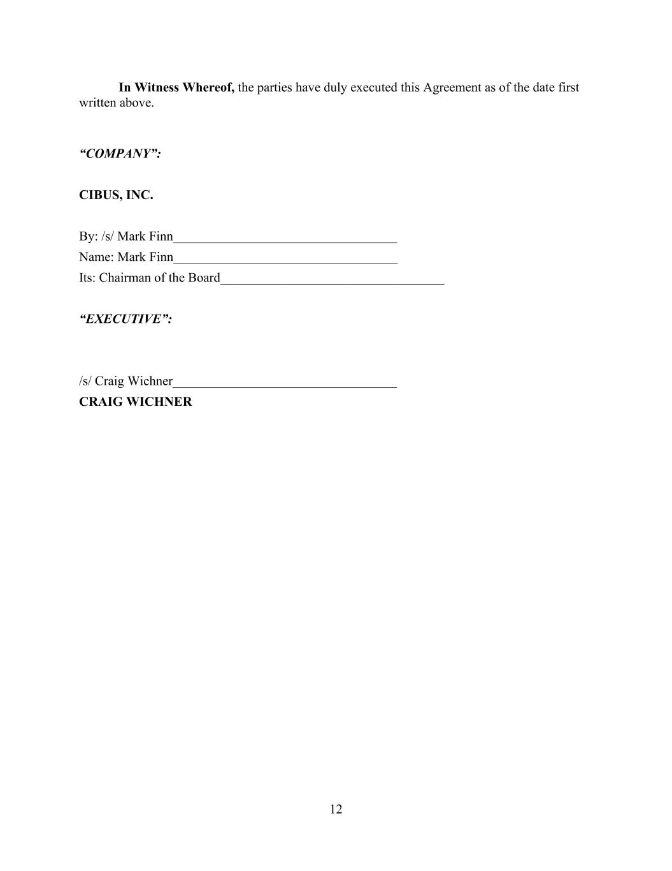
12 In Witness Whereof, the parties have duly executed this Agreement as of the date first written above. “COMPANY”: CIBUS, INC. By: /s/ Mark Finn__________________________________ Name: Mark Finn__________________________________ Its: Chairman of the Board__________________________________ “EXECUTIVE”: /s/ Craig Wichner__________________________________ CRAIG WICHNER

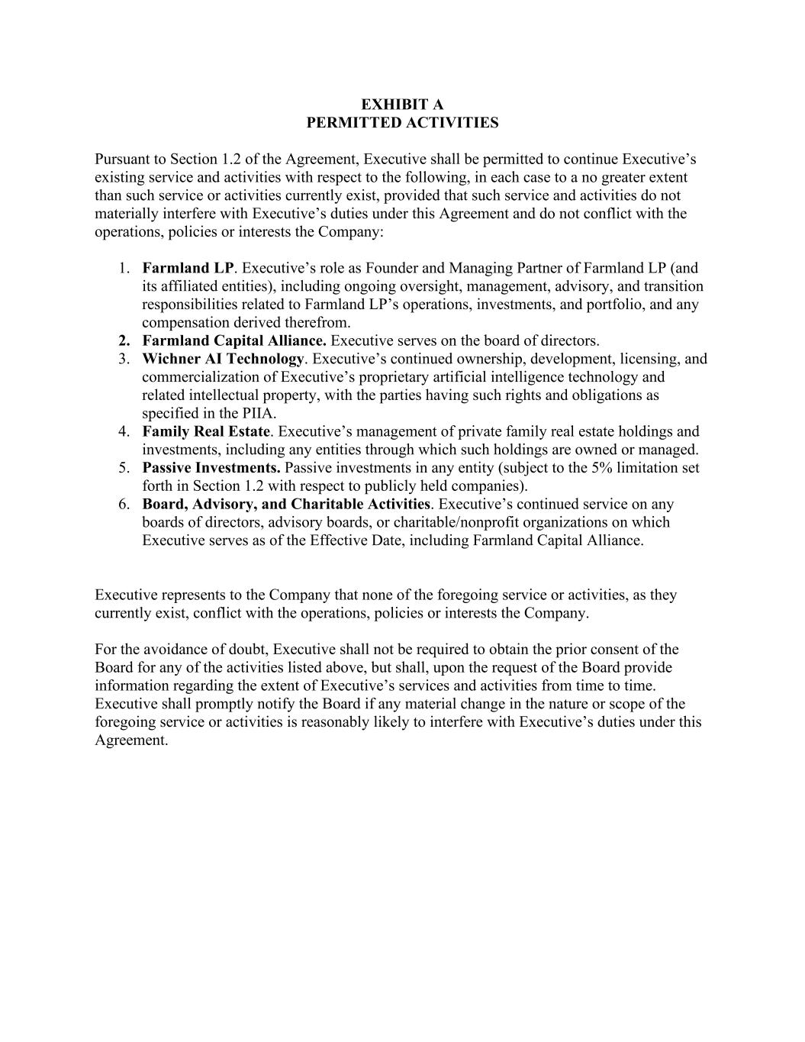
EXHIBIT A PERMITTED ACTIVITIES Pursuant to Section 1.2 of the Agreement, Executive shall be permitted to continue Executive’s existing service and activities with respect to the following, in each case to a no greater extent than such service or activities currently exist, provided that such service and activities do not materially interfere with Executive’s duties under this Agreement and do not conflict with the operations, policies or interests the Company: 1. Farmland LP. Executive’s role as Founder and Managing Partner of Farmland LP (and its affiliated entities), including ongoing oversight, management, advisory, and transition responsibilities related to Farmland LP’s operations, investments, and portfolio, and any compensation derived therefrom. 2. Farmland Capital Alliance. Executive serves on the board of directors. 3. Wichner AI Technology. Executive’s continued ownership, development, licensing, and commercialization of Executive’s proprietary artificial intelligence technology and related intellectual property, with the parties having such rights and obligations as specified in the PIIA. 4. Family Real Estate. Executive’s management of private family real estate holdings and investments, including any entities through which such holdings are owned or managed. 5. Passive Investments. Passive investments in any entity (subject to the 5% limitation set forth in Section 1.2 with respect to publicly held companies). 6. Board, Advisory, and Charitable Activities. Executive’s continued service on any boards of directors, advisory boards, or charitable/nonprofit organizations on which Executive serves as of the Effective Date, including Farmland Capital Alliance. Executive represents to the Company that none of the foregoing service or activities, as they currently exist, conflict with the operations, policies or interests the Company. For the avoidance of doubt, Executive shall not be required to obtain the prior consent of the Board for any of the activities listed above, but shall, upon the request of the Board provide information regarding the extent of Executive’s services and activities from time to time. Executive shall promptly notify the Board if any material change in the nature or scope of the foregoing service or activities is reasonably likely to interfere with Executive’s duties under this Agreement.

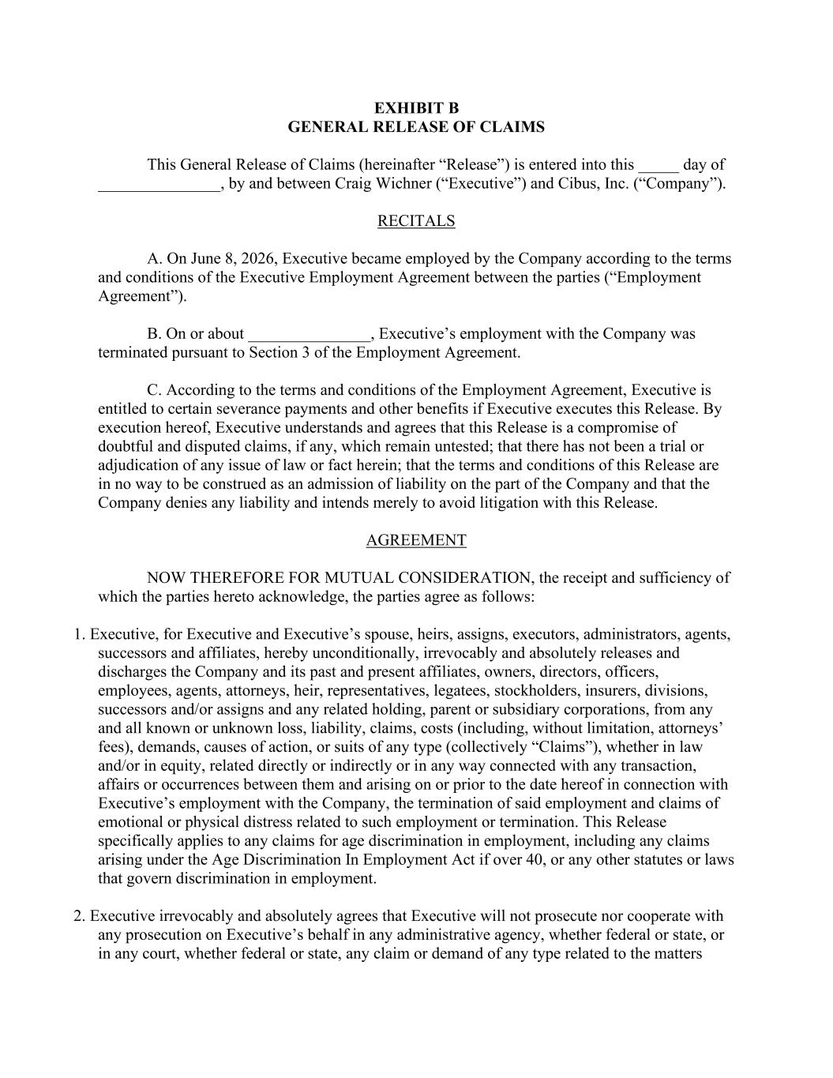
EXHIBIT B GENERAL RELEASE OF CLAIMS This General Release of Claims (hereinafter “Release”) is entered into this _____ day of _______________, by and between Craig Wichner (“Executive”) and Cibus, Inc. (“Company”). RECITALS A. On June 8, 2026, Executive became employed by the Company according to the terms and conditions of the Executive Employment Agreement between the parties (“Employment Agreement”). B. On or about _______________, Executive’s employment with the Company was terminated pursuant to Section 3 of the Employment Agreement. C. According to the terms and conditions of the Employment Agreement, Executive is entitled to certain severance payments and other benefits if Executive executes this Release. By execution hereof, Executive understands and agrees that this Release is a compromise of doubtful and disputed claims, if any, which remain untested; that there has not been a trial or adjudication of any issue of law or fact herein; that the terms and conditions of this Release are in no way to be construed as an admission of liability on the part of the Company and that the Company denies any liability and intends merely to avoid litigation with this Release. AGREEMENT NOW THEREFORE FOR MUTUAL CONSIDERATION, the receipt and sufficiency of which the parties hereto acknowledge, the parties agree as follows: 1. Executive, for Executive and Executive’s spouse, heirs, assigns, executors, administrators, agents, successors and affiliates, hereby unconditionally, irrevocably and absolutely releases and discharges the Company and its past and present affiliates, owners, directors, officers, employees, agents, attorneys, heir, representatives, legatees, stockholders, insurers, divisions, successors and/or assigns and any related holding, parent or subsidiary corporations, from any and all known or unknown loss, liability, claims, costs (including, without limitation, attorneys’ fees), demands, causes of action, or suits of any type (collectively “Claims”), whether in law and/or in equity, related directly or indirectly or in any way connected with any transaction, affairs or occurrences between them and arising on or prior to the date hereof in connection with Executive’s employment with the Company, the termination of said employment and claims of emotional or physical distress related to such employment or termination. This Release specifically applies to any claims for age discrimination in employment, including any claims arising under the Age Discrimination In Employment Act if over 40, or any other statutes or laws that govern discrimination in employment. 2. Executive irrevocably and absolutely agrees that Executive will not prosecute nor cooperate with any prosecution on Executive’s behalf in any administrative agency, whether federal or state, or in any court, whether federal or state, any claim or demand of any type related to the matters

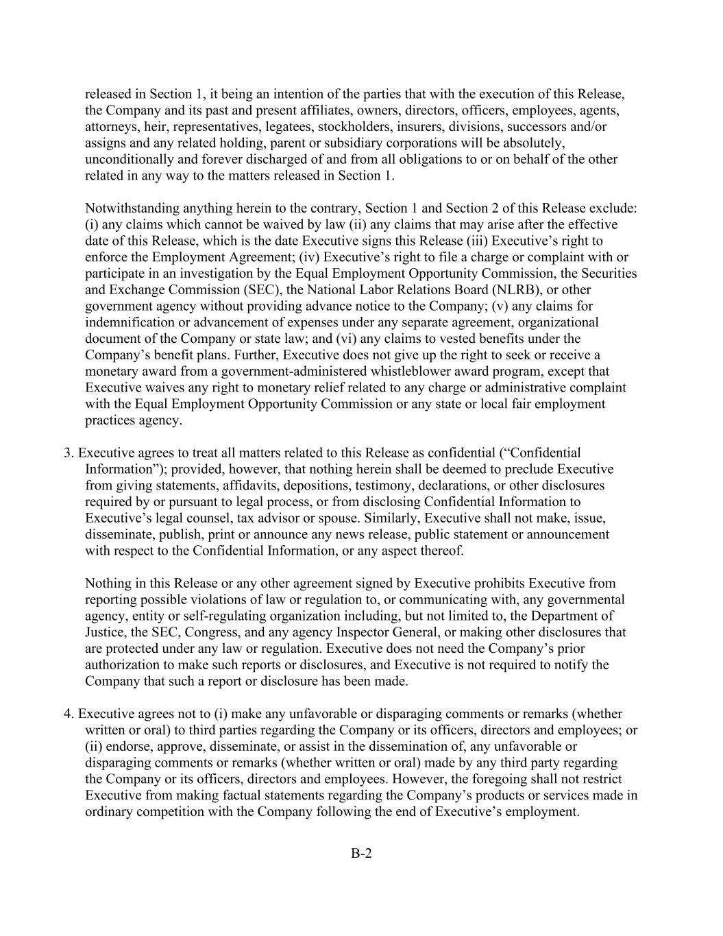
B-2 released in Section 1, it being an intention of the parties that with the execution of this Release, the Company and its past and present affiliates, owners, directors, officers, employees, agents, attorneys, heir, representatives, legatees, stockholders, insurers, divisions, successors and/or assigns and any related holding, parent or subsidiary corporations will be absolutely, unconditionally and forever discharged of and from all obligations to or on behalf of the other related in any way to the matters released in Section 1. Notwithstanding anything herein to the contrary, Section 1 and Section 2 of this Release exclude: (i) any claims which cannot be waived by law (ii) any claims that may arise after the effective date of this Release, which is the date Executive signs this Release (iii) Executive’s right to enforce the Employment Agreement; (iv) Executive’s right to file a charge or complaint with or participate in an investigation by the Equal Employment Opportunity Commission, the Securities and Exchange Commission (SEC), the National Labor Relations Board (NLRB), or other government agency without providing advance notice to the Company; (v) any claims for indemnification or advancement of expenses under any separate agreement, organizational document of the Company or state law; and (vi) any claims to vested benefits under the Company’s benefit plans. Further, Executive does not give up the right to seek or receive a monetary award from a government-administered whistleblower award program, except that Executive waives any right to monetary relief related to any charge or administrative complaint with the Equal Employment Opportunity Commission or any state or local fair employment practices agency. 3. Executive agrees to treat all matters related to this Release as confidential (“Confidential Information”); provided, however, that nothing herein shall be deemed to preclude Executive from giving statements, affidavits, depositions, testimony, declarations, or other disclosures required by or pursuant to legal process, or from disclosing Confidential Information to Executive’s legal counsel, tax advisor or spouse. Similarly, Executive shall not make, issue, disseminate, publish, print or announce any news release, public statement or announcement with respect to the Confidential Information, or any aspect thereof. Nothing in this Release or any other agreement signed by Executive prohibits Executive from reporting possible violations of law or regulation to, or communicating with, any governmental agency, entity or self-regulating organization including, but not limited to, the Department of Justice, the SEC, Congress, and any agency Inspector General, or making other disclosures that are protected under any law or regulation. Executive does not need the Company’s prior authorization to make such reports or disclosures, and Executive is not required to notify the Company that such a report or disclosure has been made. 4. Executive agrees not to (i) make any unfavorable or disparaging comments or remarks (whether written or oral) to third parties regarding the Company or its officers, directors and employees; or (ii) endorse, approve, disseminate, or assist in the dissemination of, any unfavorable or disparaging comments or remarks (whether written or oral) made by any third party regarding the Company or its officers, directors and employees. However, the foregoing shall not restrict Executive from making factual statements regarding the Company’s products or services made in ordinary competition with the Company following the end of Executive’s employment.

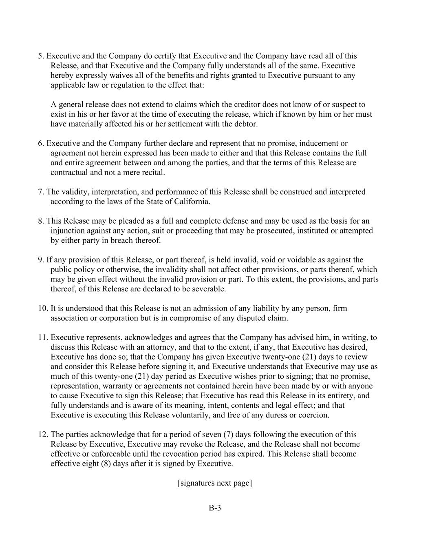
B-3 5. Executive and the Company do certify that Executive and the Company have read all of this Release, and that Executive and the Company fully understands all of the same. Executive hereby expressly waives all of the benefits and rights granted to Executive pursuant to any applicable law or regulation to the effect that: A general release does not extend to claims which the creditor does not know of or suspect to exist in his or her favor at the time of executing the release, which if known by him or her must have materially affected his or her settlement with the debtor. 6. Executive and the Company further declare and represent that no promise, inducement or agreement not herein expressed has been made to either and that this Release contains the full and entire agreement between and among the parties, and that the terms of this Release are contractual and not a mere recital. 7. The validity, interpretation, and performance of this Release shall be construed and interpreted according to the laws of the State of California. 8. This Release may be pleaded as a full and complete defense and may be used as the basis for an injunction against any action, suit or proceeding that may be prosecuted, instituted or attempted by either party in breach thereof. 9. If any provision of this Release, or part thereof, is held invalid, void or voidable as against the public policy or otherwise, the invalidity shall not affect other provisions, or parts thereof, which may be given effect without the invalid provision or part. To this extent, the provisions, and parts thereof, of this Release are declared to be severable. 10. It is understood that this Release is not an admission of any liability by any person, firm association or corporation but is in compromise of any disputed claim. 11. Executive represents, acknowledges and agrees that the Company has advised him, in writing, to discuss this Release with an attorney, and that to the extent, if any, that Executive has desired, Executive has done so; that the Company has given Executive twenty-one (21) days to review and consider this Release before signing it, and Executive understands that Executive may use as much of this twenty-one (21) day period as Executive wishes prior to signing; that no promise, representation, warranty or agreements not contained herein have been made by or with anyone to cause Executive to sign this Release; that Executive has read this Release in its entirety, and fully understands and is aware of its meaning, intent, contents and legal effect; and that Executive is executing this Release voluntarily, and free of any duress or coercion. 12. The parties acknowledge that for a period of seven (7) days following the execution of this Release by Executive, Executive may revoke the Release, and the Release shall not become effective or enforceable until the revocation period has expired. This Release shall become effective eight (8) days after it is signed by Executive. [signatures next page]

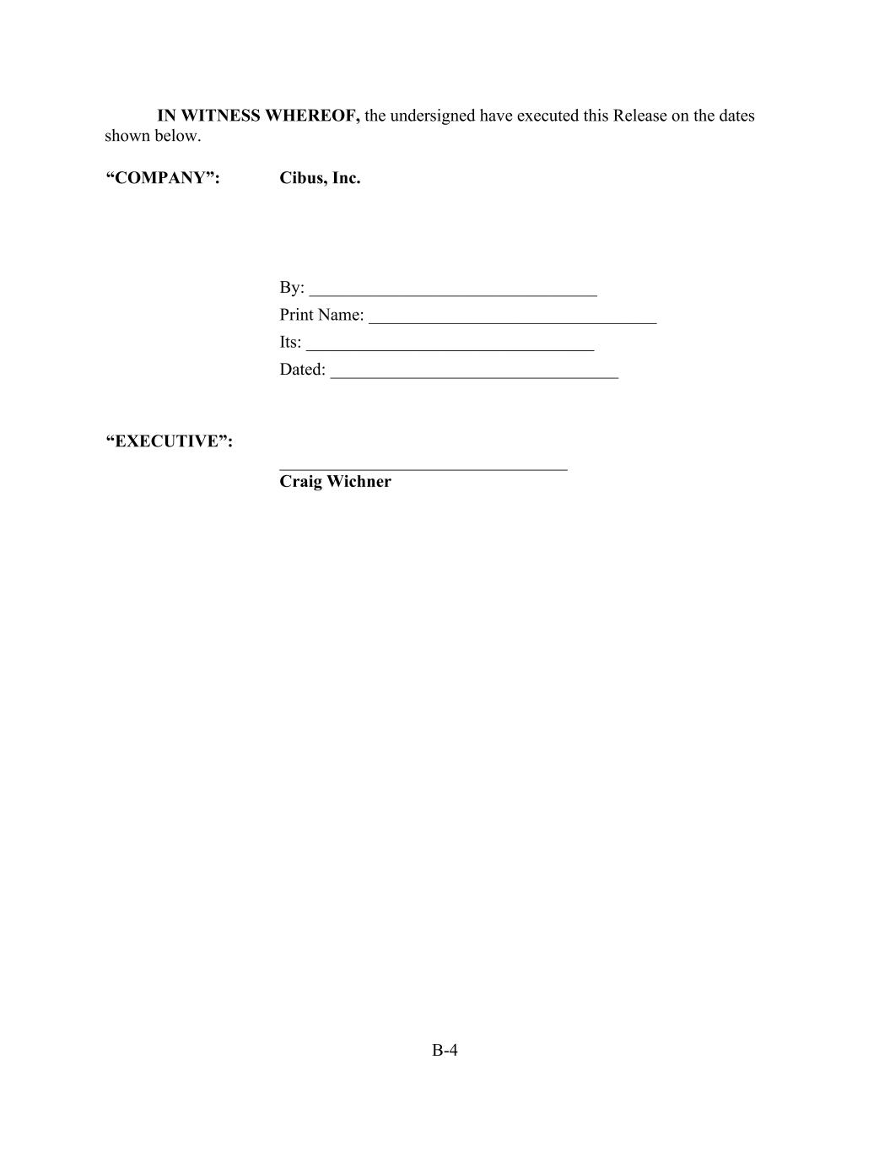
B-4 IN WITNESS WHEREOF, the undersigned have executed this Release on the dates shown below. “COMPANY”: Cibus, Inc. By: _________________________________ Print Name: _________________________________ Its: _________________________________ Dated: _________________________________ “EXECUTIVE”: _________________________________ Craig Wichner

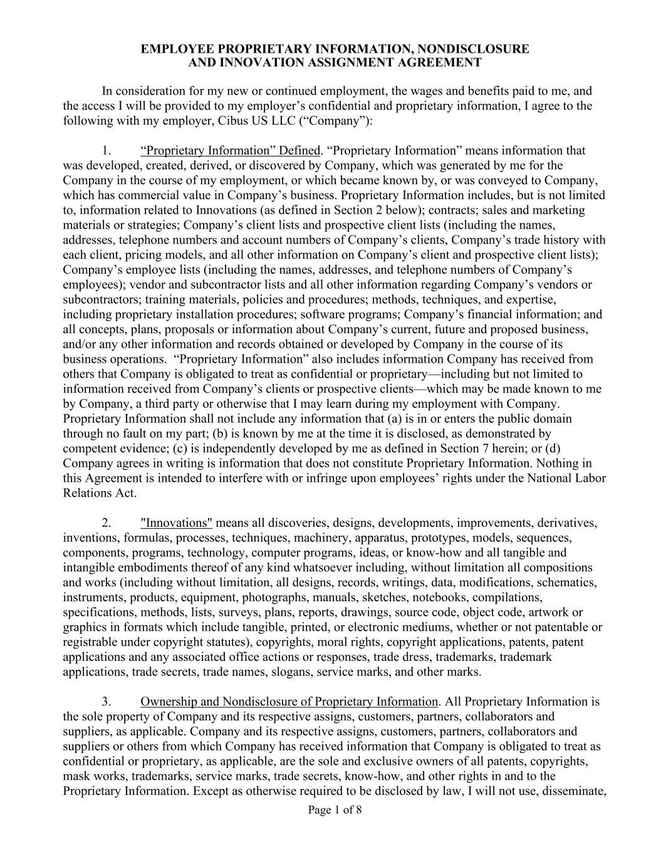
Page 1 of 8 EMPLOYEE PROPRIETARY INFORMATION, NONDISCLOSURE AND INNOVATION ASSIGNMENT AGREEMENT In consideration for my new or continued employment, the wages and benefits paid to me, and the access I will be provided to my employer’s confidential and proprietary information, I agree to the following with my employer, Cibus US LLC (“Company”): 1. “Proprietary Information” Defined. “Proprietary Information” means information that was developed, created, derived, or discovered by Company, which was generated by me for the Company in the course of my employment, or which became known by, or was conveyed to Company, which has commercial value in Company’s business. Proprietary Information includes, but is not limited to, information related to Innovations (as defined in Section 2 below); contracts; sales and marketing materials or strategies; Company’s client lists and prospective client lists (including the names, addresses, telephone numbers and account numbers of Company’s clients, Company’s trade history with each client, pricing models, and all other information on Company’s client and prospective client lists); Company’s employee lists (including the names, addresses, and telephone numbers of Company’s employees); vendor and subcontractor lists and all other information regarding Company’s vendors or subcontractors; training materials, policies and procedures; methods, techniques, and expertise, including proprietary installation procedures; software programs; Company’s financial information; and all concepts, plans, proposals or information about Company’s current, future and proposed business, and/or any other information and records obtained or developed by Company in the course of its business operations. “Proprietary Information” also includes information Company has received from others that Company is obligated to treat as confidential or proprietary—including but not limited to information received from Company’s clients or prospective clients—which may be made known to me by Company, a third party or otherwise that I may learn during my employment with Company. Proprietary Information shall not include any information that (a) is in or enters the public domain through no fault on my part; (b) is known by me at the time it is disclosed, as demonstrated by competent evidence; (c) is independently developed by me as defined in Section 7 herein; or (d) Company agrees in writing is information that does not constitute Proprietary Information. Nothing in this Agreement is intended to interfere with or infringe upon employees’ rights under the National Labor Relations Act. 2. "Innovations" means all discoveries, designs, developments, improvements, derivatives, inventions, formulas, processes, techniques, machinery, apparatus, prototypes, models, sequences, components, programs, technology, computer programs, ideas, or know-how and all tangible and intangible embodiments thereof of any kind whatsoever including, without limitation all compositions and works (including without limitation, all designs, records, writings, data, modifications, schematics, instruments, products, equipment, photographs, manuals, sketches, notebooks, compilations, specifications, methods, lists, surveys, plans, reports, drawings, source code, object code, artwork or graphics in formats which include tangible, printed, or electronic mediums, whether or not patentable or registrable under copyright statutes), copyrights, moral rights, copyright applications, patents, patent applications and any associated office actions or responses, trade dress, trademarks, trademark applications, trade secrets, trade names, slogans, service marks, and other marks. 3. Ownership and Nondisclosure of Proprietary Information. All Proprietary Information is the sole property of Company and its respective assigns, customers, partners, collaborators and suppliers, as applicable. Company and its respective assigns, customers, partners, collaborators and suppliers or others from which Company has received information that Company is obligated to treat as confidential or proprietary, as applicable, are the sole and exclusive owners of all patents, copyrights, mask works, trademarks, service marks, trade secrets, know-how, and other rights in and to the Proprietary Information. Except as otherwise required to be disclosed by law, I will not use, disseminate,

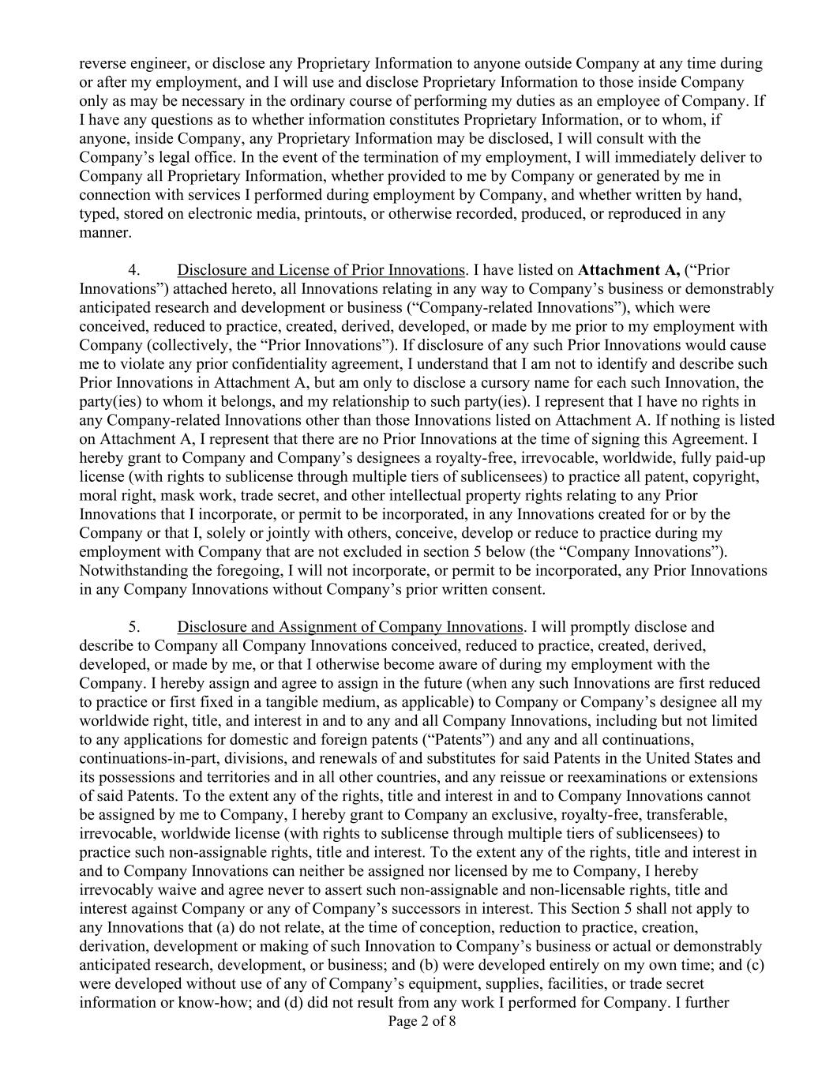
Page 2 of 8 reverse engineer, or disclose any Proprietary Information to anyone outside Company at any time during or after my employment, and I will use and disclose Proprietary Information to those inside Company only as may be necessary in the ordinary course of performing my duties as an employee of Company. If I have any questions as to whether information constitutes Proprietary Information, or to whom, if anyone, inside Company, any Proprietary Information may be disclosed, I will consult with the Company’s legal office. In the event of the termination of my employment, I will immediately deliver to Company all Proprietary Information, whether provided to me by Company or generated by me in connection with services I performed during employment by Company, and whether written by hand, typed, stored on electronic media, printouts, or otherwise recorded, produced, or reproduced in any manner. 4. Disclosure and License of Prior Innovations. I have listed on Attachment A, (“Prior Innovations”) attached hereto, all Innovations relating in any way to Company’s business or demonstrably anticipated research and development or business (“Company-related Innovations”), which were conceived, reduced to practice, created, derived, developed, or made by me prior to my employment with Company (collectively, the “Prior Innovations”). If disclosure of any such Prior Innovations would cause me to violate any prior confidentiality agreement, I understand that I am not to identify and describe such Prior Innovations in Attachment A, but am only to disclose a cursory name for each such Innovation, the party(ies) to whom it belongs, and my relationship to such party(ies). I represent that I have no rights in any Company-related Innovations other than those Innovations listed on Attachment A. If nothing is listed on Attachment A, I represent that there are no Prior Innovations at the time of signing this Agreement. I hereby grant to Company and Company’s designees a royalty-free, irrevocable, worldwide, fully paid-up license (with rights to sublicense through multiple tiers of sublicensees) to practice all patent, copyright, moral right, mask work, trade secret, and other intellectual property rights relating to any Prior Innovations that I incorporate, or permit to be incorporated, in any Innovations created for or by the Company or that I, solely or jointly with others, conceive, develop or reduce to practice during my employment with Company that are not excluded in section 5 below (the “Company Innovations”). Notwithstanding the foregoing, I will not incorporate, or permit to be incorporated, any Prior Innovations in any Company Innovations without Company’s prior written consent. 5. Disclosure and Assignment of Company Innovations. I will promptly disclose and describe to Company all Company Innovations conceived, reduced to practice, created, derived, developed, or made by me, or that I otherwise become aware of during my employment with the Company. I hereby assign and agree to assign in the future (when any such Innovations are first reduced to practice or first fixed in a tangible medium, as applicable) to Company or Company’s designee all my worldwide right, title, and interest in and to any and all Company Innovations, including but not limited to any applications for domestic and foreign patents (“Patents”) and any and all continuations, continuations-in-part, divisions, and renewals of and substitutes for said Patents in the United States and its possessions and territories and in all other countries, and any reissue or reexaminations or extensions of said Patents. To the extent any of the rights, title and interest in and to Company Innovations cannot be assigned by me to Company, I hereby grant to Company an exclusive, royalty-free, transferable, irrevocable, worldwide license (with rights to sublicense through multiple tiers of sublicensees) to practice such non-assignable rights, title and interest. To the extent any of the rights, title and interest in and to Company Innovations can neither be assigned nor licensed by me to Company, I hereby irrevocably waive and agree never to assert such non-assignable and non-licensable rights, title and interest against Company or any of Company’s successors in interest. This Section 5 shall not apply to any Innovations that (a) do not relate, at the time of conception, reduction to practice, creation, derivation, development or making of such Innovation to Company’s business or actual or demonstrably anticipated research, development, or business; and (b) were developed entirely on my own time; and (c) were developed without use of any of Company’s equipment, supplies, facilities, or trade secret information or know-how; and (d) did not result from any work I performed for Company. I further

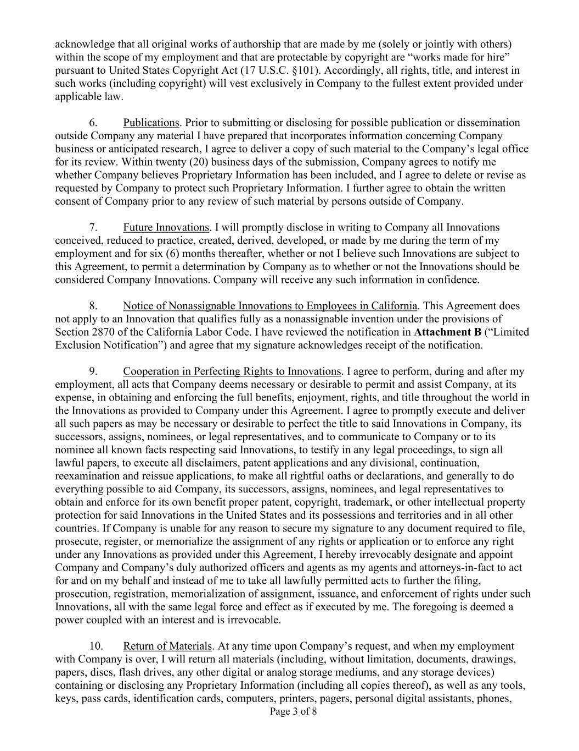
Page 3 of 8 acknowledge that all original works of authorship that are made by me (solely or jointly with others) within the scope of my employment and that are protectable by copyright are “works made for hire” pursuant to United States Copyright Act (17 U.S.C. §101). Accordingly, all rights, title, and interest in such works (including copyright) will vest exclusively in Company to the fullest extent provided under applicable law. 6. Publications. Prior to submitting or disclosing for possible publication or dissemination outside Company any material I have prepared that incorporates information concerning Company business or anticipated research, I agree to deliver a copy of such material to the Company’s legal office for its review. Within twenty (20) business days of the submission, Company agrees to notify me whether Company believes Proprietary Information has been included, and I agree to delete or revise as requested by Company to protect such Proprietary Information. I further agree to obtain the written consent of Company prior to any review of such material by persons outside of Company. 7. Future Innovations. I will promptly disclose in writing to Company all Innovations conceived, reduced to practice, created, derived, developed, or made by me during the term of my employment and for six (6) months thereafter, whether or not I believe such Innovations are subject to this Agreement, to permit a determination by Company as to whether or not the Innovations should be considered Company Innovations. Company will receive any such information in confidence. 8. Notice of Nonassignable Innovations to Employees in California. This Agreement does not apply to an Innovation that qualifies fully as a nonassignable invention under the provisions of Section 2870 of the California Labor Code. I have reviewed the notification in Attachment B (“Limited Exclusion Notification”) and agree that my signature acknowledges receipt of the notification. 9. Cooperation in Perfecting Rights to Innovations. I agree to perform, during and after my employment, all acts that Company deems necessary or desirable to permit and assist Company, at its expense, in obtaining and enforcing the full benefits, enjoyment, rights, and title throughout the world in the Innovations as provided to Company under this Agreement. I agree to promptly execute and deliver all such papers as may be necessary or desirable to perfect the title to said Innovations in Company, its successors, assigns, nominees, or legal representatives, and to communicate to Company or to its nominee all known facts respecting said Innovations, to testify in any legal proceedings, to sign all lawful papers, to execute all disclaimers, patent applications and any divisional, continuation, reexamination and reissue applications, to make all rightful oaths or declarations, and generally to do everything possible to aid Company, its successors, assigns, nominees, and legal representatives to obtain and enforce for its own benefit proper patent, copyright, trademark, or other intellectual property protection for said Innovations in the United States and its possessions and territories and in all other countries. If Company is unable for any reason to secure my signature to any document required to file, prosecute, register, or memorialize the assignment of any rights or application or to enforce any right under any Innovations as provided under this Agreement, I hereby irrevocably designate and appoint Company and Company’s duly authorized officers and agents as my agents and attorneys-in-fact to act for and on my behalf and instead of me to take all lawfully permitted acts to further the filing, prosecution, registration, memorialization of assignment, issuance, and enforcement of rights under such Innovations, all with the same legal force and effect as if executed by me. The foregoing is deemed a power coupled with an interest and is irrevocable. 10. Return of Materials. At any time upon Company’s request, and when my employment with Company is over, I will return all materials (including, without limitation, documents, drawings, papers, discs, flash drives, any other digital or analog storage mediums, and any storage devices) containing or disclosing any Proprietary Information (including all copies thereof), as well as any tools, keys, pass cards, identification cards, computers, printers, pagers, personal digital assistants, phones,

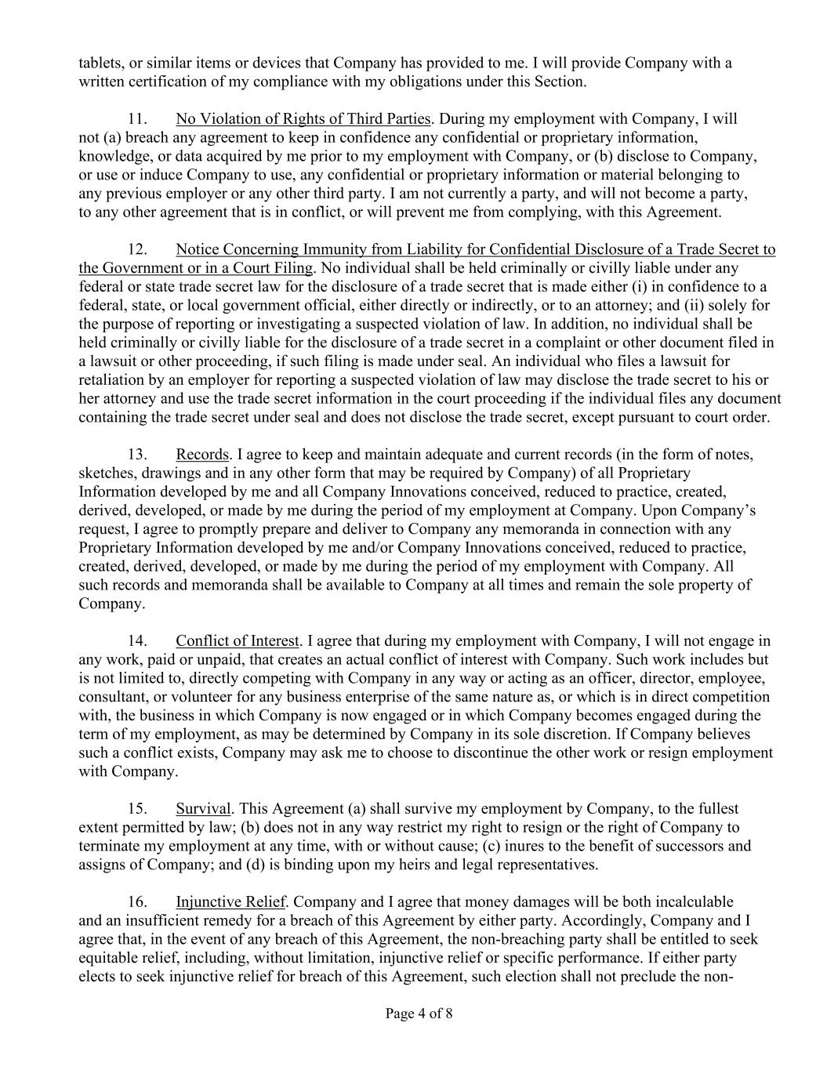
Page 4 of 8 tablets, or similar items or devices that Company has provided to me. I will provide Company with a written certification of my compliance with my obligations under this Section. 11. No Violation of Rights of Third Parties. During my employment with Company, I will not (a) breach any agreement to keep in confidence any confidential or proprietary information, knowledge, or data acquired by me prior to my employment with Company, or (b) disclose to Company, or use or induce Company to use, any confidential or proprietary information or material belonging to any previous employer or any other third party. I am not currently a party, and will not become a party, to any other agreement that is in conflict, or will prevent me from complying, with this Agreement. 12. Notice Concerning Immunity from Liability for Confidential Disclosure of a Trade Secret to the Government or in a Court Filing. No individual shall be held criminally or civilly liable under any federal or state trade secret law for the disclosure of a trade secret that is made either (i) in confidence to a federal, state, or local government official, either directly or indirectly, or to an attorney; and (ii) solely for the purpose of reporting or investigating a suspected violation of law. In addition, no individual shall be held criminally or civilly liable for the disclosure of a trade secret in a complaint or other document filed in a lawsuit or other proceeding, if such filing is made under seal. An individual who files a lawsuit for retaliation by an employer for reporting a suspected violation of law may disclose the trade secret to his or her attorney and use the trade secret information in the court proceeding if the individual files any document containing the trade secret under seal and does not disclose the trade secret, except pursuant to court order. 13. Records. I agree to keep and maintain adequate and current records (in the form of notes, sketches, drawings and in any other form that may be required by Company) of all Proprietary Information developed by me and all Company Innovations conceived, reduced to practice, created, derived, developed, or made by me during the period of my employment at Company. Upon Company’s request, I agree to promptly prepare and deliver to Company any memoranda in connection with any Proprietary Information developed by me and/or Company Innovations conceived, reduced to practice, created, derived, developed, or made by me during the period of my employment with Company. All such records and memoranda shall be available to Company at all times and remain the sole property of Company. 14. Conflict of Interest. I agree that during my employment with Company, I will not engage in any work, paid or unpaid, that creates an actual conflict of interest with Company. Such work includes but is not limited to, directly competing with Company in any way or acting as an officer, director, employee, consultant, or volunteer for any business enterprise of the same nature as, or which is in direct competition with, the business in which Company is now engaged or in which Company becomes engaged during the term of my employment, as may be determined by Company in its sole discretion. If Company believes such a conflict exists, Company may ask me to choose to discontinue the other work or resign employment with Company. 15. Survival. This Agreement (a) shall survive my employment by Company, to the fullest extent permitted by law; (b) does not in any way restrict my right to resign or the right of Company to terminate my employment at any time, with or without cause; (c) inures to the benefit of successors and assigns of Company; and (d) is binding upon my heirs and legal representatives. 16. Injunctive Relief. Company and I agree that money damages will be both incalculable and an insufficient remedy for a breach of this Agreement by either party. Accordingly, Company and I agree that, in the event of any breach of this Agreement, the non-breaching party shall be entitled to seek equitable relief, including, without limitation, injunctive relief or specific performance. If either party elects to seek injunctive relief for breach of this Agreement, such election shall not preclude the non-

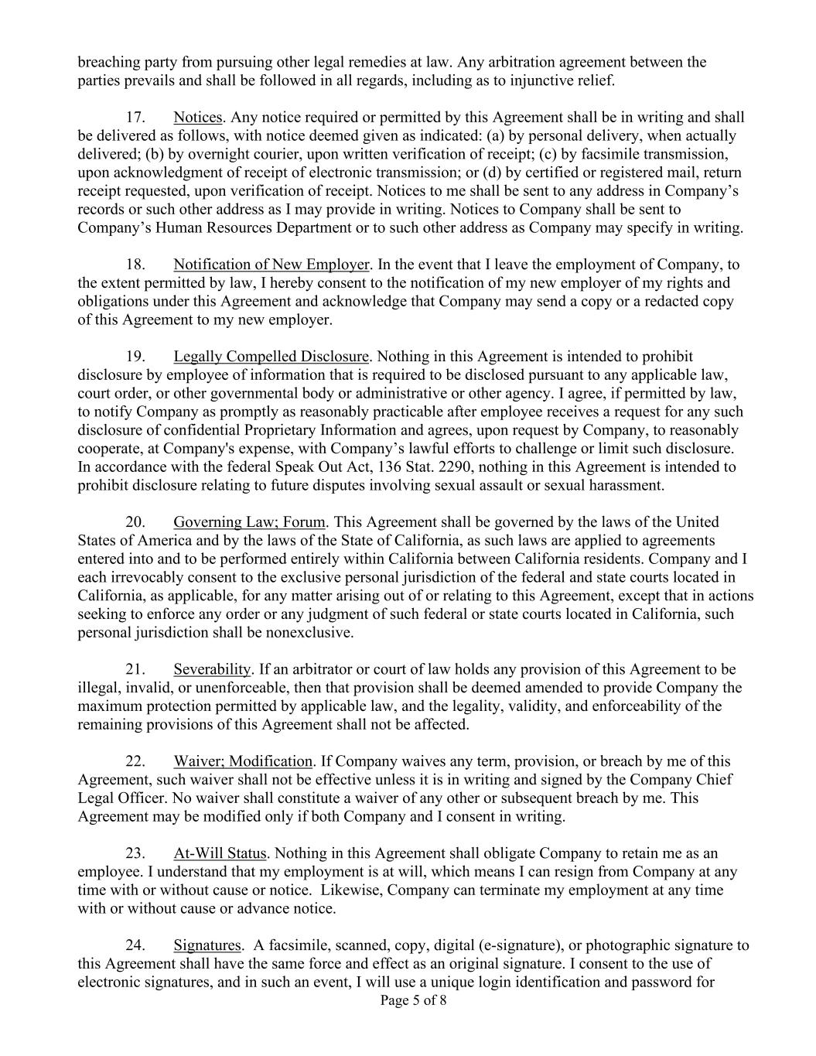
Page 5 of 8 breaching party from pursuing other legal remedies at law. Any arbitration agreement between the parties prevails and shall be followed in all regards, including as to injunctive relief. 17. Notices. Any notice required or permitted by this Agreement shall be in writing and shall be delivered as follows, with notice deemed given as indicated: (a) by personal delivery, when actually delivered; (b) by overnight courier, upon written verification of receipt; (c) by facsimile transmission, upon acknowledgment of receipt of electronic transmission; or (d) by certified or registered mail, return receipt requested, upon verification of receipt. Notices to me shall be sent to any address in Company’s records or such other address as I may provide in writing. Notices to Company shall be sent to Company’s Human Resources Department or to such other address as Company may specify in writing. 18. Notification of New Employer. In the event that I leave the employment of Company, to the extent permitted by law, I hereby consent to the notification of my new employer of my rights and obligations under this Agreement and acknowledge that Company may send a copy or a redacted copy of this Agreement to my new employer. 19. Legally Compelled Disclosure. Nothing in this Agreement is intended to prohibit disclosure by employee of information that is required to be disclosed pursuant to any applicable law, court order, or other governmental body or administrative or other agency. I agree, if permitted by law, to notify Company as promptly as reasonably practicable after employee receives a request for any such disclosure of confidential Proprietary Information and agrees, upon request by Company, to reasonably cooperate, at Company's expense, with Company’s lawful efforts to challenge or limit such disclosure. In accordance with the federal Speak Out Act, 136 Stat. 2290, nothing in this Agreement is intended to prohibit disclosure relating to future disputes involving sexual assault or sexual harassment. 20. Governing Law; Forum. This Agreement shall be governed by the laws of the United States of America and by the laws of the State of California, as such laws are applied to agreements entered into and to be performed entirely within California between California residents. Company and I each irrevocably consent to the exclusive personal jurisdiction of the federal and state courts located in California, as applicable, for any matter arising out of or relating to this Agreement, except that in actions seeking to enforce any order or any judgment of such federal or state courts located in California, such personal jurisdiction shall be nonexclusive. 21. Severability. If an arbitrator or court of law holds any provision of this Agreement to be illegal, invalid, or unenforceable, then that provision shall be deemed amended to provide Company the maximum protection permitted by applicable law, and the legality, validity, and enforceability of the remaining provisions of this Agreement shall not be affected. 22. Waiver; Modification. If Company waives any term, provision, or breach by me of this Agreement, such waiver shall not be effective unless it is in writing and signed by the Company Chief Legal Officer. No waiver shall constitute a waiver of any other or subsequent breach by me. This Agreement may be modified only if both Company and I consent in writing. 23. At-Will Status. Nothing in this Agreement shall obligate Company to retain me as an employee. I understand that my employment is at will, which means I can resign from Company at any time with or without cause or notice. Likewise, Company can terminate my employment at any time with or without cause or advance notice. 24. Signatures. A facsimile, scanned, copy, digital (e-signature), or photographic signature to this Agreement shall have the same force and effect as an original signature. I consent to the use of electronic signatures, and in such an event, I will use a unique login identification and password for

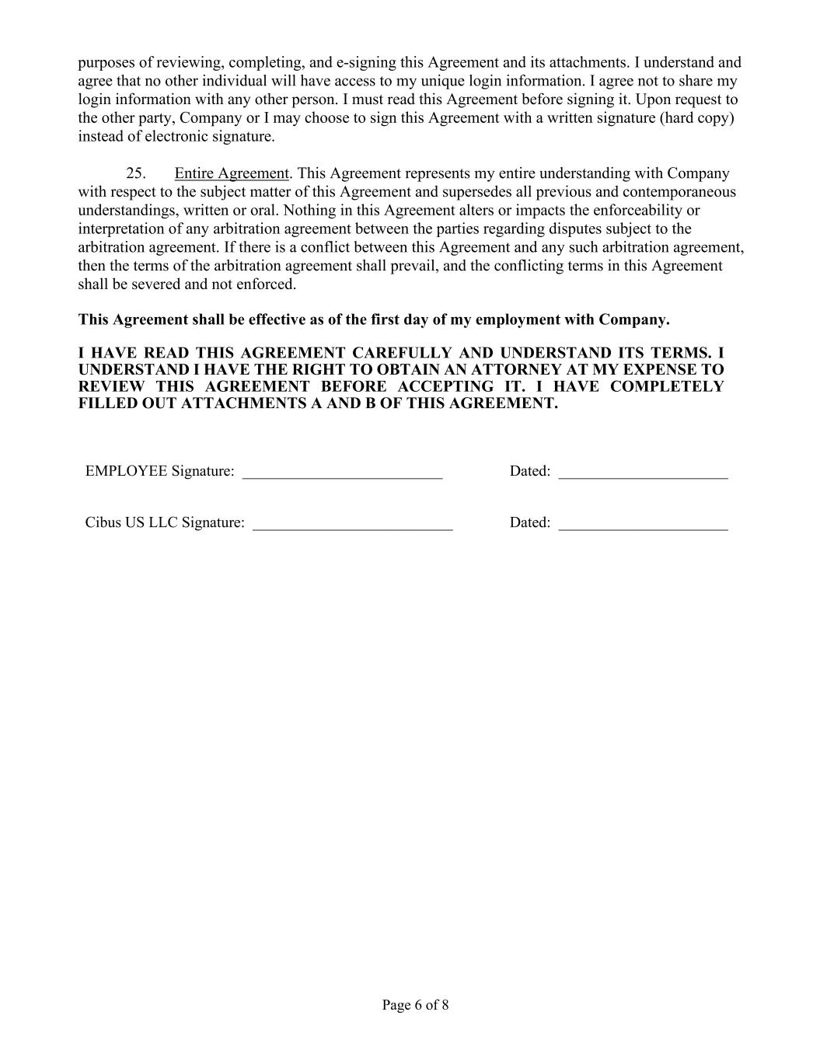
Page 6 of 8 purposes of reviewing, completing, and e-signing this Agreement and its attachments. I understand and agree that no other individual will have access to my unique login information. I agree not to share my login information with any other person. I must read this Agreement before signing it. Upon request to the other party, Company or I may choose to sign this Agreement with a written signature (hard copy) instead of electronic signature. 25. Entire Agreement. This Agreement represents my entire understanding with Company with respect to the subject matter of this Agreement and supersedes all previous and contemporaneous understandings, written or oral. Nothing in this Agreement alters or impacts the enforceability or interpretation of any arbitration agreement between the parties regarding disputes subject to the arbitration agreement. If there is a conflict between this Agreement and any such arbitration agreement, then the terms of the arbitration agreement shall prevail, and the conflicting terms in this Agreement shall be severed and not enforced. This Agreement shall be effective as of the first day of my employment with Company. I HAVE READ THIS AGREEMENT CAREFULLY AND UNDERSTAND ITS TERMS. I UNDERSTAND I HAVE THE RIGHT TO OBTAIN AN ATTORNEY AT MY EXPENSE TO REVIEW THIS AGREEMENT BEFORE ACCEPTING IT. I HAVE COMPLETELY FILLED OUT ATTACHMENTS A AND B OF THIS AGREEMENT. EMPLOYEE Signature: __________________________ Dated: ______________________ Cibus US LLC Signature: __________________________ Dated: ______________________

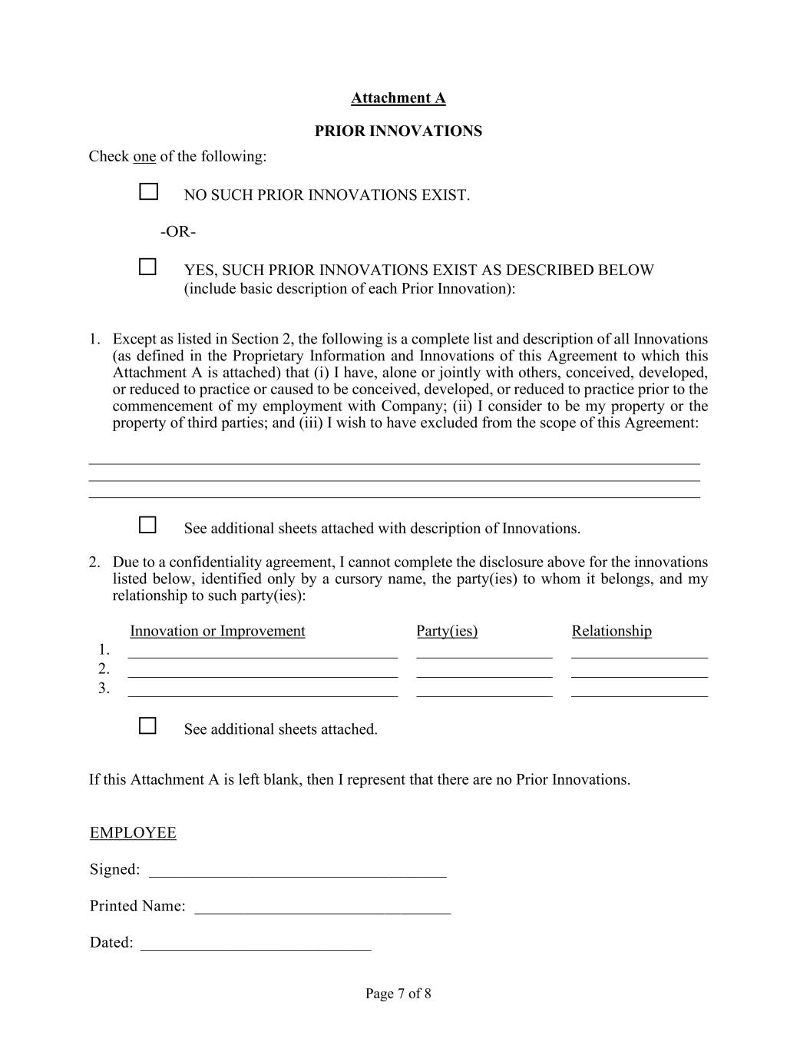
Page 7 of 8 Attachment A PRIOR INNOVATIONS Check one of the following: □ NO SUCH PRIOR INNOVATIONS EXIST. -OR- □ YES, SUCH PRIOR INNOVATIONS EXIST AS DESCRIBED BELOW (include basic description of each Prior Innovation): 1. Except as listed in Section 2, the following is a complete list and description of all Innovations (as defined in the Proprietary Information and Innovations of this Agreement to which this Attachment A is attached) that (i) I have, alone or jointly with others, conceived, developed, or reduced to practice or caused to be conceived, developed, or reduced to practice prior to the commencement of my employment with Company; (ii) I consider to be my property or the property of third parties; and (iii) I wish to have excluded from the scope of this Agreement: _____________________________________________________________________________ _____________________________________________________________________________ _____________________________________________________________________________ □ See additional sheets attached with description of Innovations. 2. Due to a confidentiality agreement, I cannot complete the disclosure above for the innovations listed below, identified only by a cursory name, the party(ies) to whom it belongs, and my relationship to such party(ies): Innovation or Improvement Party(ies) Relationship 1. 2. 3. □ See additional sheets attached. If this Attachment A is left blank, then I represent that there are no Prior Innovations. EMPLOYEE Signed: ____________________________________ Printed Name: _______________________________ Dated: ____________________________

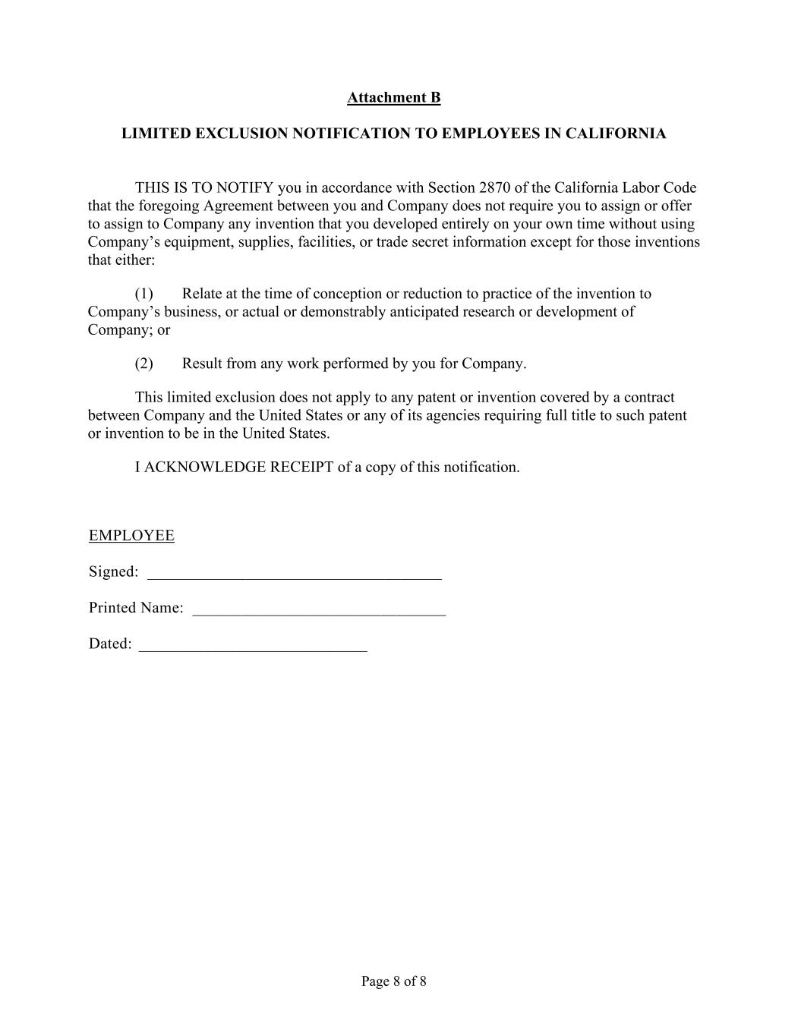
Page 8 of 8 Attachment B LIMITED EXCLUSION NOTIFICATION TO EMPLOYEES IN CALIFORNIA THIS IS TO NOTIFY you in accordance with Section 2870 of the California Labor Code that the foregoing Agreement between you and Company does not require you to assign or offer to assign to Company any invention that you developed entirely on your own time without using Company’s equipment, supplies, facilities, or trade secret information except for those inventions that either: (1) Relate at the time of conception or reduction to practice of the invention to Company’s business, or actual or demonstrably anticipated research or development of Company; or (2) Result from any work performed by you for Company. This limited exclusion does not apply to any patent or invention covered by a contract between Company and the United States or any of its agencies requiring full title to such patent or invention to be in the United States. I ACKNOWLEDGE RECEIPT of a copy of this notification. EMPLOYEE Signed: ____________________________________ Printed Name: _______________________________ Dated: ____________________________

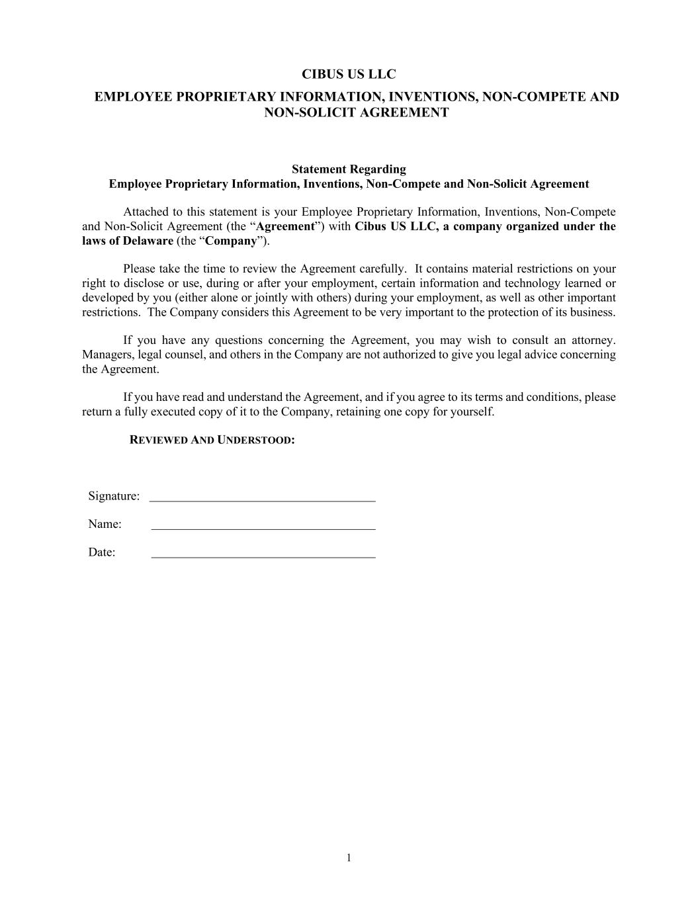
CIBUS US LLC EMPLOYEE PROPRIETARY INFORMATION, INVENTIONS, NON-COMPETE AND NON-SOLICIT AGREEMENT 1 Statement Regarding Employee Proprietary Information, Inventions, Non-Compete and Non-Solicit Agreement Attached to this statement is your Employee Proprietary Information, Inventions, Non-Compete and Non-Solicit Agreement (the “Agreement”) with Cibus US LLC, a company organized under the laws of Delaware (the “Company”). Please take the time to review the Agreement carefully. It contains material restrictions on your right to disclose or use, during or after your employment, certain information and technology learned or developed by you (either alone or jointly with others) during your employment, as well as other important restrictions. The Company considers this Agreement to be very important to the protection of its business. If you have any questions concerning the Agreement, you may wish to consult an attorney. Managers, legal counsel, and others in the Company are not authorized to give you legal advice concerning the Agreement. If you have read and understand the Agreement, and if you agree to its terms and conditions, please return a fully executed copy of it to the Company, retaining one copy for yourself. REVIEWED AND UNDERSTOOD: Signature: Name: Date:

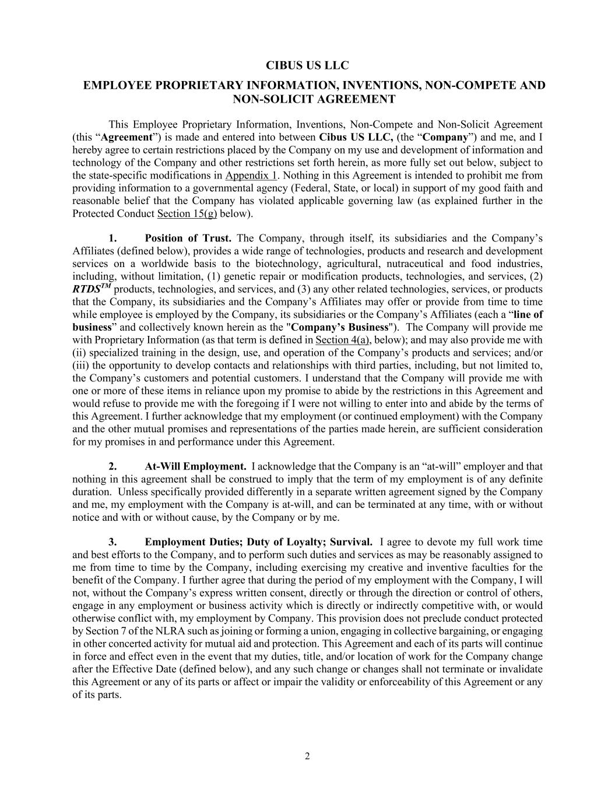
CIBUS US LLC EMPLOYEE PROPRIETARY INFORMATION, INVENTIONS, NON-COMPETE AND NON-SOLICIT AGREEMENT 2 This Employee Proprietary Information, Inventions, Non-Compete and Non-Solicit Agreement (this “Agreement”) is made and entered into between Cibus US LLC, (the “Company”) and me, and I hereby agree to certain restrictions placed by the Company on my use and development of information and technology of the Company and other restrictions set forth herein, as more fully set out below, subject to the state-specific modifications in Appendix 1. Nothing in this Agreement is intended to prohibit me from providing information to a governmental agency (Federal, State, or local) in support of my good faith and reasonable belief that the Company has violated applicable governing law (as explained further in the Protected Conduct Section 15(g) below). 1. Position of Trust. The Company, through itself, its subsidiaries and the Company’s Affiliates (defined below), provides a wide range of technologies, products and research and development services on a worldwide basis to the biotechnology, agricultural, nutraceutical and food industries, including, without limitation, (1) genetic repair or modification products, technologies, and services, (2) RTDSTM products, technologies, and services, and (3) any other related technologies, services, or products that the Company, its subsidiaries and the Company’s Affiliates may offer or provide from time to time while employee is employed by the Company, its subsidiaries or the Company’s Affiliates (each a “line of business” and collectively known herein as the "Company’s Business"). The Company will provide me with Proprietary Information (as that term is defined in Section 4(a), below); and may also provide me with (ii) specialized training in the design, use, and operation of the Company’s products and services; and/or (iii) the opportunity to develop contacts and relationships with third parties, including, but not limited to, the Company’s customers and potential customers. I understand that the Company will provide me with one or more of these items in reliance upon my promise to abide by the restrictions in this Agreement and would refuse to provide me with the foregoing if I were not willing to enter into and abide by the terms of this Agreement. I further acknowledge that my employment (or continued employment) with the Company and the other mutual promises and representations of the parties made herein, are sufficient consideration for my promises in and performance under this Agreement. 2. At-Will Employment. I acknowledge that the Company is an “at-will” employer and that nothing in this agreement shall be construed to imply that the term of my employment is of any definite duration. Unless specifically provided differently in a separate written agreement signed by the Company and me, my employment with the Company is at-will, and can be terminated at any time, with or without notice and with or without cause, by the Company or by me. 3. Employment Duties; Duty of Loyalty; Survival. I agree to devote my full work time and best efforts to the Company, and to perform such duties and services as may be reasonably assigned to me from time to time by the Company, including exercising my creative and inventive faculties for the benefit of the Company. I further agree that during the period of my employment with the Company, I will not, without the Company’s express written consent, directly or through the direction or control of others, engage in any employment or business activity which is directly or indirectly competitive with, or would otherwise conflict with, my employment by Company. This provision does not preclude conduct protected by Section 7 of the NLRA such as joining or forming a union, engaging in collective bargaining, or engaging in other concerted activity for mutual aid and protection. This Agreement and each of its parts will continue in force and effect even in the event that my duties, title, and/or location of work for the Company change after the Effective Date (defined below), and any such change or changes shall not terminate or invalidate this Agreement or any of its parts or affect or impair the validity or enforceability of this Agreement or any of its parts.

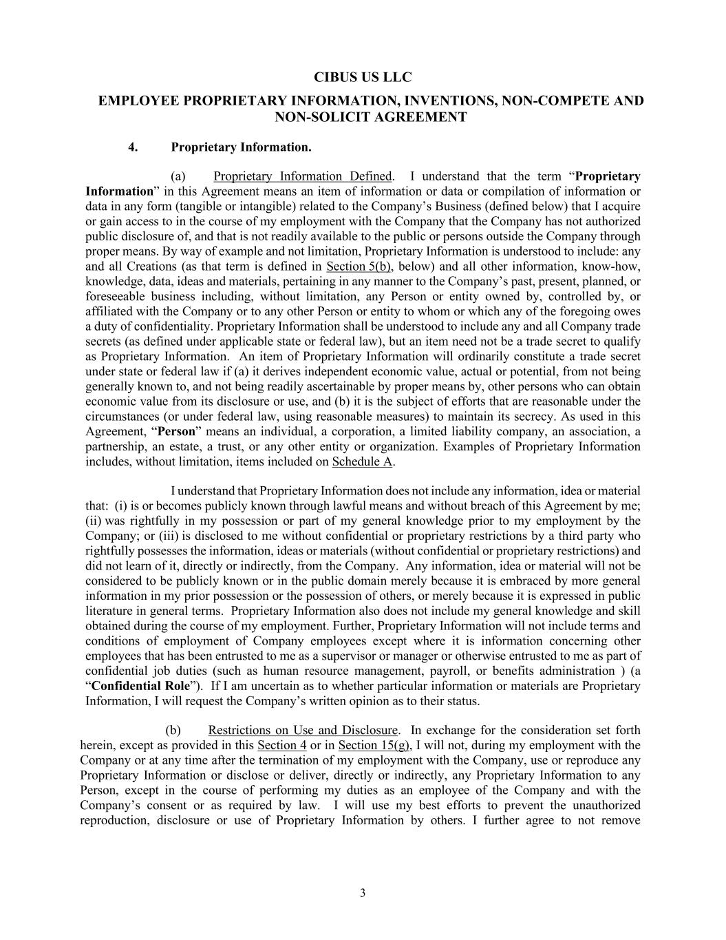
CIBUS US LLC EMPLOYEE PROPRIETARY INFORMATION, INVENTIONS, NON-COMPETE AND NON-SOLICIT AGREEMENT 3 4. Proprietary Information. (a) Proprietary Information Defined. I understand that the term “Proprietary Information” in this Agreement means an item of information or data or compilation of information or data in any form (tangible or intangible) related to the Company’s Business (defined below) that I acquire or gain access to in the course of my employment with the Company that the Company has not authorized public disclosure of, and that is not readily available to the public or persons outside the Company through proper means. By way of example and not limitation, Proprietary Information is understood to include: any and all Creations (as that term is defined in Section 5(b), below) and all other information, know-how, knowledge, data, ideas and materials, pertaining in any manner to the Company’s past, present, planned, or foreseeable business including, without limitation, any Person or entity owned by, controlled by, or affiliated with the Company or to any other Person or entity to whom or which any of the foregoing owes a duty of confidentiality. Proprietary Information shall be understood to include any and all Company trade secrets (as defined under applicable state or federal law), but an item need not be a trade secret to qualify as Proprietary Information. An item of Proprietary Information will ordinarily constitute a trade secret under state or federal law if (a) it derives independent economic value, actual or potential, from not being generally known to, and not being readily ascertainable by proper means by, other persons who can obtain economic value from its disclosure or use, and (b) it is the subject of efforts that are reasonable under the circumstances (or under federal law, using reasonable measures) to maintain its secrecy. As used in this Agreement, “Person” means an individual, a corporation, a limited liability company, an association, a partnership, an estate, a trust, or any other entity or organization. Examples of Proprietary Information includes, without limitation, items included on Schedule A. I understand that Proprietary Information does not include any information, idea or material that: (i) is or becomes publicly known through lawful means and without breach of this Agreement by me; (ii) was rightfully in my possession or part of my general knowledge prior to my employment by the Company; or (iii) is disclosed to me without confidential or proprietary restrictions by a third party who rightfully possesses the information, ideas or materials (without confidential or proprietary restrictions) and did not learn of it, directly or indirectly, from the Company. Any information, idea or material will not be considered to be publicly known or in the public domain merely because it is embraced by more general information in my prior possession or the possession of others, or merely because it is expressed in public literature in general terms. Proprietary Information also does not include my general knowledge and skill obtained during the course of my employment. Further, Proprietary Information will not include terms and conditions of employment of Company employees except where it is information concerning other employees that has been entrusted to me as a supervisor or manager or otherwise entrusted to me as part of confidential job duties (such as human resource management, payroll, or benefits administration ) (a “Confidential Role”). If I am uncertain as to whether particular information or materials are Proprietary Information, I will request the Company’s written opinion as to their status. (b) Restrictions on Use and Disclosure. In exchange for the consideration set forth herein, except as provided in this Section 4 or in Section 15(g), I will not, during my employment with the Company or at any time after the termination of my employment with the Company, use or reproduce any Proprietary Information or disclose or deliver, directly or indirectly, any Proprietary Information to any Person, except in the course of performing my duties as an employee of the Company and with the Company’s consent or as required by law. I will use my best efforts to prevent the unauthorized reproduction, disclosure or use of Proprietary Information by others. I further agree to not remove

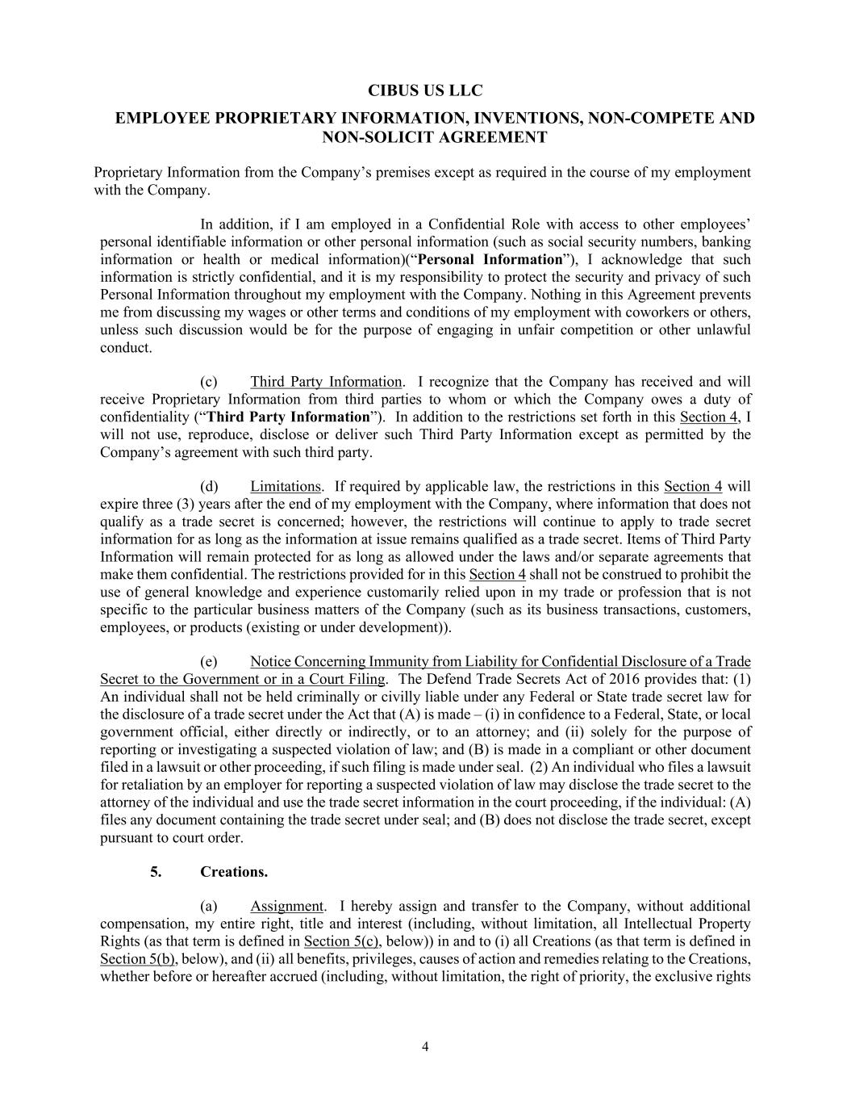
CIBUS US LLC EMPLOYEE PROPRIETARY INFORMATION, INVENTIONS, NON-COMPETE AND NON-SOLICIT AGREEMENT 4 Proprietary Information from the Company’s premises except as required in the course of my employment with the Company. In addition, if I am employed in a Confidential Role with access to other employees’ personal identifiable information or other personal information (such as social security numbers, banking information or health or medical information)(“Personal Information”), I acknowledge that such information is strictly confidential, and it is my responsibility to protect the security and privacy of such Personal Information throughout my employment with the Company. Nothing in this Agreement prevents me from discussing my wages or other terms and conditions of my employment with coworkers or others, unless such discussion would be for the purpose of engaging in unfair competition or other unlawful conduct. (c) Third Party Information. I recognize that the Company has received and will receive Proprietary Information from third parties to whom or which the Company owes a duty of confidentiality (“Third Party Information”). In addition to the restrictions set forth in this Section 4, I will not use, reproduce, disclose or deliver such Third Party Information except as permitted by the Company’s agreement with such third party. (d) Limitations. If required by applicable law, the restrictions in this Section 4 will expire three (3) years after the end of my employment with the Company, where information that does not qualify as a trade secret is concerned; however, the restrictions will continue to apply to trade secret information for as long as the information at issue remains qualified as a trade secret. Items of Third Party Information will remain protected for as long as allowed under the laws and/or separate agreements that make them confidential. The restrictions provided for in this Section 4 shall not be construed to prohibit the use of general knowledge and experience customarily relied upon in my trade or profession that is not specific to the particular business matters of the Company (such as its business transactions, customers, employees, or products (existing or under development)). (e) Notice Concerning Immunity from Liability for Confidential Disclosure of a Trade Secret to the Government or in a Court Filing. The Defend Trade Secrets Act of 2016 provides that: (1) An individual shall not be held criminally or civilly liable under any Federal or State trade secret law for the disclosure of a trade secret under the Act that (A) is made – (i) in confidence to a Federal, State, or local government official, either directly or indirectly, or to an attorney; and (ii) solely for the purpose of reporting or investigating a suspected violation of law; and (B) is made in a compliant or other document filed in a lawsuit or other proceeding, if such filing is made under seal. (2) An individual who files a lawsuit for retaliation by an employer for reporting a suspected violation of law may disclose the trade secret to the attorney of the individual and use the trade secret information in the court proceeding, if the individual: (A) files any document containing the trade secret under seal; and (B) does not disclose the trade secret, except pursuant to court order. 5. Creations. (a) Assignment. I hereby assign and transfer to the Company, without additional compensation, my entire right, title and interest (including, without limitation, all Intellectual Property Rights (as that term is defined in Section 5(c), below)) in and to (i) all Creations (as that term is defined in Section 5(b), below), and (ii) all benefits, privileges, causes of action and remedies relating to the Creations, whether before or hereafter accrued (including, without limitation, the right of priority, the exclusive rights

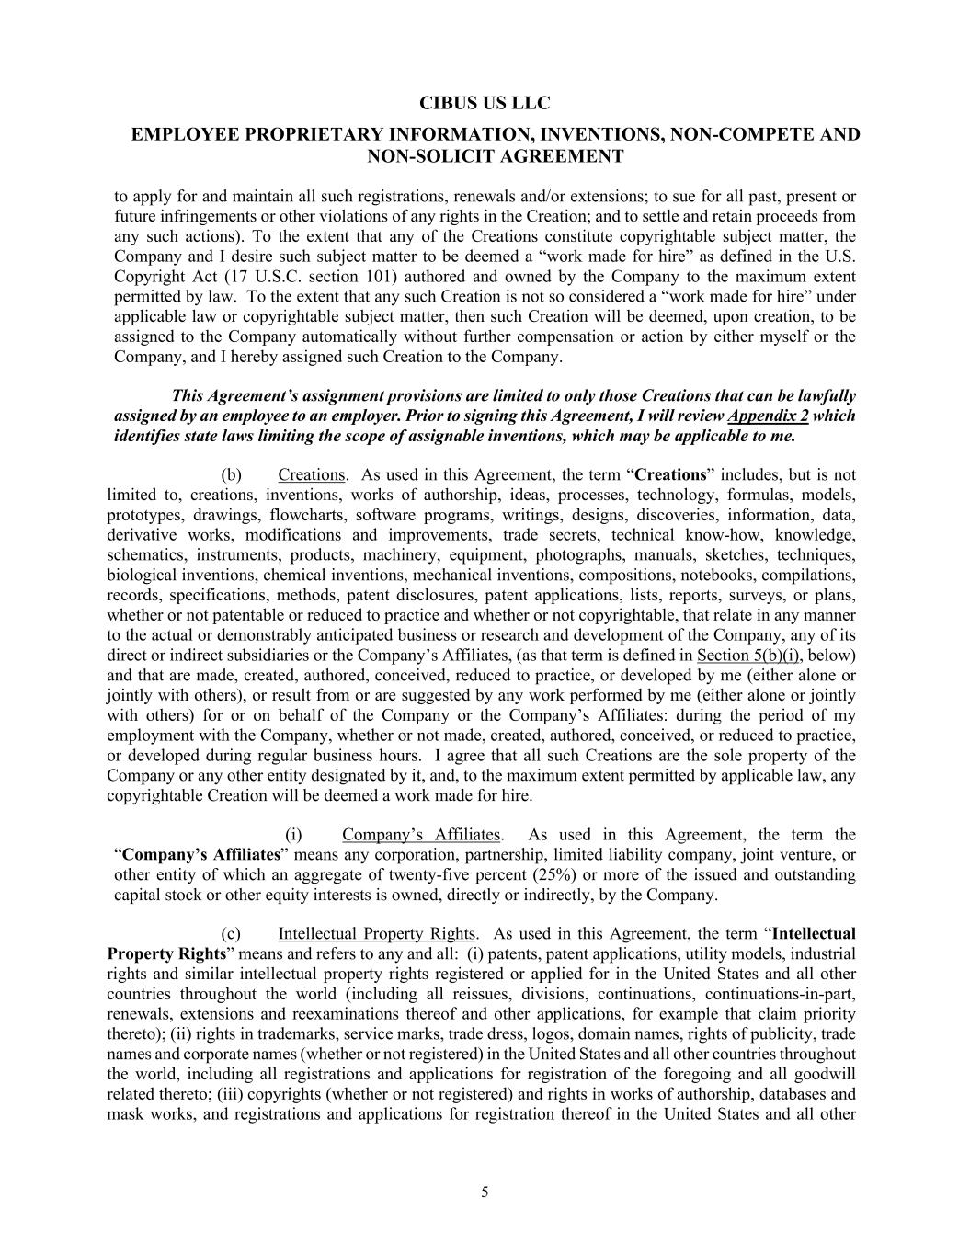
CIBUS US LLC EMPLOYEE PROPRIETARY INFORMATION, INVENTIONS, NON-COMPETE AND NON-SOLICIT AGREEMENT 5 to apply for and maintain all such registrations, renewals and/or extensions; to sue for all past, present or future infringements or other violations of any rights in the Creation; and to settle and retain proceeds from any such actions). To the extent that any of the Creations constitute copyrightable subject matter, the Company and I desire such subject matter to be deemed a “work made for hire” as defined in the U.S. Copyright Act (17 U.S.C. section 101) authored and owned by the Company to the maximum extent permitted by law. To the extent that any such Creation is not so considered a “work made for hire” under applicable law or copyrightable subject matter, then such Creation will be deemed, upon creation, to be assigned to the Company automatically without further compensation or action by either myself or the Company, and I hereby assigned such Creation to the Company. This Agreement’s assignment provisions are limited to only those Creations that can be lawfully assigned by an employee to an employer. Prior to signing this Agreement, I will review Appendix 2 which identifies state laws limiting the scope of assignable inventions, which may be applicable to me. (b) Creations. As used in this Agreement, the term “Creations” includes, but is not limited to, creations, inventions, works of authorship, ideas, processes, technology, formulas, models, prototypes, drawings, flowcharts, software programs, writings, designs, discoveries, information, data, derivative works, modifications and improvements, trade secrets, technical know-how, knowledge, schematics, instruments, products, machinery, equipment, photographs, manuals, sketches, techniques, biological inventions, chemical inventions, mechanical inventions, compositions, notebooks, compilations, records, specifications, methods, patent disclosures, patent applications, lists, reports, surveys, or plans, whether or not patentable or reduced to practice and whether or not copyrightable, that relate in any manner to the actual or demonstrably anticipated business or research and development of the Company, any of its direct or indirect subsidiaries or the Company’s Affiliates, (as that term is defined in Section 5(b)(i), below) and that are made, created, authored, conceived, reduced to practice, or developed by me (either alone or jointly with others), or result from or are suggested by any work performed by me (either alone or jointly with others) for or on behalf of the Company or the Company’s Affiliates: during the period of my employment with the Company, whether or not made, created, authored, conceived, or reduced to practice, or developed during regular business hours. I agree that all such Creations are the sole property of the Company or any other entity designated by it, and, to the maximum extent permitted by applicable law, any copyrightable Creation will be deemed a work made for hire. (i) Company’s Affiliates. As used in this Agreement, the term the “Company’s Affiliates” means any corporation, partnership, limited liability company, joint venture, or other entity of which an aggregate of twenty-five percent (25%) or more of the issued and outstanding capital stock or other equity interests is owned, directly or indirectly, by the Company. (c) Intellectual Property Rights. As used in this Agreement, the term “Intellectual Property Rights” means and refers to any and all: (i) patents, patent applications, utility models, industrial rights and similar intellectual property rights registered or applied for in the United States and all other countries throughout the world (including all reissues, divisions, continuations, continuations-in-part, renewals, extensions and reexaminations thereof and other applications, for example that claim priority thereto); (ii) rights in trademarks, service marks, trade dress, logos, domain names, rights of publicity, trade names and corporate names (whether or not registered) in the United States and all other countries throughout the world, including all registrations and applications for registration of the foregoing and all goodwill related thereto; (iii) copyrights (whether or not registered) and rights in works of authorship, databases and mask works, and registrations and applications for registration thereof in the United States and all other

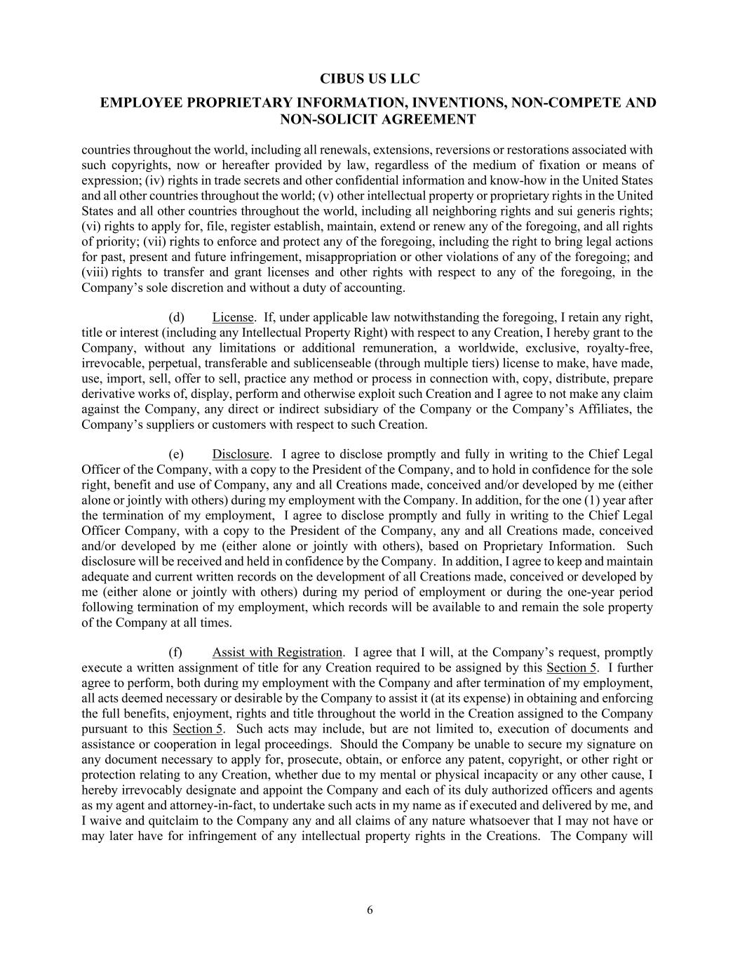
CIBUS US LLC EMPLOYEE PROPRIETARY INFORMATION, INVENTIONS, NON-COMPETE AND NON-SOLICIT AGREEMENT 6 countries throughout the world, including all renewals, extensions, reversions or restorations associated with such copyrights, now or hereafter provided by law, regardless of the medium of fixation or means of expression; (iv) rights in trade secrets and other confidential information and know-how in the United States and all other countries throughout the world; (v) other intellectual property or proprietary rights in the United States and all other countries throughout the world, including all neighboring rights and sui generis rights; (vi) rights to apply for, file, register establish, maintain, extend or renew any of the foregoing, and all rights of priority; (vii) rights to enforce and protect any of the foregoing, including the right to bring legal actions for past, present and future infringement, misappropriation or other violations of any of the foregoing; and (viii) rights to transfer and grant licenses and other rights with respect to any of the foregoing, in the Company’s sole discretion and without a duty of accounting. (d) License. If, under applicable law notwithstanding the foregoing, I retain any right, title or interest (including any Intellectual Property Right) with respect to any Creation, I hereby grant to the Company, without any limitations or additional remuneration, a worldwide, exclusive, royalty-free, irrevocable, perpetual, transferable and sublicenseable (through multiple tiers) license to make, have made, use, import, sell, offer to sell, practice any method or process in connection with, copy, distribute, prepare derivative works of, display, perform and otherwise exploit such Creation and I agree to not make any claim against the Company, any direct or indirect subsidiary of the Company or the Company’s Affiliates, the Company’s suppliers or customers with respect to such Creation. (e) Disclosure. I agree to disclose promptly and fully in writing to the Chief Legal Officer of the Company, with a copy to the President of the Company, and to hold in confidence for the sole right, benefit and use of Company, any and all Creations made, conceived and/or developed by me (either alone or jointly with others) during my employment with the Company. In addition, for the one (1) year after the termination of my employment, I agree to disclose promptly and fully in writing to the Chief Legal Officer Company, with a copy to the President of the Company, any and all Creations made, conceived and/or developed by me (either alone or jointly with others), based on Proprietary Information. Such disclosure will be received and held in confidence by the Company. In addition, I agree to keep and maintain adequate and current written records on the development of all Creations made, conceived or developed by me (either alone or jointly with others) during my period of employment or during the one-year period following termination of my employment, which records will be available to and remain the sole property of the Company at all times. (f) Assist with Registration. I agree that I will, at the Company’s request, promptly execute a written assignment of title for any Creation required to be assigned by this Section 5. I further agree to perform, both during my employment with the Company and after termination of my employment, all acts deemed necessary or desirable by the Company to assist it (at its expense) in obtaining and enforcing the full benefits, enjoyment, rights and title throughout the world in the Creation assigned to the Company pursuant to this Section 5. Such acts may include, but are not limited to, execution of documents and assistance or cooperation in legal proceedings. Should the Company be unable to secure my signature on any document necessary to apply for, prosecute, obtain, or enforce any patent, copyright, or other right or protection relating to any Creation, whether due to my mental or physical incapacity or any other cause, I hereby irrevocably designate and appoint the Company and each of its duly authorized officers and agents as my agent and attorney-in-fact, to undertake such acts in my name as if executed and delivered by me, and I waive and quitclaim to the Company any and all claims of any nature whatsoever that I may not have or may later have for infringement of any intellectual property rights in the Creations. The Company will

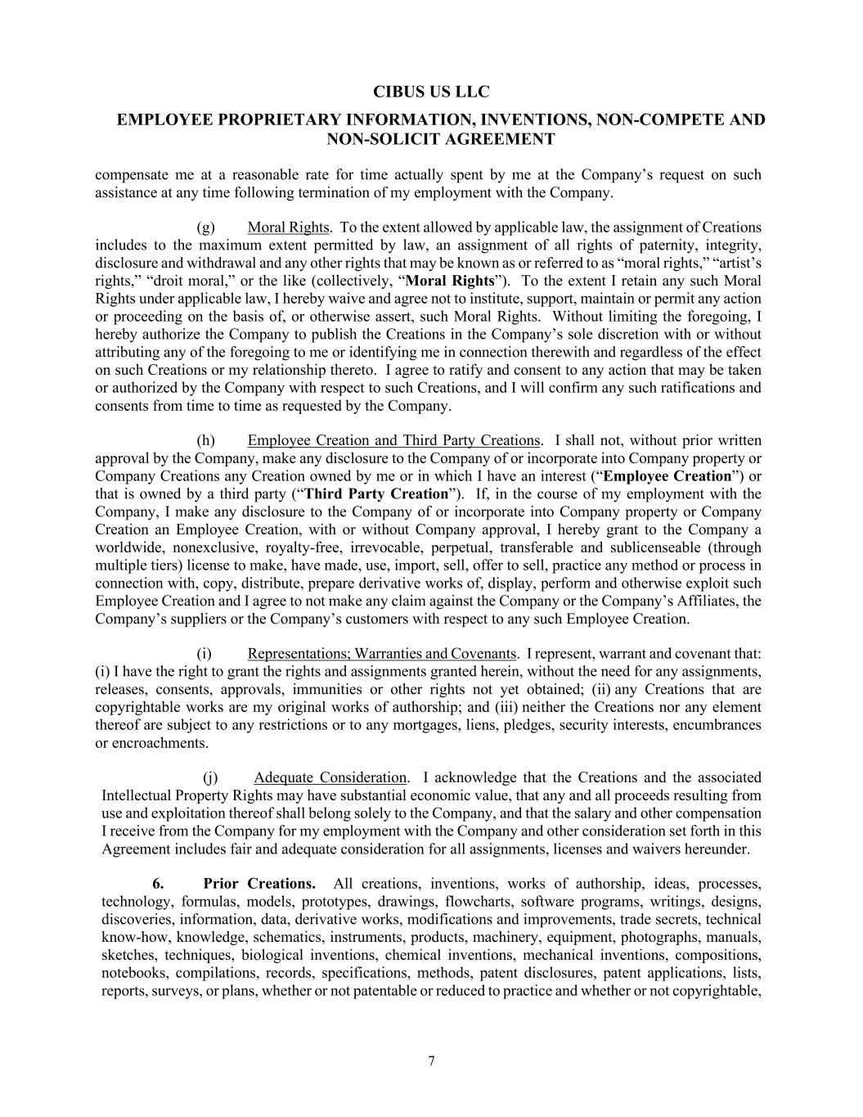
CIBUS US LLC EMPLOYEE PROPRIETARY INFORMATION, INVENTIONS, NON-COMPETE AND NON-SOLICIT AGREEMENT 7 compensate me at a reasonable rate for time actually spent by me at the Company’s request on such assistance at any time following termination of my employment with the Company. (g) Moral Rights. To the extent allowed by applicable law, the assignment of Creations includes to the maximum extent permitted by law, an assignment of all rights of paternity, integrity, disclosure and withdrawal and any other rights that may be known as or referred to as “moral rights,” “artist’s rights,” “droit moral,” or the like (collectively, “Moral Rights”). To the extent I retain any such Moral Rights under applicable law, I hereby waive and agree not to institute, support, maintain or permit any action or proceeding on the basis of, or otherwise assert, such Moral Rights. Without limiting the foregoing, I hereby authorize the Company to publish the Creations in the Company’s sole discretion with or without attributing any of the foregoing to me or identifying me in connection therewith and regardless of the effect on such Creations or my relationship thereto. I agree to ratify and consent to any action that may be taken or authorized by the Company with respect to such Creations, and I will confirm any such ratifications and consents from time to time as requested by the Company. (h) Employee Creation and Third Party Creations. I shall not, without prior written approval by the Company, make any disclosure to the Company of or incorporate into Company property or Company Creations any Creation owned by me or in which I have an interest (“Employee Creation”) or that is owned by a third party (“Third Party Creation”). If, in the course of my employment with the Company, I make any disclosure to the Company of or incorporate into Company property or Company Creation an Employee Creation, with or without Company approval, I hereby grant to the Company a worldwide, nonexclusive, royalty-free, irrevocable, perpetual, transferable and sublicenseable (through multiple tiers) license to make, have made, use, import, sell, offer to sell, practice any method or process in connection with, copy, distribute, prepare derivative works of, display, perform and otherwise exploit such Employee Creation and I agree to not make any claim against the Company or the Company’s Affiliates, the Company’s suppliers or the Company’s customers with respect to any such Employee Creation. (i) Representations; Warranties and Covenants. I represent, warrant and covenant that: (i) I have the right to grant the rights and assignments granted herein, without the need for any assignments, releases, consents, approvals, immunities or other rights not yet obtained; (ii) any Creations that are copyrightable works are my original works of authorship; and (iii) neither the Creations nor any element thereof are subject to any restrictions or to any mortgages, liens, pledges, security interests, encumbrances or encroachments. (j) Adequate Consideration. I acknowledge that the Creations and the associated Intellectual Property Rights may have substantial economic value, that any and all proceeds resulting from use and exploitation thereof shall belong solely to the Company, and that the salary and other compensation I receive from the Company for my employment with the Company and other consideration set forth in this Agreement includes fair and adequate consideration for all assignments, licenses and waivers hereunder. 6. Prior Creations. All creations, inventions, works of authorship, ideas, processes, technology, formulas, models, prototypes, drawings, flowcharts, software programs, writings, designs, discoveries, information, data, derivative works, modifications and improvements, trade secrets, technical know-how, knowledge, schematics, instruments, products, machinery, equipment, photographs, manuals, sketches, techniques, biological inventions, chemical inventions, mechanical inventions, compositions, notebooks, compilations, records, specifications, methods, patent disclosures, patent applications, lists, reports, surveys, or plans, whether or not patentable or reduced to practice and whether or not copyrightable,

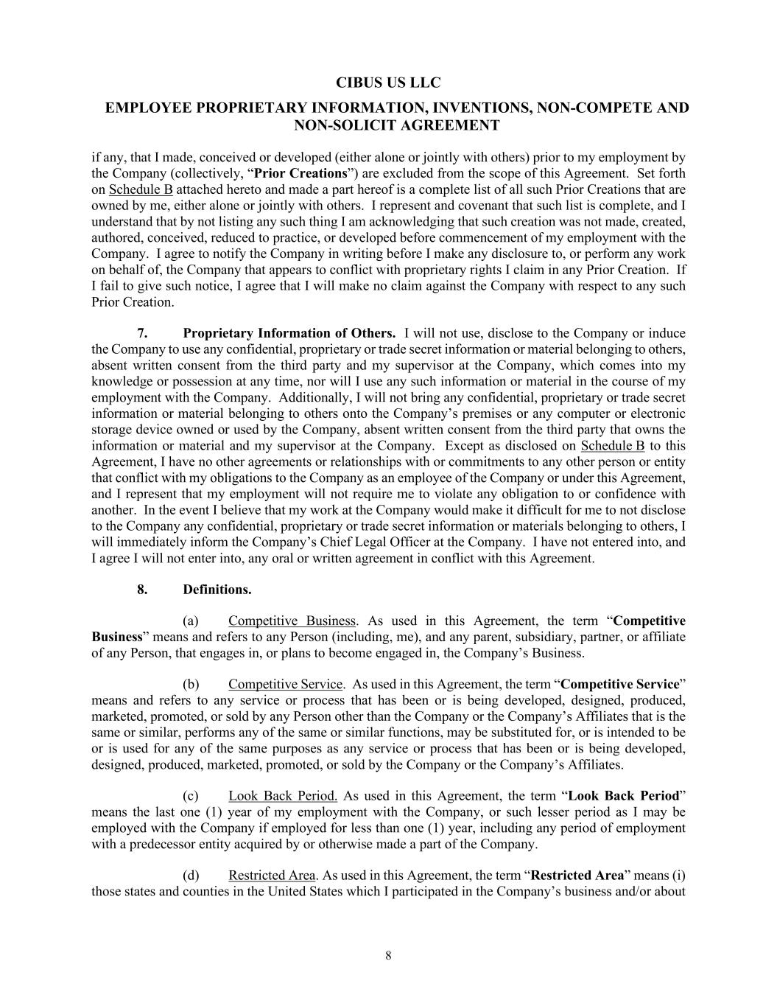
CIBUS US LLC EMPLOYEE PROPRIETARY INFORMATION, INVENTIONS, NON-COMPETE AND NON-SOLICIT AGREEMENT 8 if any, that I made, conceived or developed (either alone or jointly with others) prior to my employment by the Company (collectively, “Prior Creations”) are excluded from the scope of this Agreement. Set forth on Schedule B attached hereto and made a part hereof is a complete list of all such Prior Creations that are owned by me, either alone or jointly with others. I represent and covenant that such list is complete, and I understand that by not listing any such thing I am acknowledging that such creation was not made, created, authored, conceived, reduced to practice, or developed before commencement of my employment with the Company. I agree to notify the Company in writing before I make any disclosure to, or perform any work on behalf of, the Company that appears to conflict with proprietary rights I claim in any Prior Creation. If I fail to give such notice, I agree that I will make no claim against the Company with respect to any such Prior Creation. 7. Proprietary Information of Others. I will not use, disclose to the Company or induce the Company to use any confidential, proprietary or trade secret information or material belonging to others, absent written consent from the third party and my supervisor at the Company, which comes into my knowledge or possession at any time, nor will I use any such information or material in the course of my employment with the Company. Additionally, I will not bring any confidential, proprietary or trade secret information or material belonging to others onto the Company’s premises or any computer or electronic storage device owned or used by the Company, absent written consent from the third party that owns the information or material and my supervisor at the Company. Except as disclosed on Schedule B to this Agreement, I have no other agreements or relationships with or commitments to any other person or entity that conflict with my obligations to the Company as an employee of the Company or under this Agreement, and I represent that my employment will not require me to violate any obligation to or confidence with another. In the event I believe that my work at the Company would make it difficult for me to not disclose to the Company any confidential, proprietary or trade secret information or materials belonging to others, I will immediately inform the Company’s Chief Legal Officer at the Company. I have not entered into, and I agree I will not enter into, any oral or written agreement in conflict with this Agreement. 8. Definitions. (a) Competitive Business. As used in this Agreement, the term “Competitive Business” means and refers to any Person (including, me), and any parent, subsidiary, partner, or affiliate of any Person, that engages in, or plans to become engaged in, the Company’s Business. (b) Competitive Service. As used in this Agreement, the term “Competitive Service” means and refers to any service or process that has been or is being developed, designed, produced, marketed, promoted, or sold by any Person other than the Company or the Company’s Affiliates that is the same or similar, performs any of the same or similar functions, may be substituted for, or is intended to be or is used for any of the same purposes as any service or process that has been or is being developed, designed, produced, marketed, promoted, or sold by the Company or the Company’s Affiliates. (c) Look Back Period. As used in this Agreement, the term “Look Back Period” means the last one (1) year of my employment with the Company, or such lesser period as I may be employed with the Company if employed for less than one (1) year, including any period of employment with a predecessor entity acquired by or otherwise made a part of the Company. (d) Restricted Area. As used in this Agreement, the term “Restricted Area” means (i) those states and counties in the United States which I participated in the Company’s business and/or about

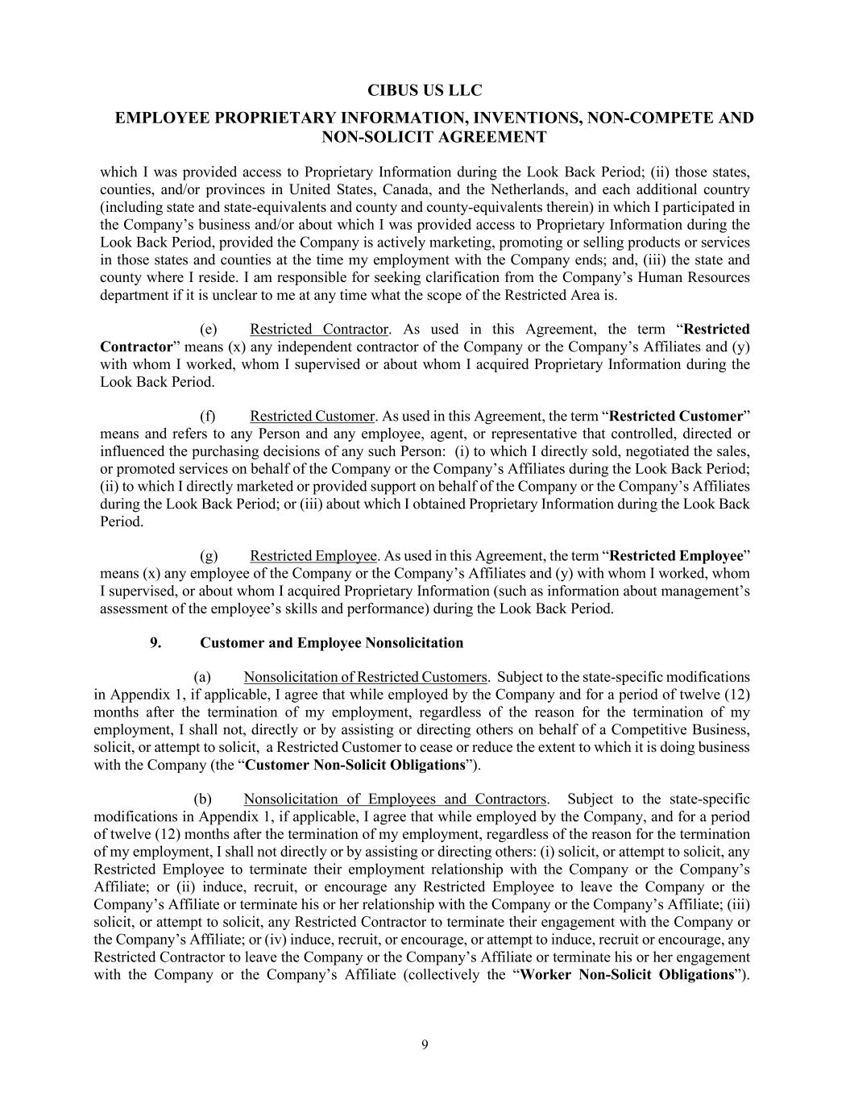
CIBUS US LLC EMPLOYEE PROPRIETARY INFORMATION, INVENTIONS, NON-COMPETE AND NON-SOLICIT AGREEMENT 9 which I was provided access to Proprietary Information during the Look Back Period; (ii) those states, counties, and/or provinces in United States, Canada, and the Netherlands, and each additional country (including state and state-equivalents and county and county-equivalents therein) in which I participated in the Company’s business and/or about which I was provided access to Proprietary Information during the Look Back Period, provided the Company is actively marketing, promoting or selling products or services in those states and counties at the time my employment with the Company ends; and, (iii) the state and county where I reside. I am responsible for seeking clarification from the Company’s Human Resources department if it is unclear to me at any time what the scope of the Restricted Area is. (e) Restricted Contractor. As used in this Agreement, the term “Restricted Contractor” means (x) any independent contractor of the Company or the Company’s Affiliates and (y) with whom I worked, whom I supervised or about whom I acquired Proprietary Information during the Look Back Period. (f) Restricted Customer. As used in this Agreement, the term “Restricted Customer” means and refers to any Person and any employee, agent, or representative that controlled, directed or influenced the purchasing decisions of any such Person: (i) to which I directly sold, negotiated the sales, or promoted services on behalf of the Company or the Company’s Affiliates during the Look Back Period; (ii) to which I directly marketed or provided support on behalf of the Company or the Company’s Affiliates during the Look Back Period; or (iii) about which I obtained Proprietary Information during the Look Back Period. (g) Restricted Employee. As used in this Agreement, the term “Restricted Employee” means (x) any employee of the Company or the Company’s Affiliates and (y) with whom I worked, whom I supervised, or about whom I acquired Proprietary Information (such as information about management’s assessment of the employee’s skills and performance) during the Look Back Period. 9. Customer and Employee Nonsolicitation (a) Nonsolicitation of Restricted Customers. Subject to the state-specific modifications in Appendix 1, if applicable, I agree that while employed by the Company and for a period of twelve (12) months after the termination of my employment, regardless of the reason for the termination of my employment, I shall not, directly or by assisting or directing others on behalf of a Competitive Business, solicit, or attempt to solicit, a Restricted Customer to cease or reduce the extent to which it is doing business with the Company (the “Customer Non-Solicit Obligations”). (b) Nonsolicitation of Employees and Contractors. Subject to the state-specific modifications in Appendix 1, if applicable, I agree that while employed by the Company, and for a period of twelve (12) months after the termination of my employment, regardless of the reason for the termination of my employment, I shall not directly or by assisting or directing others: (i) solicit, or attempt to solicit, any Restricted Employee to terminate their employment relationship with the Company or the Company’s Affiliate; or (ii) induce, recruit, or encourage any Restricted Employee to leave the Company or the Company’s Affiliate or terminate his or her relationship with the Company or the Company’s Affiliate; (iii) solicit, or attempt to solicit, any Restricted Contractor to terminate their engagement with the Company or the Company’s Affiliate; or (iv) induce, recruit, or encourage, or attempt to induce, recruit or encourage, any Restricted Contractor to leave the Company or the Company’s Affiliate or terminate his or her engagement with the Company or the Company’s Affiliate (collectively the “Worker Non-Solicit Obligations”).

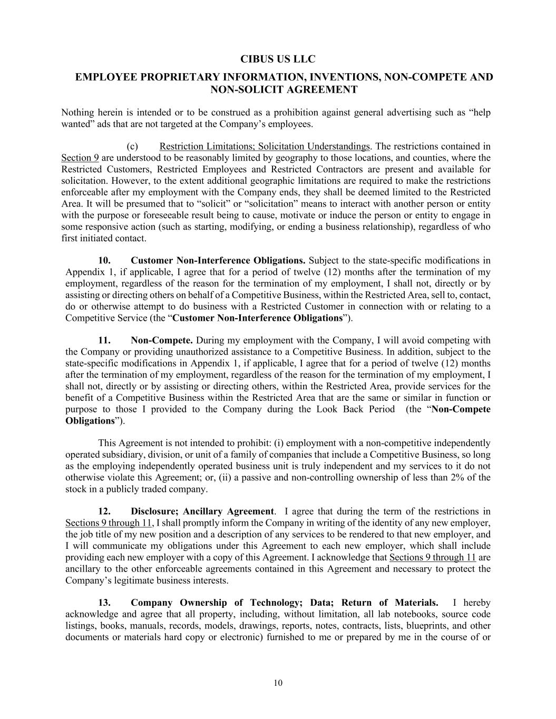
CIBUS US LLC EMPLOYEE PROPRIETARY INFORMATION, INVENTIONS, NON-COMPETE AND NON-SOLICIT AGREEMENT 10 Nothing herein is intended or to be construed as a prohibition against general advertising such as “help wanted” ads that are not targeted at the Company’s employees. (c) Restriction Limitations; Solicitation Understandings. The restrictions contained in Section 9 are understood to be reasonably limited by geography to those locations, and counties, where the Restricted Customers, Restricted Employees and Restricted Contractors are present and available for solicitation. However, to the extent additional geographic limitations are required to make the restrictions enforceable after my employment with the Company ends, they shall be deemed limited to the Restricted Area. It will be presumed that to “solicit” or “solicitation” means to interact with another person or entity with the purpose or foreseeable result being to cause, motivate or induce the person or entity to engage in some responsive action (such as starting, modifying, or ending a business relationship), regardless of who first initiated contact. 10. Customer Non-Interference Obligations. Subject to the state-specific modifications in Appendix 1, if applicable, I agree that for a period of twelve (12) months after the termination of my employment, regardless of the reason for the termination of my employment, I shall not, directly or by assisting or directing others on behalf of a Competitive Business, within the Restricted Area, sell to, contact, do or otherwise attempt to do business with a Restricted Customer in connection with or relating to a Competitive Service (the “Customer Non-Interference Obligations”). 11. Non-Compete. During my employment with the Company, I will avoid competing with the Company or providing unauthorized assistance to a Competitive Business. In addition, subject to the state-specific modifications in Appendix 1, if applicable, I agree that for a period of twelve (12) months after the termination of my employment, regardless of the reason for the termination of my employment, I shall not, directly or by assisting or directing others, within the Restricted Area, provide services for the benefit of a Competitive Business within the Restricted Area that are the same or similar in function or purpose to those I provided to the Company during the Look Back Period (the “Non-Compete Obligations”). This Agreement is not intended to prohibit: (i) employment with a non-competitive independently operated subsidiary, division, or unit of a family of companies that include a Competitive Business, so long as the employing independently operated business unit is truly independent and my services to it do not otherwise violate this Agreement; or, (ii) a passive and non-controlling ownership of less than 2% of the stock in a publicly traded company. 12. Disclosure; Ancillary Agreement. I agree that during the term of the restrictions in Sections 9 through 11, I shall promptly inform the Company in writing of the identity of any new employer, the job title of my new position and a description of any services to be rendered to that new employer, and I will communicate my obligations under this Agreement to each new employer, which shall include providing each new employer with a copy of this Agreement. I acknowledge that Sections 9 through 11 are ancillary to the other enforceable agreements contained in this Agreement and necessary to protect the Company’s legitimate business interests. 13. Company Ownership of Technology; Data; Return of Materials. I hereby acknowledge and agree that all property, including, without limitation, all lab notebooks, source code listings, books, manuals, records, models, drawings, reports, notes, contracts, lists, blueprints, and other documents or materials hard copy or electronic) furnished to me or prepared by me in the course of or

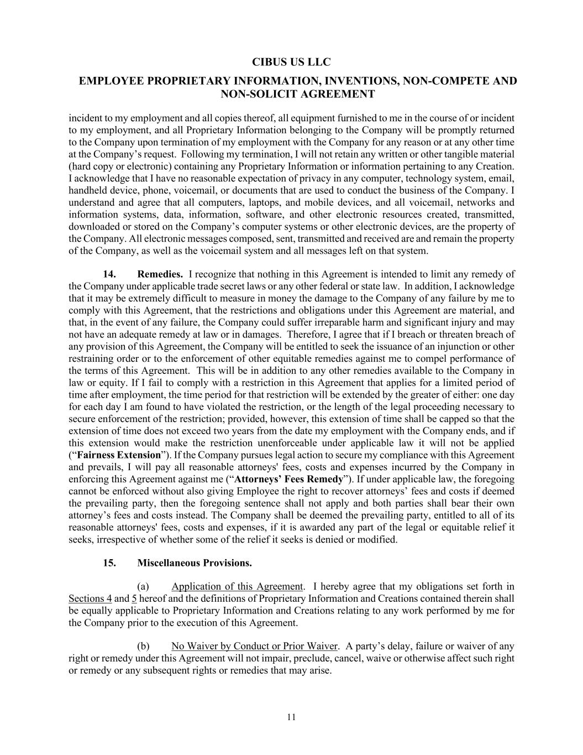
CIBUS US LLC EMPLOYEE PROPRIETARY INFORMATION, INVENTIONS, NON-COMPETE AND NON-SOLICIT AGREEMENT 11 incident to my employment and all copies thereof, all equipment furnished to me in the course of or incident to my employment, and all Proprietary Information belonging to the Company will be promptly returned to the Company upon termination of my employment with the Company for any reason or at any other time at the Company’s request. Following my termination, I will not retain any written or other tangible material (hard copy or electronic) containing any Proprietary Information or information pertaining to any Creation. I acknowledge that I have no reasonable expectation of privacy in any computer, technology system, email, handheld device, phone, voicemail, or documents that are used to conduct the business of the Company. I understand and agree that all computers, laptops, and mobile devices, and all voicemail, networks and information systems, data, information, software, and other electronic resources created, transmitted, downloaded or stored on the Company’s computer systems or other electronic devices, are the property of the Company. All electronic messages composed, sent, transmitted and received are and remain the property of the Company, as well as the voicemail system and all messages left on that system. 14. Remedies. I recognize that nothing in this Agreement is intended to limit any remedy of the Company under applicable trade secret laws or any other federal or state law. In addition, I acknowledge that it may be extremely difficult to measure in money the damage to the Company of any failure by me to comply with this Agreement, that the restrictions and obligations under this Agreement are material, and that, in the event of any failure, the Company could suffer irreparable harm and significant injury and may not have an adequate remedy at law or in damages. Therefore, I agree that if I breach or threaten breach of any provision of this Agreement, the Company will be entitled to seek the issuance of an injunction or other restraining order or to the enforcement of other equitable remedies against me to compel performance of the terms of this Agreement. This will be in addition to any other remedies available to the Company in law or equity. If I fail to comply with a restriction in this Agreement that applies for a limited period of time after employment, the time period for that restriction will be extended by the greater of either: one day for each day I am found to have violated the restriction, or the length of the legal proceeding necessary to secure enforcement of the restriction; provided, however, this extension of time shall be capped so that the extension of time does not exceed two years from the date my employment with the Company ends, and if this extension would make the restriction unenforceable under applicable law it will not be applied (“Fairness Extension”). If the Company pursues legal action to secure my compliance with this Agreement and prevails, I will pay all reasonable attorneys' fees, costs and expenses incurred by the Company in enforcing this Agreement against me (“Attorneys’ Fees Remedy”). If under applicable law, the foregoing cannot be enforced without also giving Employee the right to recover attorneys’ fees and costs if deemed the prevailing party, then the foregoing sentence shall not apply and both parties shall bear their own attorney’s fees and costs instead. The Company shall be deemed the prevailing party, entitled to all of its reasonable attorneys' fees, costs and expenses, if it is awarded any part of the legal or equitable relief it seeks, irrespective of whether some of the relief it seeks is denied or modified. 15. Miscellaneous Provisions. (a) Application of this Agreement. I hereby agree that my obligations set forth in Sections 4 and 5 hereof and the definitions of Proprietary Information and Creations contained therein shall be equally applicable to Proprietary Information and Creations relating to any work performed by me for the Company prior to the execution of this Agreement. (b) No Waiver by Conduct or Prior Waiver. A party’s delay, failure or waiver of any right or remedy under this Agreement will not impair, preclude, cancel, waive or otherwise affect such right or remedy or any subsequent rights or remedies that may arise.

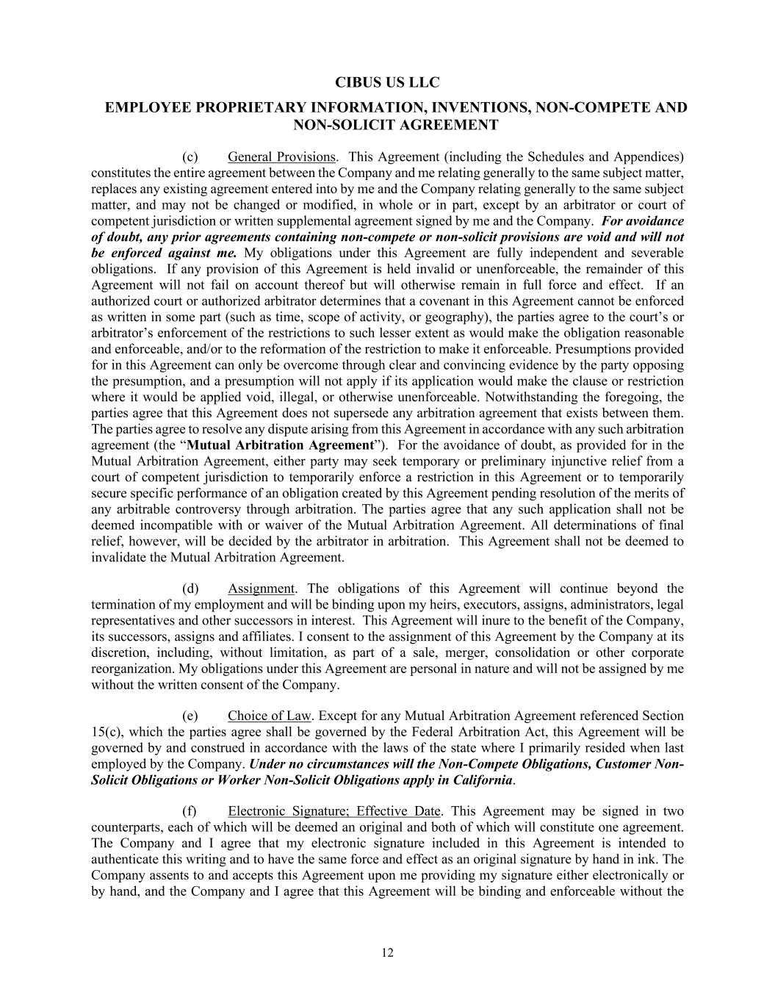
CIBUS US LLC EMPLOYEE PROPRIETARY INFORMATION, INVENTIONS, NON-COMPETE AND NON-SOLICIT AGREEMENT 12 (c) General Provisions. This Agreement (including the Schedules and Appendices) constitutes the entire agreement between the Company and me relating generally to the same subject matter, replaces any existing agreement entered into by me and the Company relating generally to the same subject matter, and may not be changed or modified, in whole or in part, except by an arbitrator or court of competent jurisdiction or written supplemental agreement signed by me and the Company. For avoidance of doubt, any prior agreements containing non-compete or non-solicit provisions are void and will not be enforced against me. My obligations under this Agreement are fully independent and severable obligations. If any provision of this Agreement is held invalid or unenforceable, the remainder of this Agreement will not fail on account thereof but will otherwise remain in full force and effect. If an authorized court or authorized arbitrator determines that a covenant in this Agreement cannot be enforced as written in some part (such as time, scope of activity, or geography), the parties agree to the court’s or arbitrator’s enforcement of the restrictions to such lesser extent as would make the obligation reasonable and enforceable, and/or to the reformation of the restriction to make it enforceable. Presumptions provided for in this Agreement can only be overcome through clear and convincing evidence by the party opposing the presumption, and a presumption will not apply if its application would make the clause or restriction where it would be applied void, illegal, or otherwise unenforceable. Notwithstanding the foregoing, the parties agree that this Agreement does not supersede any arbitration agreement that exists between them. The parties agree to resolve any dispute arising from this Agreement in accordance with any such arbitration agreement (the “Mutual Arbitration Agreement”). For the avoidance of doubt, as provided for in the Mutual Arbitration Agreement, either party may seek temporary or preliminary injunctive relief from a court of competent jurisdiction to temporarily enforce a restriction in this Agreement or to temporarily secure specific performance of an obligation created by this Agreement pending resolution of the merits of any arbitrable controversy through arbitration. The parties agree that any such application shall not be deemed incompatible with or waiver of the Mutual Arbitration Agreement. All determinations of final relief, however, will be decided by the arbitrator in arbitration. This Agreement shall not be deemed to invalidate the Mutual Arbitration Agreement. (d) Assignment. The obligations of this Agreement will continue beyond the termination of my employment and will be binding upon my heirs, executors, assigns, administrators, legal representatives and other successors in interest. This Agreement will inure to the benefit of the Company, its successors, assigns and affiliates. I consent to the assignment of this Agreement by the Company at its discretion, including, without limitation, as part of a sale, merger, consolidation or other corporate reorganization. My obligations under this Agreement are personal in nature and will not be assigned by me without the written consent of the Company. (e) Choice of Law. Except for any Mutual Arbitration Agreement referenced Section 15(c), which the parties agree shall be governed by the Federal Arbitration Act, this Agreement will be governed by and construed in accordance with the laws of the state where I primarily resided when last employed by the Company. Under no circumstances will the Non-Compete Obligations, Customer Non- Solicit Obligations or Worker Non-Solicit Obligations apply in California. (f) Electronic Signature; Effective Date. This Agreement may be signed in two counterparts, each of which will be deemed an original and both of which will constitute one agreement. The Company and I agree that my electronic signature included in this Agreement is intended to authenticate this writing and to have the same force and effect as an original signature by hand in ink. The Company assents to and accepts this Agreement upon me providing my signature either electronically or by hand, and the Company and I agree that this Agreement will be binding and enforceable without the

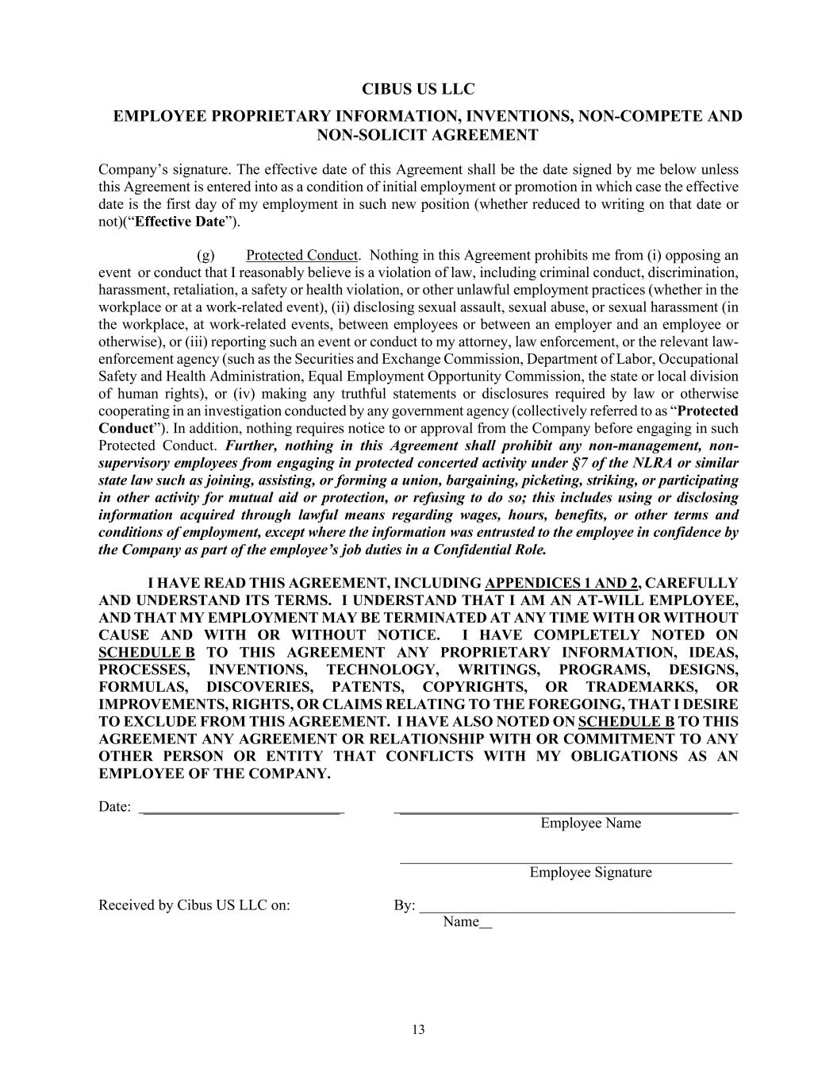
CIBUS US LLC EMPLOYEE PROPRIETARY INFORMATION, INVENTIONS, NON-COMPETE AND NON-SOLICIT AGREEMENT 13 Company’s signature. The effective date of this Agreement shall be the date signed by me below unless this Agreement is entered into as a condition of initial employment or promotion in which case the effective date is the first day of my employment in such new position (whether reduced to writing on that date or not)(“Effective Date”). (g) Protected Conduct. Nothing in this Agreement prohibits me from (i) opposing an event or conduct that I reasonably believe is a violation of law, including criminal conduct, discrimination, harassment, retaliation, a safety or health violation, or other unlawful employment practices (whether in the workplace or at a work-related event), (ii) disclosing sexual assault, sexual abuse, or sexual harassment (in the workplace, at work-related events, between employees or between an employer and an employee or otherwise), or (iii) reporting such an event or conduct to my attorney, law enforcement, or the relevant law- enforcement agency (such as the Securities and Exchange Commission, Department of Labor, Occupational Safety and Health Administration, Equal Employment Opportunity Commission, the state or local division of human rights), or (iv) making any truthful statements or disclosures required by law or otherwise cooperating in an investigation conducted by any government agency (collectively referred to as “Protected Conduct”). In addition, nothing requires notice to or approval from the Company before engaging in such Protected Conduct. Further, nothing in this Agreement shall prohibit any non-management, non- supervisory employees from engaging in protected concerted activity under §7 of the NLRA or similar state law such as joining, assisting, or forming a union, bargaining, picketing, striking, or participating in other activity for mutual aid or protection, or refusing to do so; this includes using or disclosing information acquired through lawful means regarding wages, hours, benefits, or other terms and conditions of employment, except where the information was entrusted to the employee in confidence by the Company as part of the employee’s job duties in a Confidential Role. I HAVE READ THIS AGREEMENT, INCLUDING APPENDICES 1 AND 2, CAREFULLY AND UNDERSTAND ITS TERMS. I UNDERSTAND THAT I AM AN AT-WILL EMPLOYEE, AND THAT MY EMPLOYMENT MAY BE TERMINATED AT ANY TIME WITH OR WITHOUT CAUSE AND WITH OR WITHOUT NOTICE. I HAVE COMPLETELY NOTED ON SCHEDULE B TO THIS AGREEMENT ANY PROPRIETARY INFORMATION, IDEAS, PROCESSES, INVENTIONS, TECHNOLOGY, WRITINGS, PROGRAMS, DESIGNS, FORMULAS, DISCOVERIES, PATENTS, COPYRIGHTS, OR TRADEMARKS, OR IMPROVEMENTS, RIGHTS, OR CLAIMS RELATING TO THE FOREGOING, THAT I DESIRE TO EXCLUDE FROM THIS AGREEMENT. I HAVE ALSO NOTED ON SCHEDULE B TO THIS AGREEMENT ANY AGREEMENT OR RELATIONSHIP WITH OR COMMITMENT TO ANY OTHER PERSON OR ENTITY THAT CONFLICTS WITH MY OBLIGATIONS AS AN EMPLOYEE OF THE COMPANY. Date: __________________________ ____________________________________________ Employee Name ____________________________________________ Employee Signature Received by Cibus US LLC on: By: __________________________________________ Name

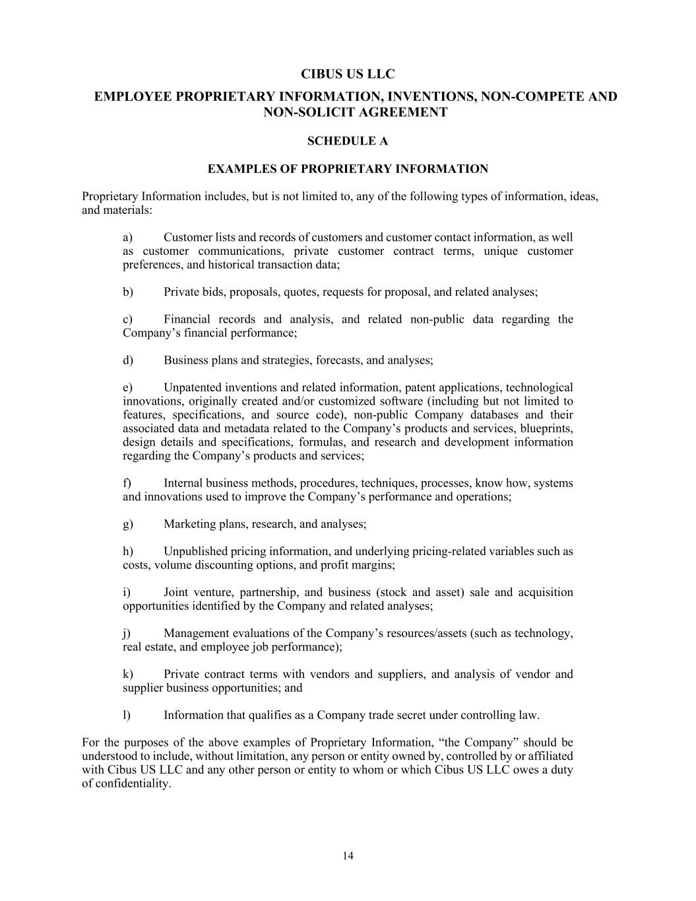
CIBUS US LLC EMPLOYEE PROPRIETARY INFORMATION, INVENTIONS, NON-COMPETE AND NON-SOLICIT AGREEMENT 14 SCHEDULE A EXAMPLES OF PROPRIETARY INFORMATION Proprietary Information includes, but is not limited to, any of the following types of information, ideas, and materials: a) Customer lists and records of customers and customer contact information, as well as customer communications, private customer contract terms, unique customer preferences, and historical transaction data; b) Private bids, proposals, quotes, requests for proposal, and related analyses; c) Financial records and analysis, and related non-public data regarding the Company’s financial performance; d) Business plans and strategies, forecasts, and analyses; e) Unpatented inventions and related information, patent applications, technological innovations, originally created and/or customized software (including but not limited to features, specifications, and source code), non-public Company databases and their associated data and metadata related to the Company’s products and services, blueprints, design details and specifications, formulas, and research and development information regarding the Company’s products and services; f) Internal business methods, procedures, techniques, processes, know how, systems and innovations used to improve the Company’s performance and operations; g) Marketing plans, research, and analyses; h) Unpublished pricing information, and underlying pricing-related variables such as costs, volume discounting options, and profit margins; i) Joint venture, partnership, and business (stock and asset) sale and acquisition opportunities identified by the Company and related analyses; j) Management evaluations of the Company’s resources/assets (such as technology, real estate, and employee job performance); k) Private contract terms with vendors and suppliers, and analysis of vendor and supplier business opportunities; and l) Information that qualifies as a Company trade secret under controlling law. For the purposes of the above examples of Proprietary Information, “the Company” should be understood to include, without limitation, any person or entity owned by, controlled by or affiliated with Cibus US LLC and any other person or entity to whom or which Cibus US LLC owes a duty of confidentiality.

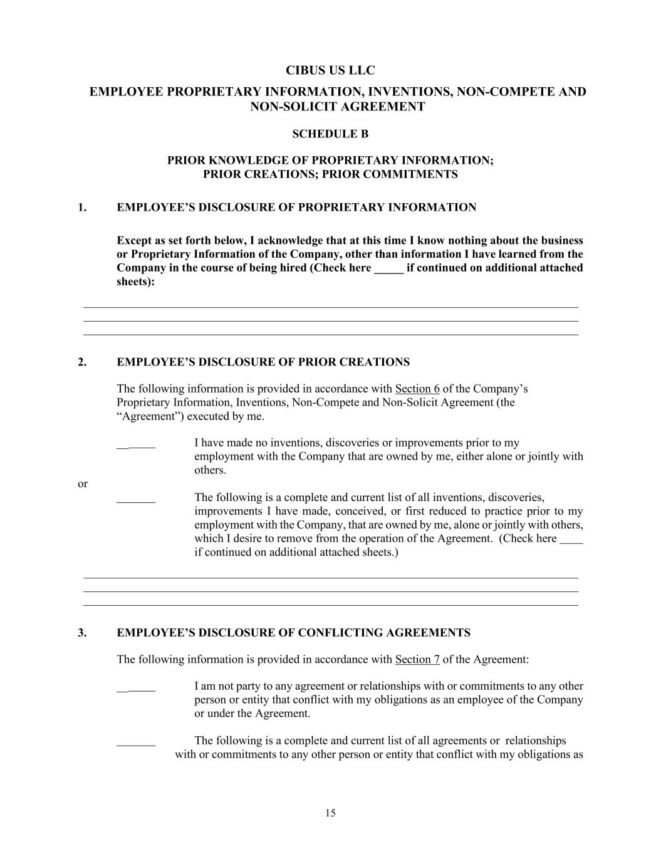
CIBUS US LLC EMPLOYEE PROPRIETARY INFORMATION, INVENTIONS, NON-COMPETE AND NON-SOLICIT AGREEMENT 15 SCHEDULE B PRIOR KNOWLEDGE OF PROPRIETARY INFORMATION; PRIOR CREATIONS; PRIOR COMMITMENTS 1. EMPLOYEE’S DISCLOSURE OF PROPRIETARY INFORMATION Except as set forth below, I acknowledge that at this time I know nothing about the business or Proprietary Information of the Company, other than information I have learned from the Company in the course of being hired (Check here _____ if continued on additional attached sheets): ___________________________________________________________________________________ ___________________________________________________________________________________ ___________________________________________________________________________________ 2. EMPLOYEE’S DISCLOSURE OF PRIOR CREATIONS The following information is provided in accordance with Section 6 of the Company’s Proprietary Information, Inventions, Non-Compete and Non-Solicit Agreement (the “Agreement”) executed by me. __ I have made no inventions, discoveries or improvements prior to my employment with the Company that are owned by me, either alone or jointly with others. or The following is a complete and current list of all inventions, discoveries, improvements I have made, conceived, or first reduced to practice prior to my employment with the Company, that are owned by me, alone or jointly with others, which I desire to remove from the operation of the Agreement. (Check here if continued on additional attached sheets.) ___________________________________________________________________________________ ___________________________________________________________________________________ ___________________________________________________________________________________ 3. EMPLOYEE’S DISCLOSURE OF CONFLICTING AGREEMENTS The following information is provided in accordance with Section 7 of the Agreement: __ I am not party to any agreement or relationships with or commitments to any other person or entity that conflict with my obligations as an employee of the Company or under the Agreement. The following is a complete and current list of all agreements or relationships with or commitments to any other person or entity that conflict with my obligations as

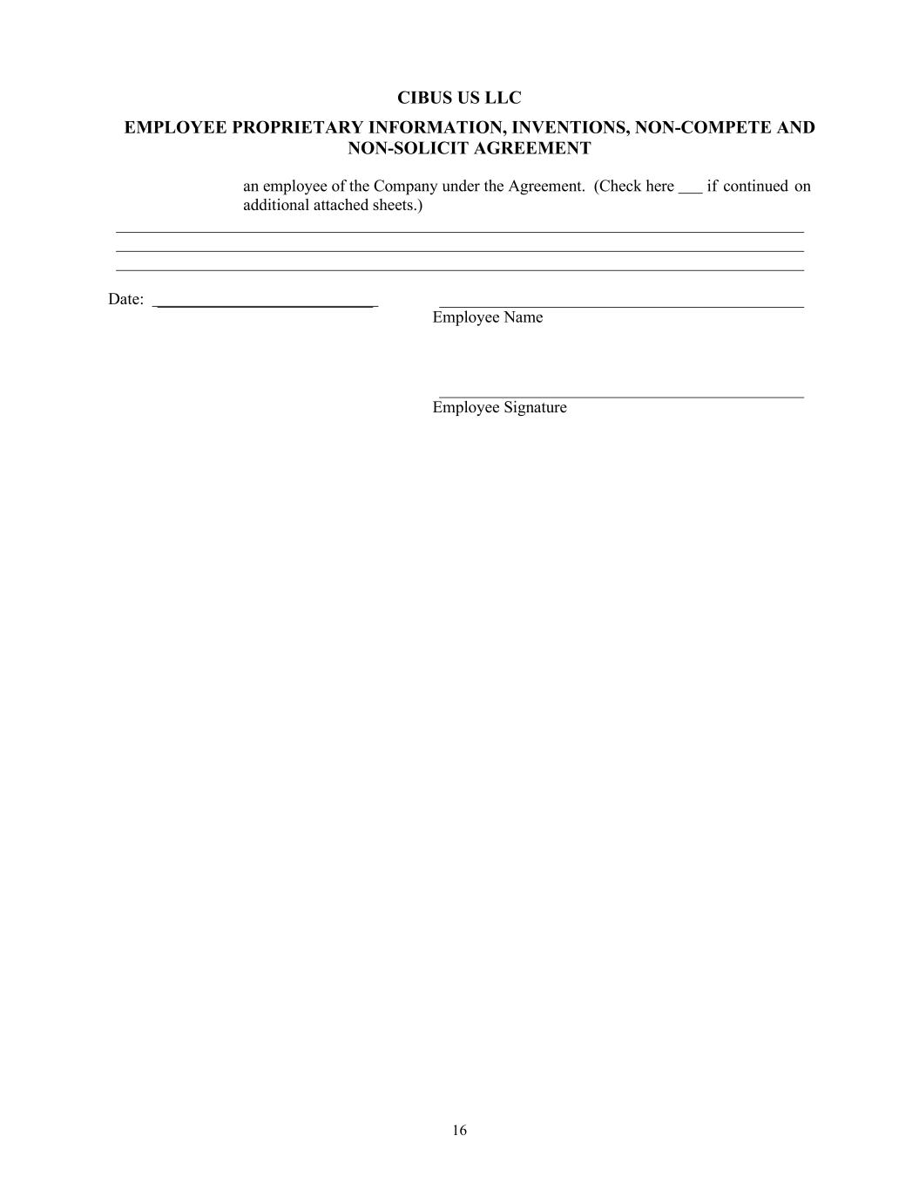
CIBUS US LLC EMPLOYEE PROPRIETARY INFORMATION, INVENTIONS, NON-COMPETE AND NON-SOLICIT AGREEMENT 16 an employee of the Company under the Agreement. (Check here if continued on additional attached sheets.) ___________________________________________________________________________________ ___________________________________________________________________________________ ___________________________________________________________________________________ Date: __________________________ ____________________________________________ Employee Name ____________________________________________ Employee Signature

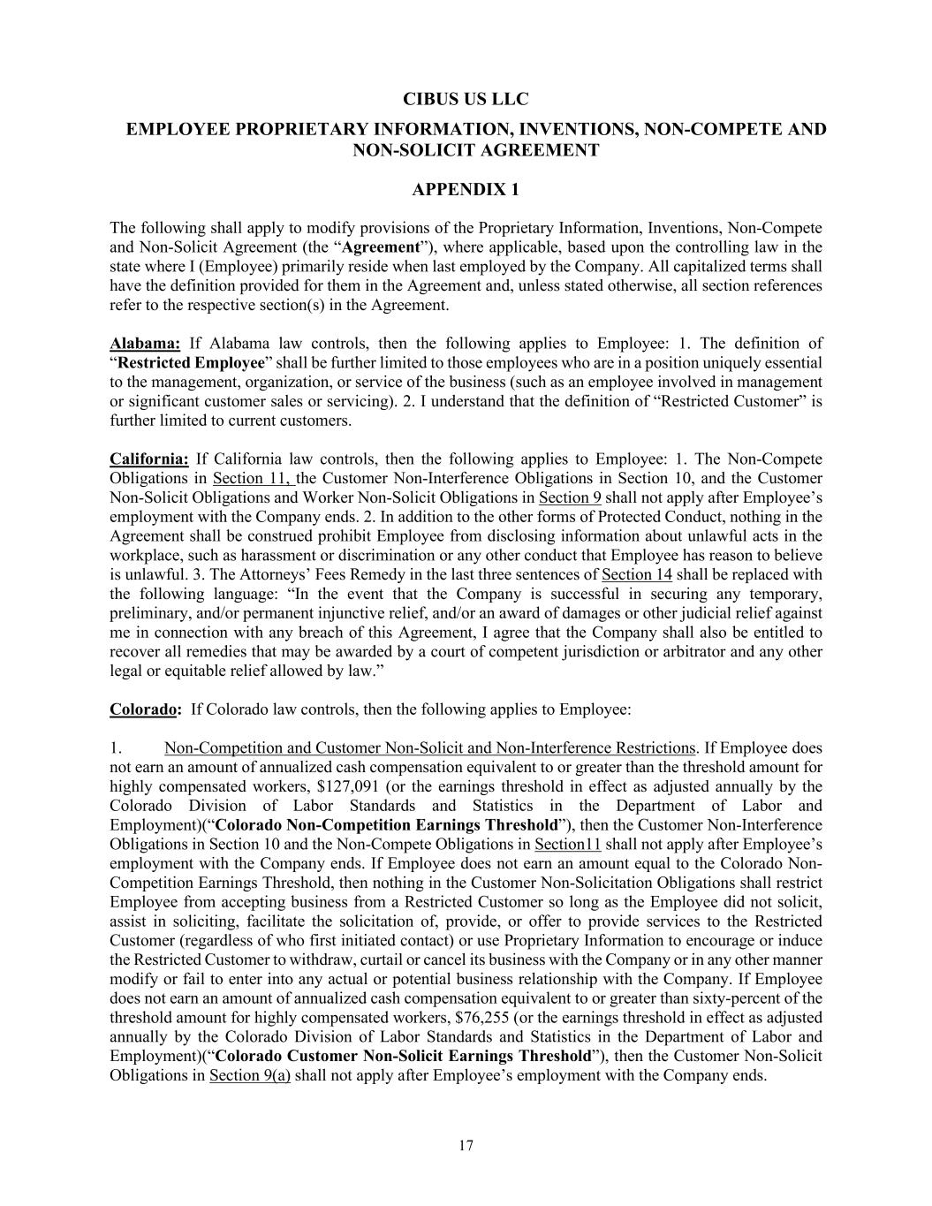
CIBUS US LLC EMPLOYEE PROPRIETARY INFORMATION, INVENTIONS, NON-COMPETE AND NON-SOLICIT AGREEMENT 17 APPENDIX 1 The following shall apply to modify provisions of the Proprietary Information, Inventions, Non-Compete and Non-Solicit Agreement (the “Agreement”), where applicable, based upon the controlling law in the state where I (Employee) primarily reside when last employed by the Company. All capitalized terms shall have the definition provided for them in the Agreement and, unless stated otherwise, all section references refer to the respective section(s) in the Agreement. Alabama: If Alabama law controls, then the following applies to Employee: 1. The definition of “Restricted Employee” shall be further limited to those employees who are in a position uniquely essential to the management, organization, or service of the business (such as an employee involved in management or significant customer sales or servicing). 2. I understand that the definition of “Restricted Customer” is further limited to current customers. California: If California law controls, then the following applies to Employee: 1. The Non-Compete Obligations in Section 11, the Customer Non-Interference Obligations in Section 10, and the Customer Non-Solicit Obligations and Worker Non-Solicit Obligations in Section 9 shall not apply after Employee’s employment with the Company ends. 2. In addition to the other forms of Protected Conduct, nothing in the Agreement shall be construed prohibit Employee from disclosing information about unlawful acts in the workplace, such as harassment or discrimination or any other conduct that Employee has reason to believe is unlawful. 3. The Attorneys’ Fees Remedy in the last three sentences of Section 14 shall be replaced with the following language: “In the event that the Company is successful in securing any temporary, preliminary, and/or permanent injunctive relief, and/or an award of damages or other judicial relief against me in connection with any breach of this Agreement, I agree that the Company shall also be entitled to recover all remedies that may be awarded by a court of competent jurisdiction or arbitrator and any other legal or equitable relief allowed by law.” Colorado: If Colorado law controls, then the following applies to Employee: 1. Non-Competition and Customer Non-Solicit and Non-Interference Restrictions. If Employee does not earn an amount of annualized cash compensation equivalent to or greater than the threshold amount for highly compensated workers, $127,091 (or the earnings threshold in effect as adjusted annually by the Colorado Division of Labor Standards and Statistics in the Department of Labor and Employment)(“Colorado Non-Competition Earnings Threshold”), then the Customer Non-Interference Obligations in Section 10 and the Non-Compete Obligations in Section11 shall not apply after Employee’s employment with the Company ends. If Employee does not earn an amount equal to the Colorado Non- Competition Earnings Threshold, then nothing in the Customer Non-Solicitation Obligations shall restrict Employee from accepting business from a Restricted Customer so long as the Employee did not solicit, assist in soliciting, facilitate the solicitation of, provide, or offer to provide services to the Restricted Customer (regardless of who first initiated contact) or use Proprietary Information to encourage or induce the Restricted Customer to withdraw, curtail or cancel its business with the Company or in any other manner modify or fail to enter into any actual or potential business relationship with the Company. If Employee does not earn an amount of annualized cash compensation equivalent to or greater than sixty-percent of the threshold amount for highly compensated workers, $76,255 (or the earnings threshold in effect as adjusted annually by the Colorado Division of Labor Standards and Statistics in the Department of Labor and Employment)(“Colorado Customer Non-Solicit Earnings Threshold”), then the Customer Non-Solicit Obligations in Section 9(a) shall not apply after Employee’s employment with the Company ends.

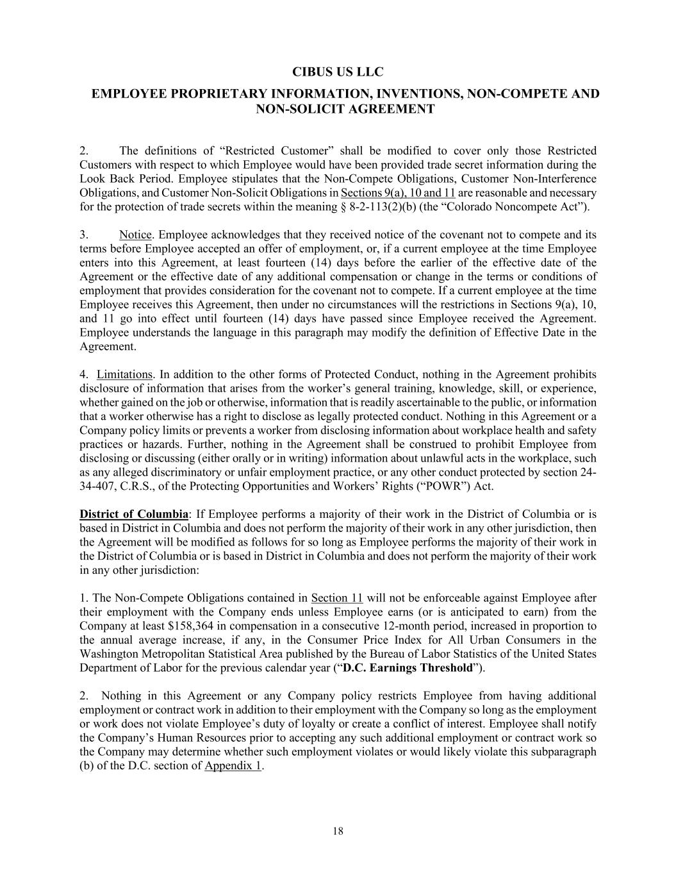
CIBUS US LLC EMPLOYEE PROPRIETARY INFORMATION, INVENTIONS, NON-COMPETE AND NON-SOLICIT AGREEMENT 18 2. The definitions of “Restricted Customer” shall be modified to cover only those Restricted Customers with respect to which Employee would have been provided trade secret information during the Look Back Period. Employee stipulates that the Non-Compete Obligations, Customer Non-Interference Obligations, and Customer Non-Solicit Obligations in Sections 9(a), 10 and 11 are reasonable and necessary for the protection of trade secrets within the meaning § 8-2-113(2)(b) (the “Colorado Noncompete Act”). 3. Notice. Employee acknowledges that they received notice of the covenant not to compete and its terms before Employee accepted an offer of employment, or, if a current employee at the time Employee enters into this Agreement, at least fourteen (14) days before the earlier of the effective date of the Agreement or the effective date of any additional compensation or change in the terms or conditions of employment that provides consideration for the covenant not to compete. If a current employee at the time Employee receives this Agreement, then under no circumstances will the restrictions in Sections 9(a), 10, and 11 go into effect until fourteen (14) days have passed since Employee received the Agreement. Employee understands the language in this paragraph may modify the definition of Effective Date in the Agreement. 4. Limitations. In addition to the other forms of Protected Conduct, nothing in the Agreement prohibits disclosure of information that arises from the worker’s general training, knowledge, skill, or experience, whether gained on the job or otherwise, information that is readily ascertainable to the public, or information that a worker otherwise has a right to disclose as legally protected conduct. Nothing in this Agreement or a Company policy limits or prevents a worker from disclosing information about workplace health and safety practices or hazards. Further, nothing in the Agreement shall be construed to prohibit Employee from disclosing or discussing (either orally or in writing) information about unlawful acts in the workplace, such as any alleged discriminatory or unfair employment practice, or any other conduct protected by section 24- 34-407, C.R.S., of the Protecting Opportunities and Workers’ Rights (“POWR”) Act. District of Columbia: If Employee performs a majority of their work in the District of Columbia or is based in District in Columbia and does not perform the majority of their work in any other jurisdiction, then the Agreement will be modified as follows for so long as Employee performs the majority of their work in the District of Columbia or is based in District in Columbia and does not perform the majority of their work in any other jurisdiction: 1. The Non-Compete Obligations contained in Section 11 will not be enforceable against Employee after their employment with the Company ends unless Employee earns (or is anticipated to earn) from the Company at least $158,364 in compensation in a consecutive 12-month period, increased in proportion to the annual average increase, if any, in the Consumer Price Index for All Urban Consumers in the Washington Metropolitan Statistical Area published by the Bureau of Labor Statistics of the United States Department of Labor for the previous calendar year (“D.C. Earnings Threshold”). 2. Nothing in this Agreement or any Company policy restricts Employee from having additional employment or contract work in addition to their employment with the Company so long as the employment or work does not violate Employee’s duty of loyalty or create a conflict of interest. Employee shall notify the Company’s Human Resources prior to accepting any such additional employment or contract work so the Company may determine whether such employment violates or would likely violate this subparagraph (b) of the D.C. section of Appendix 1.

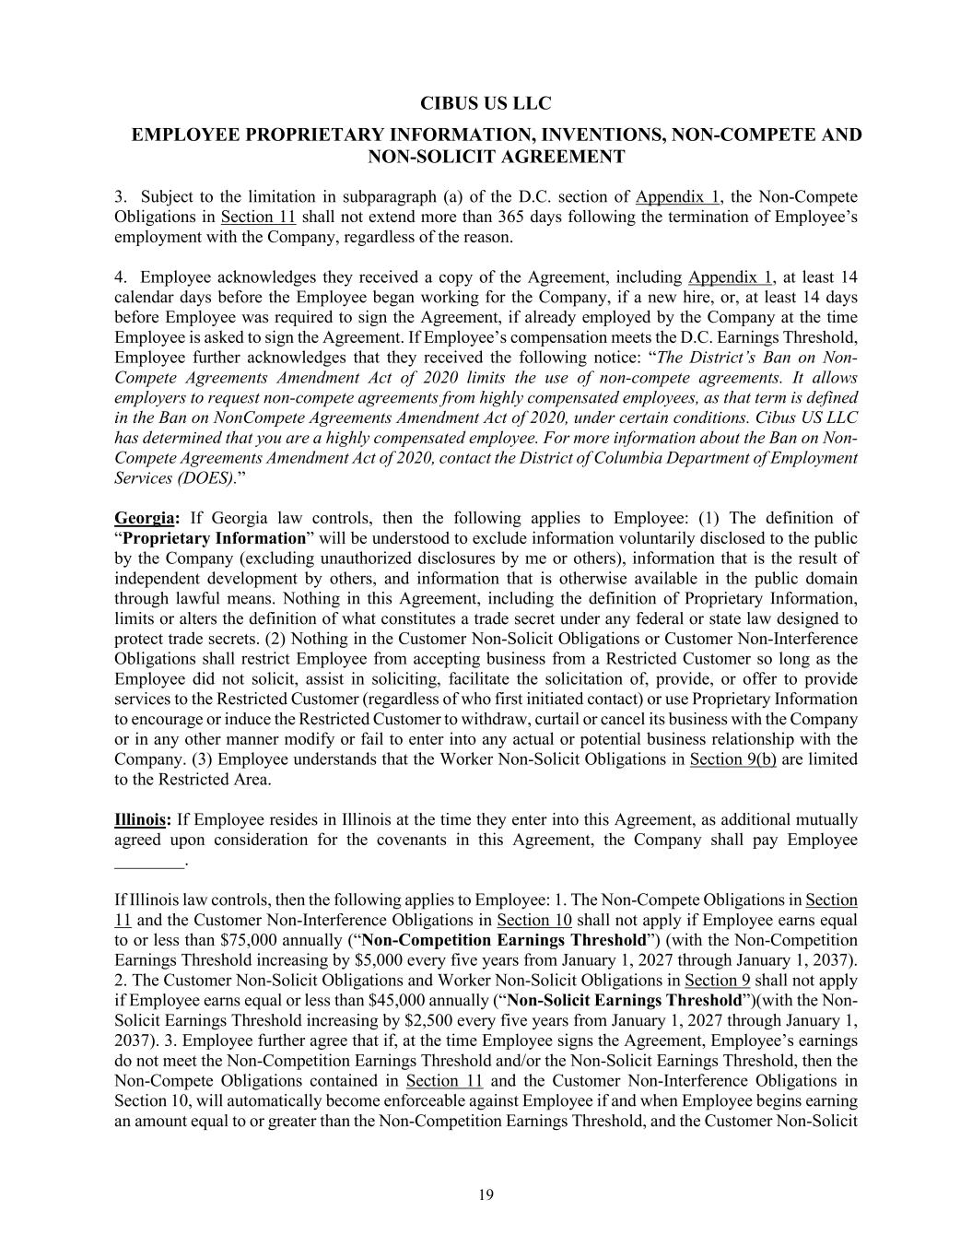
CIBUS US LLC EMPLOYEE PROPRIETARY INFORMATION, INVENTIONS, NON-COMPETE AND NON-SOLICIT AGREEMENT 19 3. Subject to the limitation in subparagraph (a) of the D.C. section of Appendix 1, the Non-Compete Obligations in Section 11 shall not extend more than 365 days following the termination of Employee’s employment with the Company, regardless of the reason. 4. Employee acknowledges they received a copy of the Agreement, including Appendix 1, at least 14 calendar days before the Employee began working for the Company, if a new hire, or, at least 14 days before Employee was required to sign the Agreement, if already employed by the Company at the time Employee is asked to sign the Agreement. If Employee’s compensation meets the D.C. Earnings Threshold, Employee further acknowledges that they received the following notice: “The District’s Ban on Non- Compete Agreements Amendment Act of 2020 limits the use of non-compete agreements. It allows employers to request non-compete agreements from highly compensated employees, as that term is defined in the Ban on NonCompete Agreements Amendment Act of 2020, under certain conditions. Cibus US LLC has determined that you are a highly compensated employee. For more information about the Ban on Non- Compete Agreements Amendment Act of 2020, contact the District of Columbia Department of Employment Services (DOES).” Georgia: If Georgia law controls, then the following applies to Employee: (1) The definition of “Proprietary Information” will be understood to exclude information voluntarily disclosed to the public by the Company (excluding unauthorized disclosures by me or others), information that is the result of independent development by others, and information that is otherwise available in the public domain through lawful means. Nothing in this Agreement, including the definition of Proprietary Information, limits or alters the definition of what constitutes a trade secret under any federal or state law designed to protect trade secrets. (2) Nothing in the Customer Non-Solicit Obligations or Customer Non-Interference Obligations shall restrict Employee from accepting business from a Restricted Customer so long as the Employee did not solicit, assist in soliciting, facilitate the solicitation of, provide, or offer to provide services to the Restricted Customer (regardless of who first initiated contact) or use Proprietary Information to encourage or induce the Restricted Customer to withdraw, curtail or cancel its business with the Company or in any other manner modify or fail to enter into any actual or potential business relationship with the Company. (3) Employee understands that the Worker Non-Solicit Obligations in Section 9(b) are limited to the Restricted Area. Illinois: If Employee resides in Illinois at the time they enter into this Agreement, as additional mutually agreed upon consideration for the covenants in this Agreement, the Company shall pay Employee ________. If Illinois law controls, then the following applies to Employee: 1. The Non-Compete Obligations in Section 11 and the Customer Non-Interference Obligations in Section 10 shall not apply if Employee earns equal to or less than $75,000 annually (“Non-Competition Earnings Threshold”) (with the Non-Competition Earnings Threshold increasing by $5,000 every five years from January 1, 2027 through January 1, 2037). 2. The Customer Non-Solicit Obligations and Worker Non-Solicit Obligations in Section 9 shall not apply if Employee earns equal or less than $45,000 annually (“Non-Solicit Earnings Threshold”)(with the Non- Solicit Earnings Threshold increasing by $2,500 every five years from January 1, 2027 through January 1, 2037). 3. Employee further agree that if, at the time Employee signs the Agreement, Employee’s earnings do not meet the Non-Competition Earnings Threshold and/or the Non-Solicit Earnings Threshold, then the Non-Compete Obligations contained in Section 11 and the Customer Non-Interference Obligations in Section 10, will automatically become enforceable against Employee if and when Employee begins earning an amount equal to or greater than the Non-Competition Earnings Threshold, and the Customer Non-Solicit

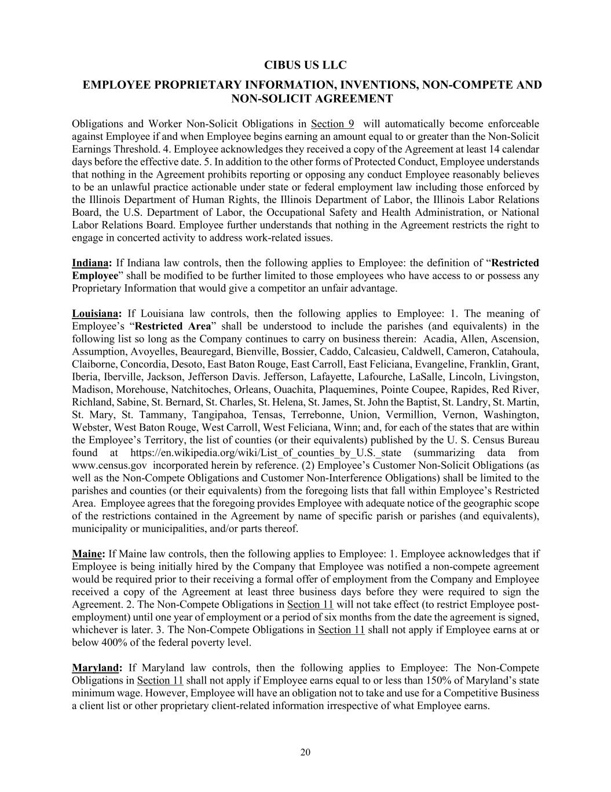
CIBUS US LLC EMPLOYEE PROPRIETARY INFORMATION, INVENTIONS, NON-COMPETE AND NON-SOLICIT AGREEMENT 20 Obligations and Worker Non-Solicit Obligations in Section 9 will automatically become enforceable against Employee if and when Employee begins earning an amount equal to or greater than the Non-Solicit Earnings Threshold. 4. Employee acknowledges they received a copy of the Agreement at least 14 calendar days before the effective date. 5. In addition to the other forms of Protected Conduct, Employee understands that nothing in the Agreement prohibits reporting or opposing any conduct Employee reasonably believes to be an unlawful practice actionable under state or federal employment law including those enforced by the Illinois Department of Human Rights, the Illinois Department of Labor, the Illinois Labor Relations Board, the U.S. Department of Labor, the Occupational Safety and Health Administration, or National Labor Relations Board. Employee further understands that nothing in the Agreement restricts the right to engage in concerted activity to address work-related issues. Indiana: If Indiana law controls, then the following applies to Employee: the definition of “Restricted Employee” shall be modified to be further limited to those employees who have access to or possess any Proprietary Information that would give a competitor an unfair advantage. Louisiana: If Louisiana law controls, then the following applies to Employee: 1. The meaning of Employee’s “Restricted Area” shall be understood to include the parishes (and equivalents) in the following list so long as the Company continues to carry on business therein: Acadia, Allen, Ascension, Assumption, Avoyelles, Beauregard, Bienville, Bossier, Caddo, Calcasieu, Caldwell, Cameron, Catahoula, Claiborne, Concordia, Desoto, East Baton Rouge, East Carroll, East Feliciana, Evangeline, Franklin, Grant, Iberia, Iberville, Jackson, Jefferson Davis. Jefferson, Lafayette, Lafourche, LaSalle, Lincoln, Livingston, Madison, Morehouse, Natchitoches, Orleans, Ouachita, Plaquemines, Pointe Coupee, Rapides, Red River, Richland, Sabine, St. Bernard, St. Charles, St. Helena, St. James, St. John the Baptist, St. Landry, St. Martin, St. Mary, St. Tammany, Tangipahoa, Tensas, Terrebonne, Union, Vermillion, Vernon, Washington, Webster, West Baton Rouge, West Carroll, West Feliciana, Winn; and, for each of the states that are within the Employee’s Territory, the list of counties (or their equivalents) published by the U. S. Census Bureau found at https://en.wikipedia.org/wiki/List_of_counties_by_U.S._state (summarizing data from www.census.gov incorporated herein by reference. (2) Employee’s Customer Non-Solicit Obligations (as well as the Non-Compete Obligations and Customer Non-Interference Obligations) shall be limited to the parishes and counties (or their equivalents) from the foregoing lists that fall within Employee’s Restricted Area. Employee agrees that the foregoing provides Employee with adequate notice of the geographic scope of the restrictions contained in the Agreement by name of specific parish or parishes (and equivalents), municipality or municipalities, and/or parts thereof. Maine: If Maine law controls, then the following applies to Employee: 1. Employee acknowledges that if Employee is being initially hired by the Company that Employee was notified a non-compete agreement would be required prior to their receiving a formal offer of employment from the Company and Employee received a copy of the Agreement at least three business days before they were required to sign the Agreement. 2. The Non-Compete Obligations in Section 11 will not take effect (to restrict Employee post- employment) until one year of employment or a period of six months from the date the agreement is signed, whichever is later. 3. The Non-Compete Obligations in Section 11 shall not apply if Employee earns at or below 400% of the federal poverty level. Maryland: If Maryland law controls, then the following applies to Employee: The Non-Compete Obligations in Section 11 shall not apply if Employee earns equal to or less than 150% of Maryland’s state minimum wage. However, Employee will have an obligation not to take and use for a Competitive Business a client list or other proprietary client-related information irrespective of what Employee earns.

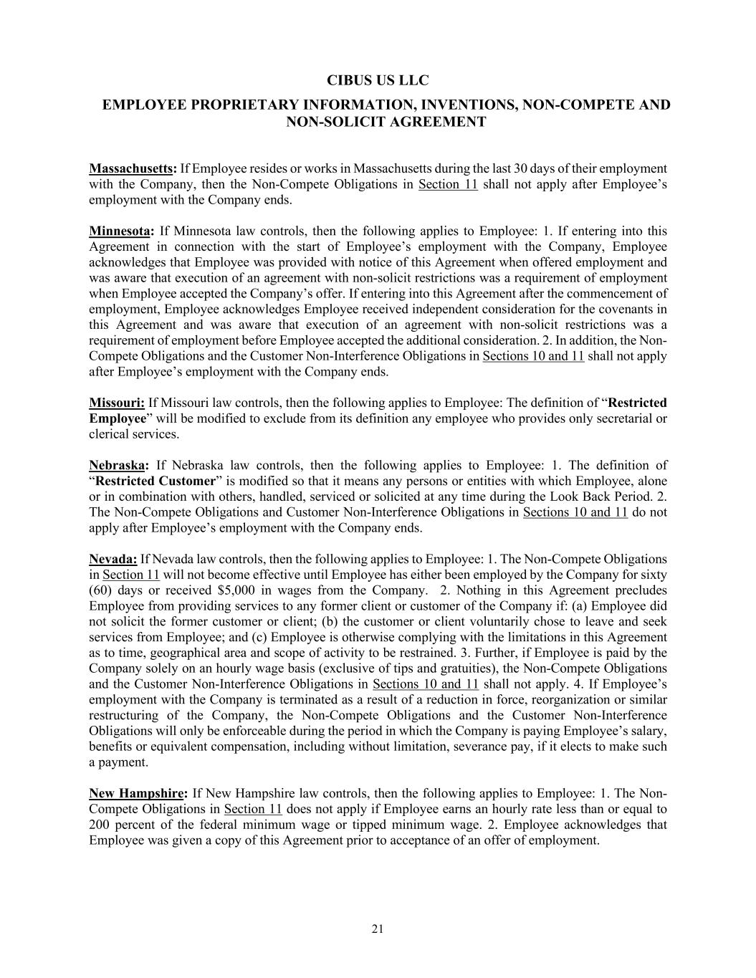
CIBUS US LLC EMPLOYEE PROPRIETARY INFORMATION, INVENTIONS, NON-COMPETE AND NON-SOLICIT AGREEMENT 21 Massachusetts: If Employee resides or works in Massachusetts during the last 30 days of their employment with the Company, then the Non-Compete Obligations in Section 11 shall not apply after Employee’s employment with the Company ends. Minnesota: If Minnesota law controls, then the following applies to Employee: 1. If entering into this Agreement in connection with the start of Employee’s employment with the Company, Employee acknowledges that Employee was provided with notice of this Agreement when offered employment and was aware that execution of an agreement with non-solicit restrictions was a requirement of employment when Employee accepted the Company’s offer. If entering into this Agreement after the commencement of employment, Employee acknowledges Employee received independent consideration for the covenants in this Agreement and was aware that execution of an agreement with non-solicit restrictions was a requirement of employment before Employee accepted the additional consideration. 2. In addition, the Non- Compete Obligations and the Customer Non-Interference Obligations in Sections 10 and 11 shall not apply after Employee’s employment with the Company ends. Missouri: If Missouri law controls, then the following applies to Employee: The definition of “Restricted Employee” will be modified to exclude from its definition any employee who provides only secretarial or clerical services. Nebraska: If Nebraska law controls, then the following applies to Employee: 1. The definition of “Restricted Customer” is modified so that it means any persons or entities with which Employee, alone or in combination with others, handled, serviced or solicited at any time during the Look Back Period. 2. The Non-Compete Obligations and Customer Non-Interference Obligations in Sections 10 and 11 do not apply after Employee’s employment with the Company ends. Nevada: If Nevada law controls, then the following applies to Employee: 1. The Non-Compete Obligations in Section 11 will not become effective until Employee has either been employed by the Company for sixty (60) days or received $5,000 in wages from the Company. 2. Nothing in this Agreement precludes Employee from providing services to any former client or customer of the Company if: (a) Employee did not solicit the former customer or client; (b) the customer or client voluntarily chose to leave and seek services from Employee; and (c) Employee is otherwise complying with the limitations in this Agreement as to time, geographical area and scope of activity to be restrained. 3. Further, if Employee is paid by the Company solely on an hourly wage basis (exclusive of tips and gratuities), the Non-Compete Obligations and the Customer Non-Interference Obligations in Sections 10 and 11 shall not apply. 4. If Employee’s employment with the Company is terminated as a result of a reduction in force, reorganization or similar restructuring of the Company, the Non-Compete Obligations and the Customer Non-Interference Obligations will only be enforceable during the period in which the Company is paying Employee’s salary, benefits or equivalent compensation, including without limitation, severance pay, if it elects to make such a payment. New Hampshire: If New Hampshire law controls, then the following applies to Employee: 1. The Non- Compete Obligations in Section 11 does not apply if Employee earns an hourly rate less than or equal to 200 percent of the federal minimum wage or tipped minimum wage. 2. Employee acknowledges that Employee was given a copy of this Agreement prior to acceptance of an offer of employment.

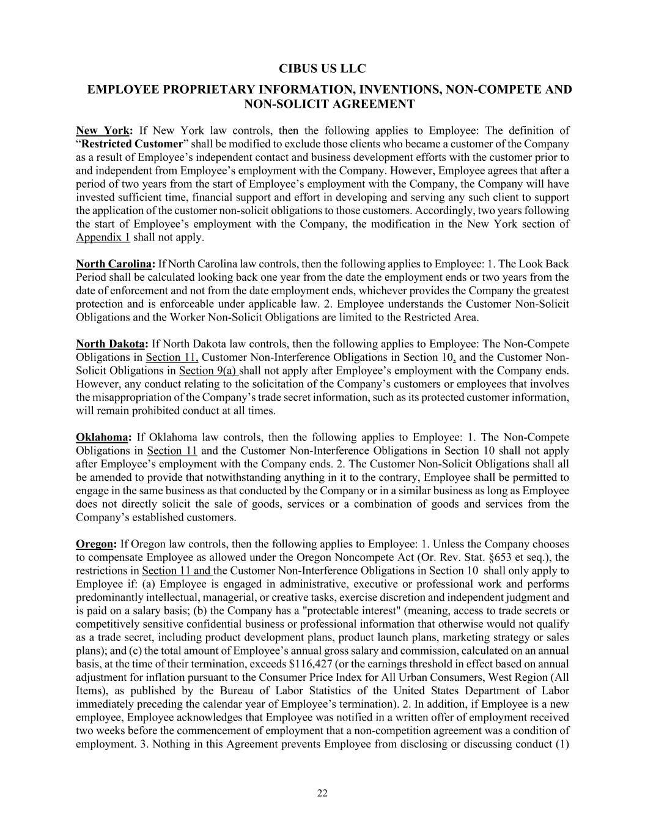
CIBUS US LLC EMPLOYEE PROPRIETARY INFORMATION, INVENTIONS, NON-COMPETE AND NON-SOLICIT AGREEMENT 22 New York: If New York law controls, then the following applies to Employee: The definition of “Restricted Customer” shall be modified to exclude those clients who became a customer of the Company as a result of Employee’s independent contact and business development efforts with the customer prior to and independent from Employee’s employment with the Company. However, Employee agrees that after a period of two years from the start of Employee’s employment with the Company, the Company will have invested sufficient time, financial support and effort in developing and serving any such client to support the application of the customer non-solicit obligations to those customers. Accordingly, two years following the start of Employee’s employment with the Company, the modification in the New York section of Appendix 1 shall not apply. North Carolina: If North Carolina law controls, then the following applies to Employee: 1. The Look Back Period shall be calculated looking back one year from the date the employment ends or two years from the date of enforcement and not from the date employment ends, whichever provides the Company the greatest protection and is enforceable under applicable law. 2. Employee understands the Customer Non-Solicit Obligations and the Worker Non-Solicit Obligations are limited to the Restricted Area. North Dakota: If North Dakota law controls, then the following applies to Employee: The Non-Compete Obligations in Section 11, Customer Non-Interference Obligations in Section 10, and the Customer Non- Solicit Obligations in Section 9(a) shall not apply after Employee’s employment with the Company ends. However, any conduct relating to the solicitation of the Company’s customers or employees that involves the misappropriation of the Company’s trade secret information, such as its protected customer information, will remain prohibited conduct at all times. Oklahoma: If Oklahoma law controls, then the following applies to Employee: 1. The Non-Compete Obligations in Section 11 and the Customer Non-Interference Obligations in Section 10 shall not apply after Employee’s employment with the Company ends. 2. The Customer Non-Solicit Obligations shall all be amended to provide that notwithstanding anything in it to the contrary, Employee shall be permitted to engage in the same business as that conducted by the Company or in a similar business as long as Employee does not directly solicit the sale of goods, services or a combination of goods and services from the Company’s established customers. Oregon: If Oregon law controls, then the following applies to Employee: 1. Unless the Company chooses to compensate Employee as allowed under the Oregon Noncompete Act (Or. Rev. Stat. §653 et seq.), the restrictions in Section 11 and the Customer Non-Interference Obligations in Section 10 shall only apply to Employee if: (a) Employee is engaged in administrative, executive or professional work and performs predominantly intellectual, managerial, or creative tasks, exercise discretion and independent judgment and is paid on a salary basis; (b) the Company has a "protectable interest" (meaning, access to trade secrets or competitively sensitive confidential business or professional information that otherwise would not qualify as a trade secret, including product development plans, product launch plans, marketing strategy or sales plans); and (c) the total amount of Employee’s annual gross salary and commission, calculated on an annual basis, at the time of their termination, exceeds $116,427 (or the earnings threshold in effect based on annual adjustment for inflation pursuant to the Consumer Price Index for All Urban Consumers, West Region (All Items), as published by the Bureau of Labor Statistics of the United States Department of Labor immediately preceding the calendar year of Employee’s termination). 2. In addition, if Employee is a new employee, Employee acknowledges that Employee was notified in a written offer of employment received two weeks before the commencement of employment that a non-competition agreement was a condition of employment. 3. Nothing in this Agreement prevents Employee from disclosing or discussing conduct (1)

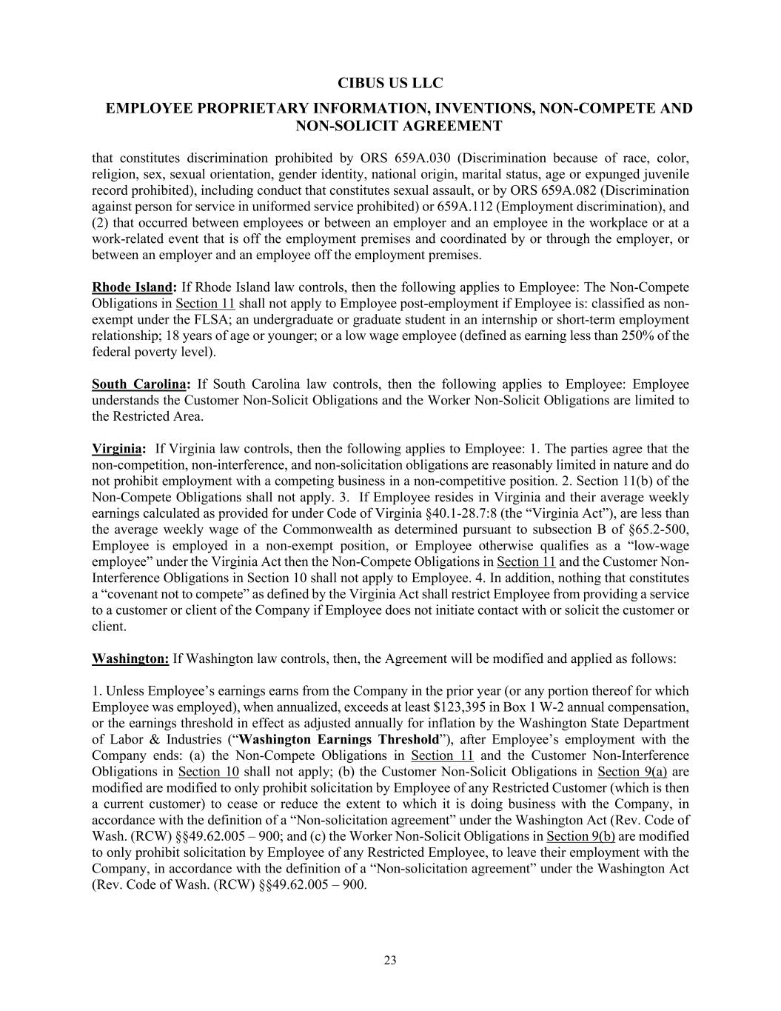
CIBUS US LLC EMPLOYEE PROPRIETARY INFORMATION, INVENTIONS, NON-COMPETE AND NON-SOLICIT AGREEMENT 23 that constitutes discrimination prohibited by ORS 659A.030 (Discrimination because of race, color, religion, sex, sexual orientation, gender identity, national origin, marital status, age or expunged juvenile record prohibited), including conduct that constitutes sexual assault, or by ORS 659A.082 (Discrimination against person for service in uniformed service prohibited) or 659A.112 (Employment discrimination), and (2) that occurred between employees or between an employer and an employee in the workplace or at a work-related event that is off the employment premises and coordinated by or through the employer, or between an employer and an employee off the employment premises. Rhode Island: If Rhode Island law controls, then the following applies to Employee: The Non-Compete Obligations in Section 11 shall not apply to Employee post-employment if Employee is: classified as non- exempt under the FLSA; an undergraduate or graduate student in an internship or short-term employment relationship; 18 years of age or younger; or a low wage employee (defined as earning less than 250% of the federal poverty level). South Carolina: If South Carolina law controls, then the following applies to Employee: Employee understands the Customer Non-Solicit Obligations and the Worker Non-Solicit Obligations are limited to the Restricted Area. Virginia: If Virginia law controls, then the following applies to Employee: 1. The parties agree that the non-competition, non-interference, and non-solicitation obligations are reasonably limited in nature and do not prohibit employment with a competing business in a non-competitive position. 2. Section 11(b) of the Non-Compete Obligations shall not apply. 3. If Employee resides in Virginia and their average weekly earnings calculated as provided for under Code of Virginia §40.1-28.7:8 (the “Virginia Act”), are less than the average weekly wage of the Commonwealth as determined pursuant to subsection B of §65.2-500, Employee is employed in a non-exempt position, or Employee otherwise qualifies as a “low-wage employee” under the Virginia Act then the Non-Compete Obligations in Section 11 and the Customer Non- Interference Obligations in Section 10 shall not apply to Employee. 4. In addition, nothing that constitutes a “covenant not to compete” as defined by the Virginia Act shall restrict Employee from providing a service to a customer or client of the Company if Employee does not initiate contact with or solicit the customer or client. Washington: If Washington law controls, then, the Agreement will be modified and applied as follows: 1. Unless Employee’s earnings earns from the Company in the prior year (or any portion thereof for which Employee was employed), when annualized, exceeds at least $123,395 in Box 1 W-2 annual compensation, or the earnings threshold in effect as adjusted annually for inflation by the Washington State Department of Labor & Industries (“Washington Earnings Threshold”), after Employee’s employment with the Company ends: (a) the Non-Compete Obligations in Section 11 and the Customer Non-Interference Obligations in Section 10 shall not apply; (b) the Customer Non-Solicit Obligations in Section 9(a) are modified are modified to only prohibit solicitation by Employee of any Restricted Customer (which is then a current customer) to cease or reduce the extent to which it is doing business with the Company, in accordance with the definition of a “Non-solicitation agreement” under the Washington Act (Rev. Code of Wash. (RCW) §§49.62.005 – 900; and (c) the Worker Non-Solicit Obligations in Section 9(b) are modified to only prohibit solicitation by Employee of any Restricted Employee, to leave their employment with the Company, in accordance with the definition of a “Non-solicitation agreement” under the Washington Act (Rev. Code of Wash. (RCW) §§49.62.005 – 900.

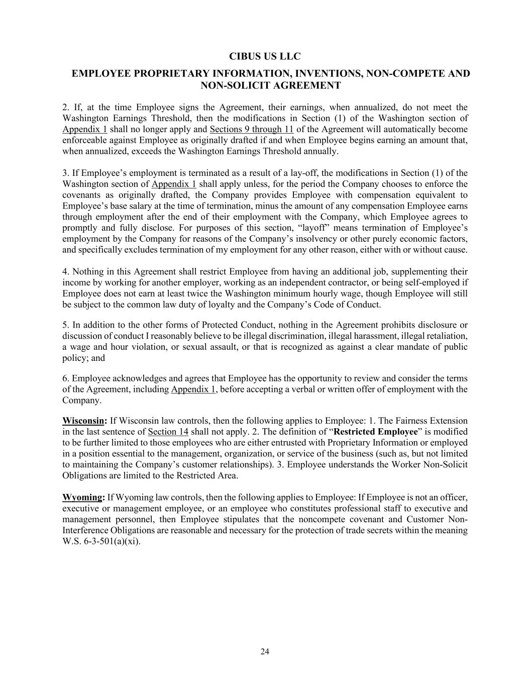
CIBUS US LLC EMPLOYEE PROPRIETARY INFORMATION, INVENTIONS, NON-COMPETE AND NON-SOLICIT AGREEMENT 24 2. If, at the time Employee signs the Agreement, their earnings, when annualized, do not meet the Washington Earnings Threshold, then the modifications in Section (1) of the Washington section of Appendix 1 shall no longer apply and Sections 9 through 11 of the Agreement will automatically become enforceable against Employee as originally drafted if and when Employee begins earning an amount that, when annualized, exceeds the Washington Earnings Threshold annually. 3. If Employee’s employment is terminated as a result of a lay-off, the modifications in Section (1) of the Washington section of Appendix 1 shall apply unless, for the period the Company chooses to enforce the covenants as originally drafted, the Company provides Employee with compensation equivalent to Employee’s base salary at the time of termination, minus the amount of any compensation Employee earns through employment after the end of their employment with the Company, which Employee agrees to promptly and fully disclose. For purposes of this section, “layoff” means termination of Employee’s employment by the Company for reasons of the Company’s insolvency or other purely economic factors, and specifically excludes termination of my employment for any other reason, either with or without cause. 4. Nothing in this Agreement shall restrict Employee from having an additional job, supplementing their income by working for another employer, working as an independent contractor, or being self-employed if Employee does not earn at least twice the Washington minimum hourly wage, though Employee will still be subject to the common law duty of loyalty and the Company’s Code of Conduct. 5. In addition to the other forms of Protected Conduct, nothing in the Agreement prohibits disclosure or discussion of conduct I reasonably believe to be illegal discrimination, illegal harassment, illegal retaliation, a wage and hour violation, or sexual assault, or that is recognized as against a clear mandate of public policy; and 6. Employee acknowledges and agrees that Employee has the opportunity to review and consider the terms of the Agreement, including Appendix 1, before accepting a verbal or written offer of employment with the Company. Wisconsin: If Wisconsin law controls, then the following applies to Employee: 1. The Fairness Extension in the last sentence of Section 14 shall not apply. 2. The definition of “Restricted Employee” is modified to be further limited to those employees who are either entrusted with Proprietary Information or employed in a position essential to the management, organization, or service of the business (such as, but not limited to maintaining the Company’s customer relationships). 3. Employee understands the Worker Non-Solicit Obligations are limited to the Restricted Area. Wyoming: If Wyoming law controls, then the following applies to Employee: If Employee is not an officer, executive or management employee, or an employee who constitutes professional staff to executive and management personnel, then Employee stipulates that the noncompete covenant and Customer Non- Interference Obligations are reasonable and necessary for the protection of trade secrets within the meaning W.S. 6-3-501(a)(xi).

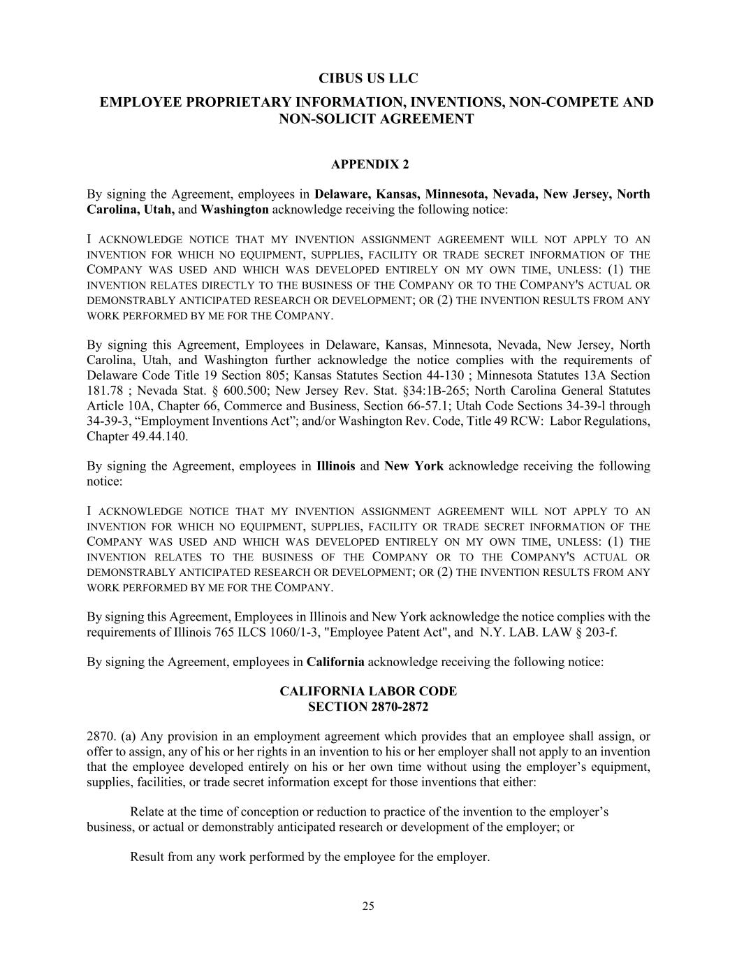
CIBUS US LLC EMPLOYEE PROPRIETARY INFORMATION, INVENTIONS, NON-COMPETE AND NON-SOLICIT AGREEMENT 25 APPENDIX 2 By signing the Agreement, employees in Delaware, Kansas, Minnesota, Nevada, New Jersey, North Carolina, Utah, and Washington acknowledge receiving the following notice: I ACKNOWLEDGE NOTICE THAT MY INVENTION ASSIGNMENT AGREEMENT WILL NOT APPLY TO AN INVENTION FOR WHICH NO EQUIPMENT, SUPPLIES, FACILITY OR TRADE SECRET INFORMATION OF THE COMPANY WAS USED AND WHICH WAS DEVELOPED ENTIRELY ON MY OWN TIME, UNLESS: (1) THE INVENTION RELATES DIRECTLY TO THE BUSINESS OF THE COMPANY OR TO THE COMPANY'S ACTUAL OR DEMONSTRABLY ANTICIPATED RESEARCH OR DEVELOPMENT; OR (2) THE INVENTION RESULTS FROM ANY WORK PERFORMED BY ME FOR THE COMPANY. By signing this Agreement, Employees in Delaware, Kansas, Minnesota, Nevada, New Jersey, North Carolina, Utah, and Washington further acknowledge the notice complies with the requirements of Delaware Code Title 19 Section 805; Kansas Statutes Section 44-130 ; Minnesota Statutes 13A Section 181.78 ; Nevada Stat. § 600.500; New Jersey Rev. Stat. §34:1B-265; North Carolina General Statutes Article 10A, Chapter 66, Commerce and Business, Section 66-57.1; Utah Code Sections 34-39-l through 34-39-3, “Employment Inventions Act”; and/or Washington Rev. Code, Title 49 RCW: Labor Regulations, Chapter 49.44.140. By signing the Agreement, employees in Illinois and New York acknowledge receiving the following notice: I ACKNOWLEDGE NOTICE THAT MY INVENTION ASSIGNMENT AGREEMENT WILL NOT APPLY TO AN INVENTION FOR WHICH NO EQUIPMENT, SUPPLIES, FACILITY OR TRADE SECRET INFORMATION OF THE COMPANY WAS USED AND WHICH WAS DEVELOPED ENTIRELY ON MY OWN TIME, UNLESS: (1) THE INVENTION RELATES TO THE BUSINESS OF THE COMPANY OR TO THE COMPANY'S ACTUAL OR DEMONSTRABLY ANTICIPATED RESEARCH OR DEVELOPMENT; OR (2) THE INVENTION RESULTS FROM ANY WORK PERFORMED BY ME FOR THE COMPANY. By signing this Agreement, Employees in Illinois and New York acknowledge the notice complies with the requirements of Illinois 765 ILCS 1060/1-3, "Employee Patent Act", and N.Y. LAB. LAW § 203-f. By signing the Agreement, employees in California acknowledge receiving the following notice: CALIFORNIA LABOR CODE SECTION 2870-2872 2870. (a) Any provision in an employment agreement which provides that an employee shall assign, or offer to assign, any of his or her rights in an invention to his or her employer shall not apply to an invention that the employee developed entirely on his or her own time without using the employer’s equipment, supplies, facilities, or trade secret information except for those inventions that either: Relate at the time of conception or reduction to practice of the invention to the employer’s business, or actual or demonstrably anticipated research or development of the employer; or Result from any work performed by the employee for the employer.

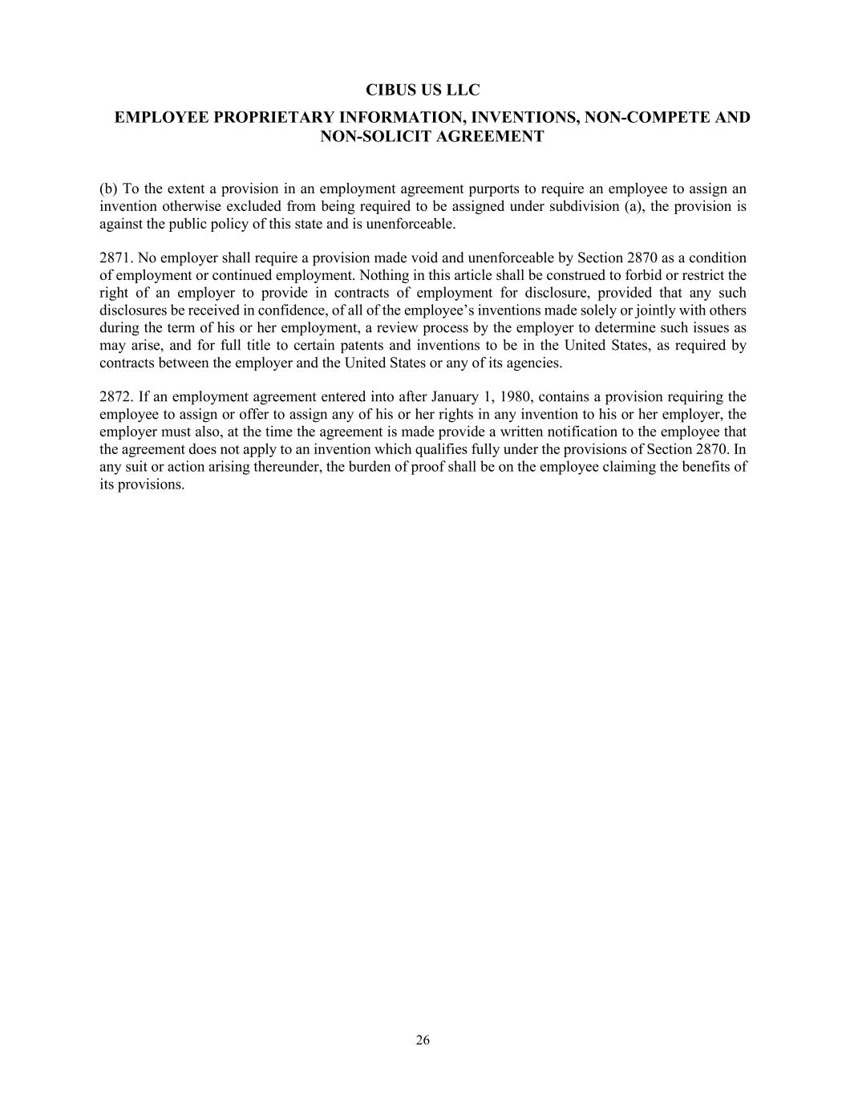
CIBUS US LLC EMPLOYEE PROPRIETARY INFORMATION, INVENTIONS, NON-COMPETE AND NON-SOLICIT AGREEMENT 26 (b) To the extent a provision in an employment agreement purports to require an employee to assign an invention otherwise excluded from being required to be assigned under subdivision (a), the provision is against the public policy of this state and is unenforceable. 2871. No employer shall require a provision made void and unenforceable by Section 2870 as a condition of employment or continued employment. Nothing in this article shall be construed to forbid or restrict the right of an employer to provide in contracts of employment for disclosure, provided that any such disclosures be received in confidence, of all of the employee’s inventions made solely or jointly with others during the term of his or her employment, a review process by the employer to determine such issues as may arise, and for full title to certain patents and inventions to be in the United States, as required by contracts between the employer and the United States or any of its agencies. 2872. If an employment agreement entered into after January 1, 1980, contains a provision requiring the employee to assign or offer to assign any of his or her rights in any invention to his or her employer, the employer must also, at the time the agreement is made provide a written notification to the employee that the agreement does not apply to an invention which qualifies fully under the provisions of Section 2870. In any suit or action arising thereunder, the burden of proof shall be on the employee claiming the benefits of its provisions.

Exhibit 31.1
CERTIFICATION PURSUANT TO RULES 13a-l4(a) AND l5d-l4(a)
UNDER THE SECURITIES EXCHANGE ACT, AS AMENDED
I, Craig Wichner, certify that:
1.I have reviewed this Quarterly Report on Form 10-Q of Cibus, Inc.;
2.Based on my knowledge, this report does not contain any untrue statement of a material fact or omit to state a material fact necessary to make the statements made, in light of the circumstances under which such statements were made, not misleading with respect to the period covered by this report;
3.Based on my knowledge, the financial statements, and other financial information included in this report, fairly present in all material respects the financial condition, results of operations and cash flows of the registrant as of, and for, the periods presented in this report;
4.The registrant’s other certifying officer and I are responsible for establishing and maintaining disclosure controls and procedures (as defined in Exchange Act Rules 13a-15(e) and 15d-15(e)) and internal control over financial reporting (as defined in Exchange Act Rules 13a-15(f) and 15d-15(f)) for the registrant and have:
a.Designed such disclosure controls and procedures, or caused such disclosure controls and procedures to be designed under our supervision, to ensure that material information relating to the registrant, including its consolidated subsidiaries, is made known to us by others within those entities, particularly during the period in which this report is being prepared;
b.Designed such internal control over financial reporting, or caused such internal control over financial reporting to be designed under our supervision, to provide reasonable assurance regarding the reliability of financial reporting and the preparation of financial statements for external purposes in accordance with generally accepted accounting principles;
c.Evaluated the effectiveness of the registrant’s disclosure controls and procedures and presented in this report our conclusions about the effectiveness of the disclosure controls and procedures, as of the end of the period covered by this report based on such evaluation; and
d.Disclosed in this report any change in the registrant’s internal control over financial reporting that occurred during the registrant’s most recent fiscal quarter (the registrant’s fourth fiscal quarter in the case of an annual report) that has materially affected, or is reasonably likely to materially affect, the registrant’s internal control over financial reporting; and
5.The registrant’s other certifying officer and I have disclosed, based on our most recent evaluation of internal control over financial reporting, to the registrant’s auditors and the audit committee of the registrant’s board of directors (or persons performing the equivalent functions):
a.All significant deficiencies and material weaknesses in the design or operation of internal control over financial reporting which are reasonably likely to adversely affect the registrant’s ability to record, process, summarize and report financial information; and
b.Any fraud, whether or not material, that involves management or other employees who have a significant role in the registrant’s internal control over financial reporting.
Date: August 13, 2026
/s/ Craig Wichner
Craig Wichner
Chief Executive Officer

Exhibit 31.2
CERTIFICATION PURSUANT TO RULES 13a-14(a) AND 15d-14(a)
UNDER THE SECURITIES EXCHANGE ACT, AS AMENDED
I, Cornelis (Carlo) Broos, certify that:
1.I have reviewed this Quarterly Report on Form 10-Q of Cibus, Inc.;
2.Based on my knowledge, this report does not contain any untrue statement of a material fact or omit to state a material fact necessary to make the statements made, in light of the circumstances under which such statements were made, not misleading with respect to the period covered by this report;
3.Based on my knowledge, the financial statements, and other financial information included in this report, fairly present in all material respects the financial condition, results of operations and cash flows of the registrant as of, and for, the periods presented in this report;
4.The registrant’s other certifying officer and I are responsible for establishing and maintaining disclosure controls and procedures (as defined in Exchange Act Rules 13a-15(e) and 15d-15(e)) and internal control over financial reporting (as defined in Exchange Act Rules 13a-15(f) and 15d-15(f)) for the registrant and have:
a.Designed such disclosure controls and procedures, or caused such disclosure controls and procedures to be designed under our supervision, to ensure that material information relating to the registrant, including its consolidated subsidiaries, is made known to us by others within those entities, particularly during the period in which this report is being prepared;
b.Designed such internal control over financial reporting, or caused such internal control over financial reporting to be designed under our supervision, to provide reasonable assurance regarding the reliability of financial reporting and the preparation of financial statements for external purposes in accordance with generally accepted accounting principles;
c.Evaluated the effectiveness of the registrant’s disclosure controls and procedures and presented in this report our conclusions about the effectiveness of the disclosure controls and procedures, as of the end of the period covered by this report based on such evaluation; and
d.Disclosed in this report any change in the registrant’s internal control over financial reporting that occurred during the registrant’s most recent fiscal quarter (the registrant’s fourth fiscal quarter in the case of an annual report) that has materially affected, or is reasonably likely to materially affect, the registrant’s internal control over financial reporting; and
5.The registrant’s other certifying officer and I have disclosed, based on our most recent evaluation of internal control over financial reporting, to the registrant’s auditors and the audit committee of the registrant’s board of directors (or persons performing the equivalent functions):
a.All significant deficiencies and material weaknesses in the design or operation of internal control over financial reporting which are reasonably likely to adversely affect the registrant’s ability to record, process, summarize and report financial information; and
b.Any fraud, whether or not material, that involves management or other employees who have a significant role in the registrant’s internal control over financial reporting.
Date: August 13, 2026
/s/ Cornelis (Carlo) Broos
Cornelis (Carlo) Broos
Chief Financial Officer

Exhibit 32.1
CERTIFICATION PURSUANT TO
18 U.S.C. SECTION 1350, AS ADOPTED PURSUANT TO
SECTION 906 OF THE SARBANES-OXLEY ACT OF 2002
In connection with the Quarterly Report of Cibus, Inc. (the “Company”) on Form 10-Q for the period ended June 30, 2026, as filed with the Securities and Exchange Commission on the date hereof (the “Report”), each of the undersigned hereby certifies, pursuant to 18 U.S.C. § 1350, as adopted pursuant to § 906 of the Sarbanes-Oxley Act of 2002, that, to his knowledge:
(1)The Report fully complies with the requirements of section 13(a) or 15(d) of the Securities Exchange Act of 1934; and
(2)The information contained in the Report fairly presents, in all material respects, the financial condition and results of operations of the Company.
Date: August 13, 2026
/s/ Craig Wichner
Craig Wichner
Chief Executive Officer
/s/ Cornelis (Carlo) Broos
Cornelis (Carlo) Broos
Chief Financial Officer

